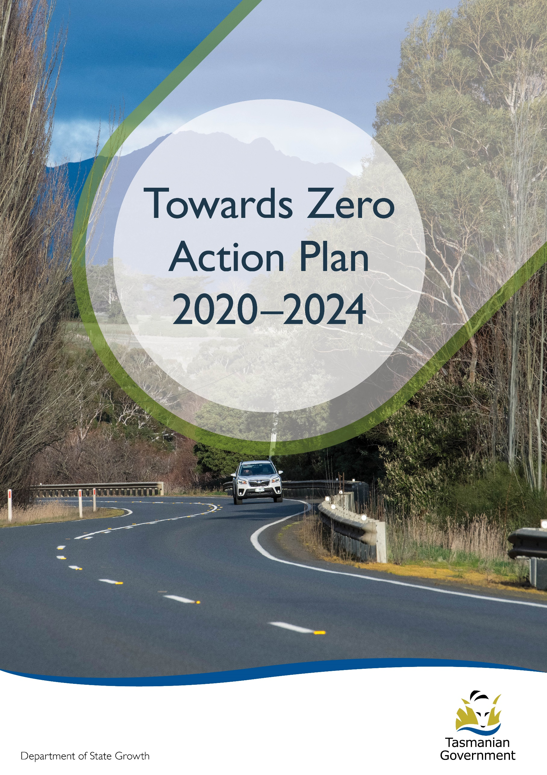
Quarterly Progress Report to RSAC as at 30 September 2021
Contents
Progress on meeting Towards Zero Strategy targets 3
Serious Casualties 3
Fatalities 3
2021 YTD 3
Serious Casualties Tasmania – Annual Count, Percentage Split by Quarter and Towards Zero Target 3
Annual fatalities – Rate per 100,000 population 4
Progress on meeting MAIB targets 5
Fatalities – 12 Month Rolling Total 5
Total Serious Claims – 12 Month Rolling Total 5
Statistics 6
Serious Casualties by Quarter by Age Group – 12 period moving average 6
Serious Casualties by Quarter by Sex – 12 period moving average 6
Serious Casualties by Quarter by Road User Type – 12 period moving average 7
Serious Casualties by Quarter by Speed Zone – 12 period moving average 7
Serious Casualties by Quarter by Crash Type (DCA) – 12 period moving average 8
Serious Casualties by Quarter by Urban/Non-Urban – 12 period moving average 8
Serious Casualty locations to 30 September 2021 (Black = Fatality, Red = Serious Injury) 9
Key themes and priority actions 2020-2024 10
Funding of key themes 10
Project status report 11
Progress on key themes 12
Rural roads grants program for local government 12
Infrastructure upgrades on low volume State roads 13
Motorcyclist safety on rural roads 13
Speed moderation and community engagement strategy 13
Safe system knowledge and skills training 13
Targeted infrastructure upgrades in high traffic urban areas 15
Vulnerable Road User Program 15
Community Road Safety Grants Program 16
Trial of innovative technologies 16
Innovative infrastructure treatment demonstrations 16
Learner Driver Mentor Program and Driver Mentoring Tasmania 17
Graduated Licensing System Project 17
Motorcyclist Graduated Licensing System review 18
Rotary Youth Driver Awareness Program (RYDA) 18
Driving for Jobs Program 19
RACT education initiatives 19
Real Mates media campaign 19
Bicycle Network bike education 20
Safety arounds schools 20
Kidsafe child restraint check program 20
Full Gear motorcycle safety project 20
Inattention and distraction 22
Safe behaviour campaigns 23
Mandatory Alcohol Interlock Program (MAIP) 23
Protective clothing for motorcyclists 23
Road safety penalties review 24
Speed enforcement strategy 24
Enforcement of high-risk behaviours 24
Automated Speed Enforcement Program 25
High-risk motorcycling enforcement 25
Road Rules Awareness 26
Tourist road safety signage program 27
Responsive electronic signage trial 27
Tourist education materials 27
Strategic partnerships 28
Tourist education at gateway entry points 28
Stakeholder alliances 28
Australasian New Car Assessment Program (ANCAP) 29
Safer cars for young drivers 29
Autonomous vehicle and crash avoidance readiness 29
Workplace driver safety 30
Light vehicle strategy 30

Progress on meeting Towards Zero Strategy targets
The key interim target for the Towards Zero – Tasmanian Road Safety Strategy 2017-2026 (Towards Zero Strategy) is to reduce the number of annual serious injuries and deaths on Tasmanian roads to fewer than 200 by 2026. This is an ambitious target of 100 fewer serious casualties per year than for the period 2012-2016 (annual average) and will move us towards the long-term goal of zero serious casualties on Tasmanian roads.

Serious Casualties
The number of serious casualties in 2020 was 327, compared to 278 in 2019, a 17.6 per cent increase. The 2020 figure of 327 is a 6.2 per cent increase on the five year serious casualty average of 308 (2015-2019).

Fatalities
In 2020, there were 37 fatalities on Tasmanian roads which is eight more than the number recorded in 2019. The figure of 37 fatalities in 2020 is an 14.2 per cent increase on the five year fatalities average of 32.4 (2015-2019).

2021 YTD
There have been 222 serious casualties (29 fatalities and 193 serious injuries) to 30 September 2021, three fewer than the number recorded at the same time last year (27 fatalities and 198 serious injuries) and an increase of 0.8 per cent on the five year average of 220.2 serious casualties.

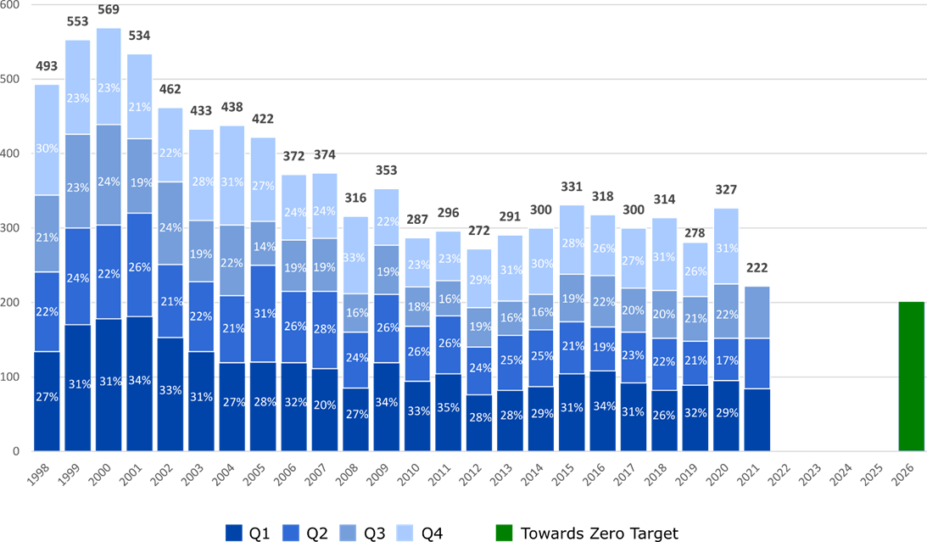
Serious Casualties Tasmania – Annual Count, Percentage Split by Quarter and Towards Zero Target

Annual fatalities – Rate per 100,000 population
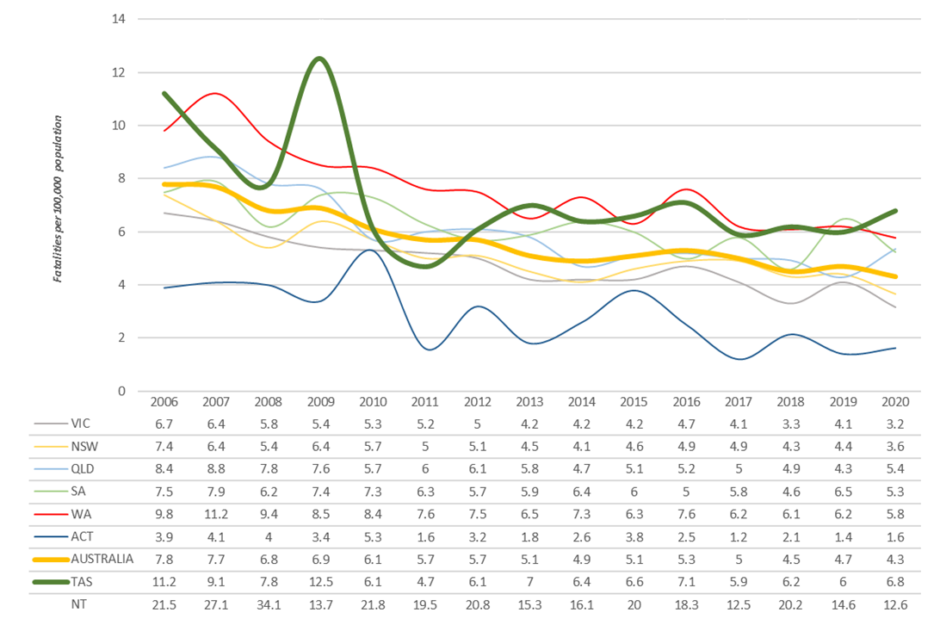

Note: NT omitted from chart for clarity purposes.

Progress on meeting MAIB targets
Motor Accidents Insurance Board (MAIB) injury statistics show the number of fatalities and the level of claims for serious injuries on our roads.
Various claim reduction targets are specified in the Memorandum of Understanding between the Department of State Growth (State Growth) and the MAIB. Progress against high level targets is shown below, expressed as 12 month moving totals

Fatalities – 12 Month Rolling Total
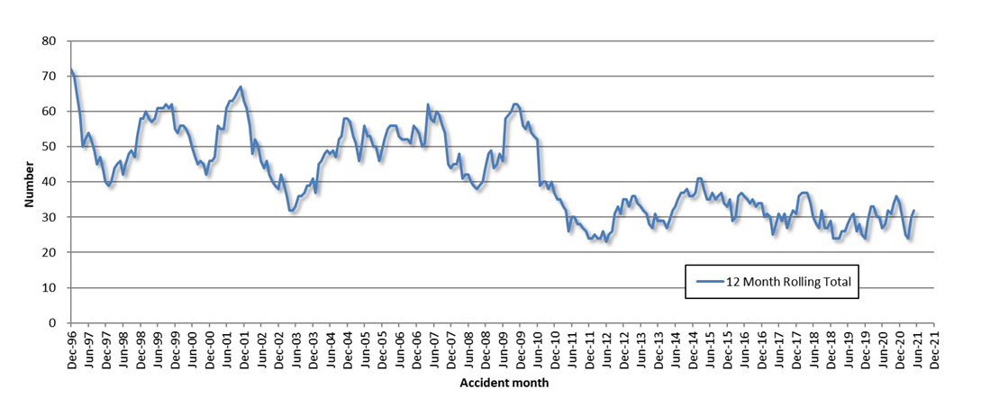

Total Serious Claims – 12 Month Rolling Total
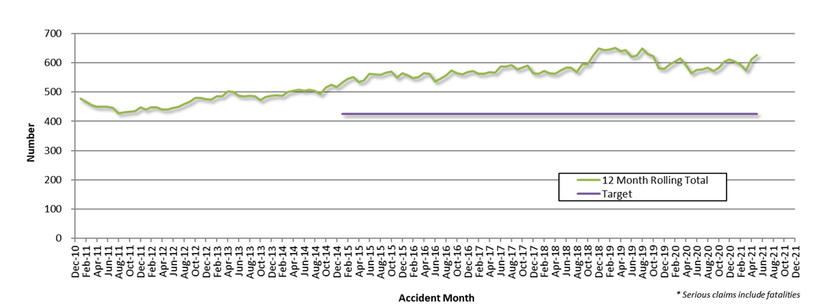

Statistics

Serious Casualties by Quarter by Age Group – 12 period moving average
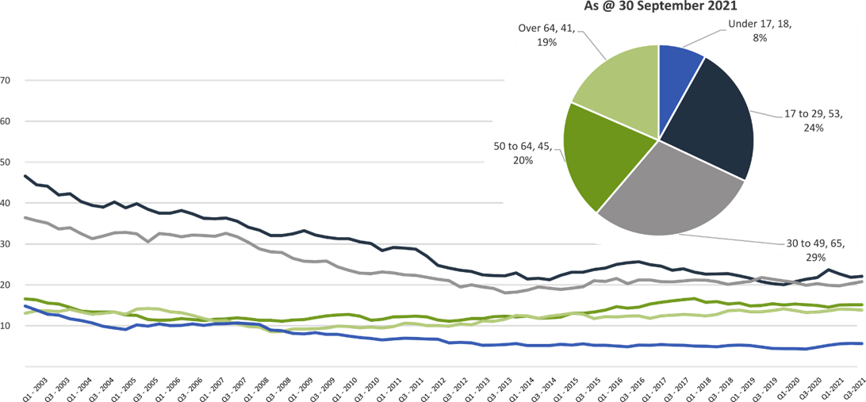

Serious Casualties by Quarter by Sex – 12 period moving average
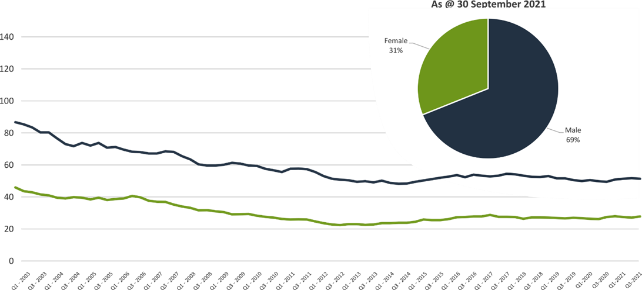

Serious Casualties by Quarter by Road User Type – 12 period moving average
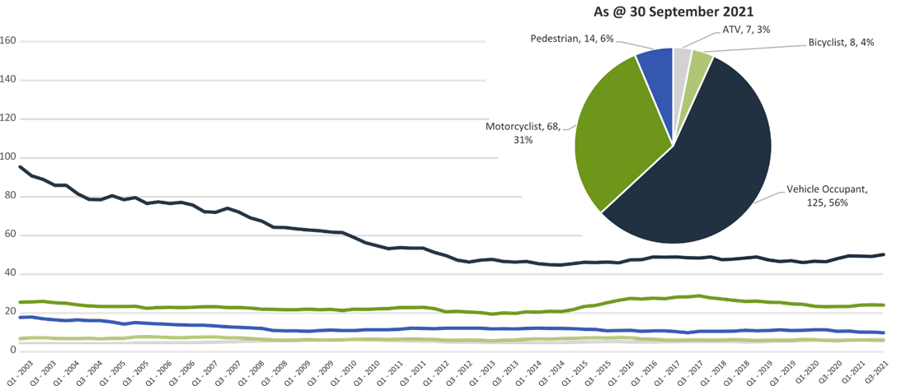

Serious Casualties by Quarter by Speed Zone – 12 period moving average
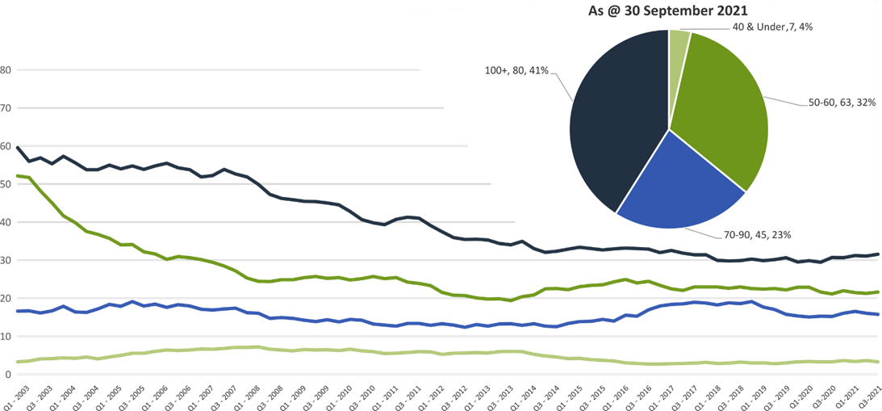

Pie chart excludes serious casualties where speed zone is recorded as ‘not known’

Serious Casualties by Quarter by Crash Type (DCA) – 12 period moving average
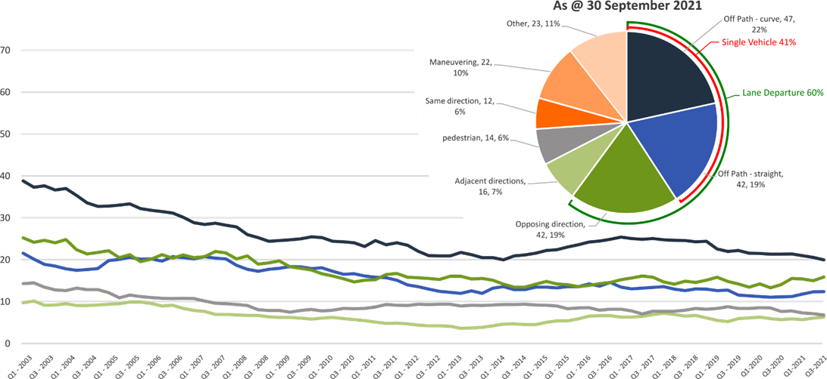

Other includes crash types: on-path (5%), overtaking (3%) & Passenger and Miscellaneous (3%).

Serious Casualties by Quarter by Urban/Non-Urban – 12 period moving average
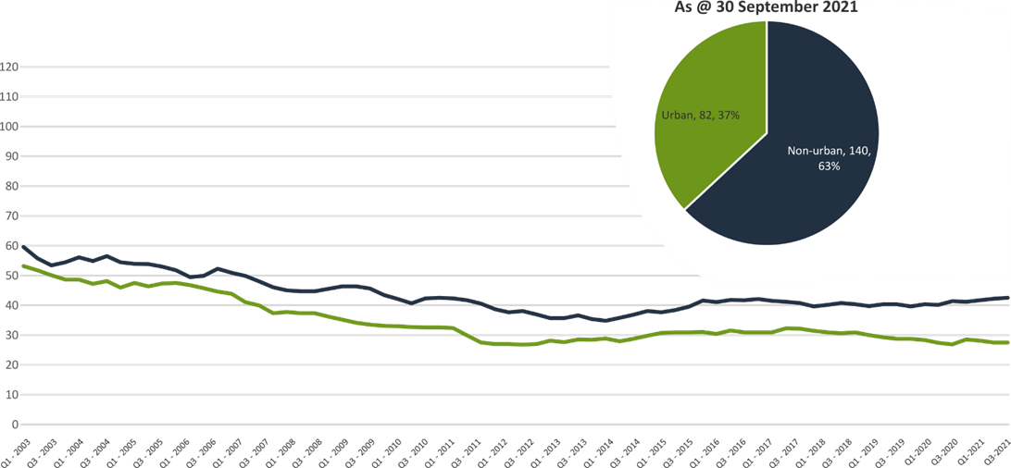

Based on the Australian Bureau of Statistics’ ‘significant urban area’ geographic definition.

Serious Casualty locations to 30 September 2021 (Black = Fatality, Red = Serious Injury)
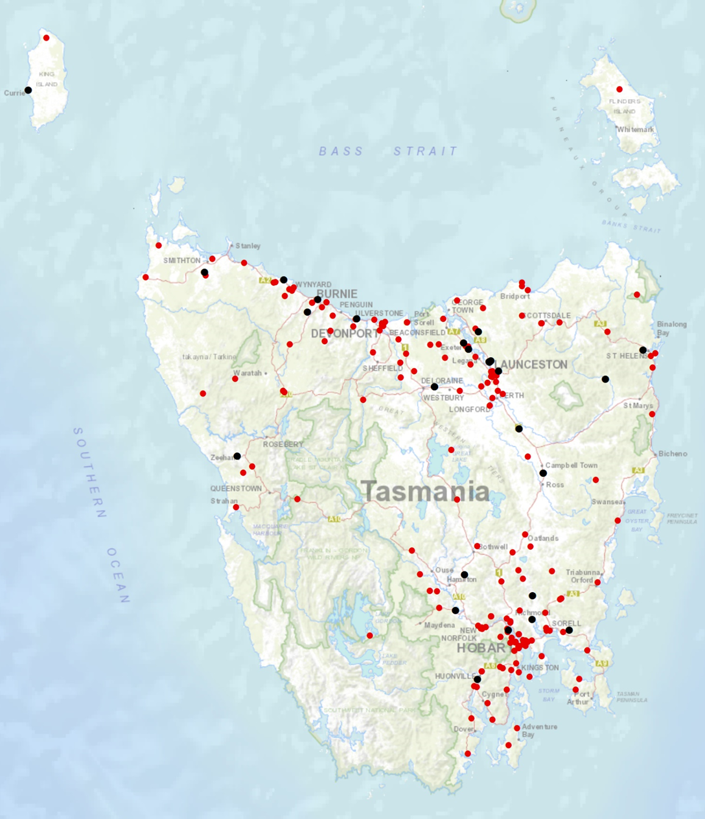

Key themes and priority actions 2020-2024
The Quarterly Progress Report details progress on key themes and priority actions under the Towards Zero Action Plan 2020-2024 and the Towards Zero – Tasmanian Road Safety Strategy 2017-2026.
The progress report should be read in conjunction with the Action Plan and understood in the context of the Towards Zero Strategy. These documents are available at: www.towardszero.tas.gov.au

Funding of key themes
Over $20 million Over $31 million
Over $12 million Over $4 million

$2 million Over $3 million

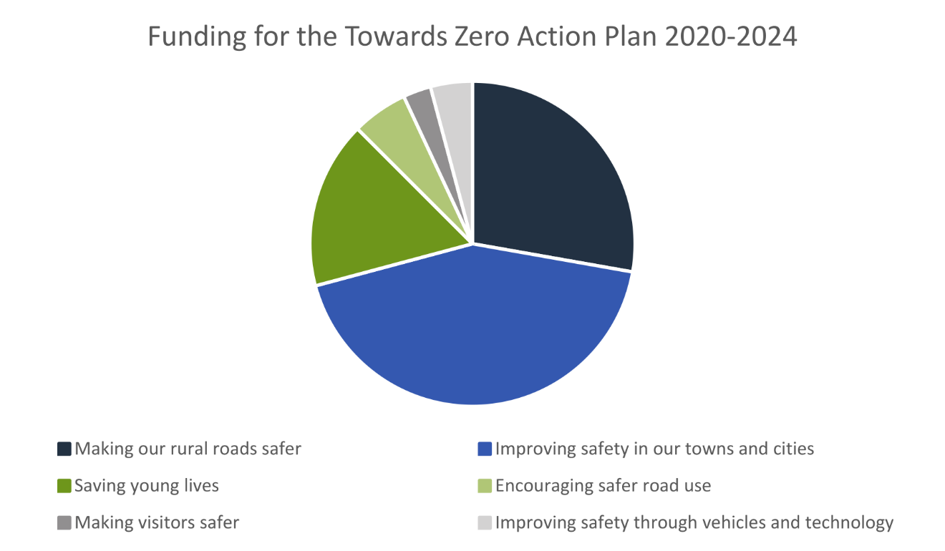

Project status report
Making our rural roads safer
Rural road grants program for local government | On schedule |  | Infrastructure upgrades on low volume State roads | On schedule
Motorcyclist safety on rural roads | On hold |  | Speed moderation and community engagement strategy | Not yet commenced
Safe system knowledge and skills training | On schedule
Improving safety in our cities and towns
Targeted infrastructure upgrades in high traffic urban areas | Not yet commenced |  | Vulnerable Road User Program | On schedule
Community Road Safety Program | On schedule |  | Trial of innovative technologies | On hold
Innovative infrastructure treatment demonstrations | On hold
Saving young lives
Learner Driver Mentor Program and Driver Mentoring Tasmania | On schedule |  | Graduated Licensing System Project for drivers | On schedule
Rotary Youth Driver Awareness Program | On schedule |  | Driving for Jobs Program | On schedule
RACT education initiatives | On schedule |  | Real Mates media campaign | On schedule
Bicycle Network bike education | On schedule |  | Safety around schools | On schedule
Kidsafe child restraint check program | On schedule |  | Full Gear motorcycle safety project | On schedule
Develop a Graduated Licensing System for motorcyclists | On schedule
Encouraging safer road use
Inattention and distraction | On schedule |  | Safe behaviour campaigns | On schedule
Mandatory Alcohol Interlock Program | Major delays |  | Protective clothing for motorcyclists | On schedule
Road safety penalties review | Complete |  | Speed enforcement strategy | On schedule
Enforcement of high-risk behaviours | On schedule |  | Automated Speed Enforcement Program | On schedule
High-risk motorcycling enforcement | Not yet commenced |  | Road Rules Awareness | On schedule
Making visitors safer
Tourist road safety signage program | On hold |  | Responsive electronic signage trial | On hold
Tourist education materials | Limited activity |  | Strategic partnerships | On hold
Tourist education at gateway entry points | Limited activity |  | Stakeholder alliances | On hold
Improving safety through vehicles and technology
ANCAP | On schedule |  | Safer cars for young drivers | Not yet commenced
Autonomous vehicle and crash avoidance readiness | On schedule |  | Workplace driver safety | Not yet commenced
Light vehicle strategy | On hold

Progress on key themes
Progress on key themes is reported as:
Status | Major delays/on hold/high risk | Delayed/some issues/medium risk | On schedule/progressing/low risk | Not yet commenced

60 per cent of fatalities occur in rural areas

Rural roads grants program for local government
The Safer Rural Roads Program (SRRP) provides funding to councils to implement infrastructure treatments on rural road corridors to reduce lane departure crashes and lessen the harm when they do occur. An allocation of $10 million was made to the SRRP to be administered over five funding rounds of $2 million for the life of the Action Plan.
Comments
The Australian Government Road Safety Program (RSP) is the result of a $2 billion 2020-2021 Commonwealth Budget commitment and subsequently extended to $3 billion in the 2021-2022 Commonwealth Budget. Under the RSP, Tasmania was allocated up to $66 million in funding for small-scale road safety infrastructure projects, to be delivered over five 6-month funding tranches. Under tranche one of the RSP, which runs from 1 January 2021 until 30 June 2021, $33.3 million in funding was allocated to Tasmania. To secure the $33.3 million in funding, the Tasmanian Government was required to make a co-contribution of $12.3 million.
The RSP has provided valuable additional funding to the SRRP. As a result, two funding rounds have been held during the 2020-2021 financial year.
In 2020-2021, 62 applications were received under SRRP and 59 of those received funding. The successful projects totalled approximately $10 million in value. This included Australian Government funding of $6 076 418, and Local Government co-contributions of $1 644 846.
Status | risk |  | On schedule/progressing/low risk

Infrastructure upgrades on low volume State roads
This program will provide funding for lower volume State roads, where cost effective treatments such as shoulder sealing, pavement markings, curve warnings, road side hazard removal and safety barriers will achieve maximum value for money.
Current situation / comments
$6.95 million has been committed for infrastructure improvements on the Railton Main Road. $450 000 is required for the design and development stage and $6.5 million required for works in the delivery stage.
Status |  |  | On schedule/progressing/low risk

Motorcyclist safety on rural roads
Road safety audits will be conducted on high risk touring routes across Tasmania. This program will involve local motorcyclists and a safe system approach will inform audits. Findings will be shared with stakeholders to identify countermeasure that go beyond typical infrastructure solutions.
Current situation / comments
Safe System motorcycle road safety audits
Two audits have been completed and funding allocated. The Central Highlands Council has been provided with a grant deed up to $200 000, to undertake works on Hollow Tree Road. Works have now been completed.
Funding up to $350 000 has been allocated for State Growth to carry out low-cost infrastructure treatments to improve road safety for motorcyclists on Lake Leake Road, works are scheduled to commence in 2021.
Status | On hold

Speed moderation and community engagement strategy
Speed moderation requires a holistic strategy encompassing public education, road risk assessments, enforcement, speed limit setting, speed limit mapping and technology, penalties, KPIs and evaluation. This project will involve community engagement to inform and build support for action on safer speeds. A significant ongoing coordination effort will be required to support the strategy.
Current situation / comments
To commence 2021.
Status |  |  |  | Not yet commenced

Safe system knowledge and skills training
This program aims to improve Safe System knowledge for all those in a position to influence road safety outcomes and support Safe System infrastructure design and speed setting. It will include technical training sessions, workshops and forums across Tasmania.
Current situation / comments
$10 520 funding has been provided to the Tasmanian Bicycle Council to facilitate online training sessions for Tasmanian engineers and planners in designing Safe System compliant cycling lanes/paths.
Status |  |  | On schedule/progressing/low risk

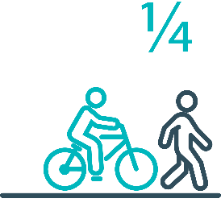

Pedestrians and cyclists are vulnerable and represent
one in four serious casualties in our towns and cities

Targeted infrastructure upgrades in high traffic urban areas
This program provides for delivery of a range of infrastructure safety upgrades to make our towns and cities safer. This will include shoulder sealing, intersection improvements, safety barriers and pavement marking at high traffic areas. This program targets high volume state roads that are not planned for major investment in the short term.
Current situation / comments
Not yet commenced.
Status |  |  |  | Not yet commenced

Vulnerable Road User Program
The Vulnerable Road User Program (VRUP) is an established grants program which assists local government with the costs of installing safety improvements in built up areas. The aim of the program is to reduce conflict between vehicles and vulnerable road users - cyclists, pedestrians and motorcyclists. The funding available under the VRUP was increased from $500 000 per year to $1 000 000 under the current Action Plan.
Current situation / comments
The Australian Government Road Safety Program (RSP) has provided valuable additional funding to the VRUP. As a result, three funding rounds have been held during 2020-2021. The first round of funding closed in April 2020. Twenty-eight applications were received, and funding of $831 941 was awarded in total to 20 projects.
The second funding round closed in November 2020. Forty-two applications were received, and 26 projects were awarded over $3 million in total funding.
A third round of the VRUP was opened in February 2021. Twenty-five applications were received, all projects were approved and awarded over $5 million in total funding.
Status |  |  | On schedule/progressing/low risk

Community Road Safety Grants Program
The Community Road Safety Grants Program (CRSGP) is an established grants program that aims to build community engagement in addressing local road safety issues. The program supports local councils, schools, community groups, research institutions and charity organisations to promote road safety at the grass roots level.
Current situation / comments
The CRSGP opened on 30 August 2021 and closed 30 September 2021. A total of 12 applications were received, three for Category 1 - $500 - $5 000 and nine for Category 2 - $5 000 - $35 000. The Grant Assessment Panel will meet on 12 October to decide which applications will be funded. It is assumed the full $200 000 will be fully subscribed in the funding round.
Status |  |  | On schedule/progressing/low risk

Trial of innovative technologies
This project will include monitoring, investigation and trialling of new and emerging technology based approaches to improving safety for vulnerable road users.
Current situation / comments
To commence 2021.
Status | On hold

Innovative infrastructure treatment demonstrations
This project will investigate, trial and demonstrate innovative Safe System urban infrastructure treatments to improve road safety in our urban areas. We will work with local councils to show how Tasmania’s cities and towns can be improved for the benefit of all road users, particularly cyclists and pedestrians.
Current situation / comments
To commence 2021.
Status | On hold

92 young people are seriously injured or killed on our
roads every year

Learner Driver Mentor Program and Driver Mentoring Tasmania
The Learner Driver Mentor Program (LDMP), supported by Driver Mentoring Tasmania (DMT) is a well-established program that supports disadvantaged learner drivers to gain their on-road supervised driving hours to gain a licence.
Current situation / comments
On 17 September 2021, the Hon Michael Fergusson Mp awarded two new 5-star ANCAP safety rated vehicles to Devonport Chaplaincy and one to the Circular Head Aboriginal Centre. The vehicles were to replace existing fleet vehicles identified as having a 3-star or less Used Car Safety Rating and not suitable for learners and mentors in the LDMP. State Growth continues to work with DMT to improve the performance of LDMPs and implement business improvements and good practice principles.
Status |  |  | On schedule/progressing/low risk

Graduated Licensing System Project
Changes are being made to the Graduated Licensing System (GLS) for drivers to better protect young and novice drivers and improve the licensing pathway. Young drivers are overrepresented in crash statistics and most at risk when they first get their Ps and start driving solo. The changes to the GLS aim to address this risk, and improve road safety outcomes for both young and novice drivers.
Current situation / comments
The Tasmanian Government implemented policy changes to the GLS on 1 December 2020, which was supported by a public education campaign. Tasmania’s GLS now meets the enhanced model under the national framework.
Complementing the policy changes is the new online learning platform which was launched by Government on 8 July 2021. The platform has been designed to improve learner driver education by focusing on developing safe behaviours and attitudes. It ensures new drivers know the road rules and understand the impact of the fatal five road behaviours.
A second public education campaign commenced on the date of the announcement and ran until September 2021. The campaign encouraged take-up by promoting the convenience of the platform and being able to learn and take the test almost anywhere and at any time, as long as they have access to a device (mobile, tablet, computer) and the internet.
The Plates Plus logbook is expected to be approved and ready to launch from mid-October. It is envisaged that this will replace the existing hard copy logbook for many Tasmanian learners as it provides a range of benefits and its ease of use will support an accurate reflection of supervised hours.
The Hazard Perception Test (HPT) is not expected to be launched until early 2022. Resources have been diverted to other projects of higher priority to the Government for most of 2021 and the external developer will now be unable to commence the final work until early January 2022.
Separate campaigns have been developed for both the logbook app and HPT that will commence upon the launch of these products.
Status |  |  | On schedule/progressing/low risk

Motorcyclist Graduated Licensing System review
The review will identify potential enhancements to the Graduated Licensing System (GLS) for motorcyclists. This will include greater restrictions on learners that are gradually lifted as riders acquire skills and experience under conditions that reduce risk.
Current situation / comments
The review of the current Tasmanian Motorcyclist GLS commenced earlier this year. A jurisdictional comparison was prepared and presented to RSAC at is August meeting, along with preliminary analysis of Tasmania’s motorcycle licensing and crash data.
An options paper setting out potential enhancements to the Tasmanian motorcyclist GLS is being prepared for the consideration of RSAC.
Status |  |  | On schedule/progressing/low risk

Rotary Youth Driver Awareness Program (RYDA)
RYDA is a one day road safety education program for year 10-12 students making them aware of the significant responsibility that comes with being a driver or passenger. Every year 4000 students take part in practical demonstrations and learn valuable road safety lessons from expert presenters and volunteers. RYDA is delivered by Rotary Tasmania.
Current situation / comments
Rotary recently conducted the RYDA program in southern Tasmania to 2 400 students. The program will continue in the North and North-West of Tasmania in the coming months. Rotary has reported a renewed interest in the program since the commencement of the five bonus learner licence logbook hours for attending the program under the GLS. Tasmania Police involvement was also limited due to resourcing of the COVID-19 response.
Status |  |  | On schedule/progressing/low risk

Driving for Jobs Program
The Driving for Jobs (DfJ) Program aims to support disadvantaged students who would otherwise be unable to enter and progress through the Graduated Driver Licensing System (GLS). The program provides students at selected schools with the opportunity to increase their road safety knowledge whilst also improving their job readiness. Students undertake a personalised intensive program with a strong road safety focus including professional on-road driving lessons and participation in the Rotary Youth Driver Awareness Program.
Current situation / comments
The DfJ Program operates at Jordan River Learning Federation (JRLF) in the South and expanded to Launceston and Newstead Colleges in the North at the start of term one 2021. The DfJ Steering Committee determined in early 2021 that there are insufficient disadvantaged students at New Norfolk High School to justify the program this year. A second program in the South will commence at Claremont College from the start of term four.
Status |  |  | On schedule/progressing/low risk

RACT education initiatives
The RACT delivers a range of in-class road safety education programs. This includes a program for years 10-12 students that focuses on the dangers of distraction and inattention. The program also teaches students how to progress through the GLS and about the specific rules that apply to L and P plate drivers.
Current situation / comments
In 2021-22, the RACT surpassed the requirements of their funding agreement by delivering the Years Ahead program to 802 older drivers; the Ready for the Road presentation (including Dangers of Distraction) to 426 students and the RoadSafe program to 1 727 students.
Status |  |  | On schedule/progressing/low risk

Real Mates media campaign
The MAIB-funded Real Mates campaign uses humour to engage with young men to encourage them to avoid the risks of drink driving by empowering them to speak up and stop a mate from driving after drinking.
Current situation / comments
The campaign was run in September 2021 to coincide with AFL Finals and will continue until the end of October across television, digital, and on location at pubs and clubs around Tasmania. New digital channels will be tested for the first time this campaign including Snapchat and Tik Tok to trial these advertising channels for our young target audience. We will continue ‘The Look’ messaging and creative.
A sponsorship opportunity with Cricket Tasmania and Hobart Hurricanes is being investigated as a part of this campaign roll out.
Status |  |  | On schedule/progressing/low risk

Bicycle Network bike education
The Bicycle Network delivers the Ride2School program to schools across Tasmania. Ride2School is for primary aged students and focuses on safe cycling, road safety and positive road sharing behaviour.
Current situation / comments
The Bicycle Network has reported more than 150 Ride to School sessions and two Active Maps completed for 2020-21. In addition, the Project Officer has reported repeat bookings from schools visited in 2020 and an interest in expanding Active Maps to high schools. State Growth meets quarterly with the Project Officer to ensure compliance with milestones listed in the grant agreement.
Status |  |  | On schedule/progressing/low risk

Safety arounds schools
Safety around schools is promoted through designated crossings, lower speed zones, more than 100 school crossing patrol officers and public education. The current Safety around Schools project, including the Love 40 campaign, encourages drivers to lower their speed and keep a look out for children in school zones and around buses.
Current situation / comments
The Love 40 program has continued in Term 4 2021, and the focus has been on promoting the program through contemporary media channels such as radio and digital media. Planning has commenced for a further iteration of the campaign in 2022 to capitalise on the campaigns success.
Status |  |  | On schedule/progressing/low risk

Kidsafe child restraint check program
Kidsafe Tasmania conducts free child restraint checking sessions to ensure that young children are safely and lawfully seated and restrained in cars. Kidsafe also distribute and promote educational materials to inform the public of the correct child restraint type for a child’s age and size.
Current situation / comments
Kidsafe continue to provide free restraint checks and eduction sessions at community organisations, including Child and Family Centres, with a trained child restraint fitter. COVID-19 significantly impacted the previous twelve months of operation, with group sessions for child care workers being scaled back. Efforts were made to provide parents, grandparents and carers with individual education and restrain checks.
Status |  |  | On schedule/progressing/low risk

Full Gear motorcycle safety project
The Glenorchy City Council, in partnership with Bucaan House, delivers its successful Full Gear motorcycle safety project which helps young motorcycle riders enter the licensing system and to adopt safe riding practices.
Current situation / comments
The Full Gear Coordinator continues to work with neighbouring Councils to facilitate the expansion of the program. Five participants have now completed the Full Gear program in New Norfolk, and five are due to commence before the end of 2021. In addition, plans for trial programs in Gagebrook and Chigwell are underway, with support from Councils and community organisations. The Clarence Council have also expressed interest, as it aligns with their strategic plans.
An evaluation of the Full Gear program has been undertaken and a report will be available to RSAC for noting at its November 2021 meeting.
Status |  |  | On schedule/progressing/low risk

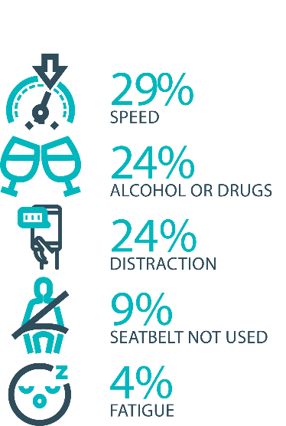

The fatal five behaviours contributing to serious
casualties

Inattention and distraction
Inattention and distraction are concerning causes of serious casualty crashes and may have a far greater impact than current data suggests. There are a number of research projects and enforcement initiatives that are being used to address this issue. This project will include consideration of emerging strategies for tacking distraction, encouraging compliance through enforcement and influencing driver behaviour through public education campaigns.
Current situation / comments
Enforcement
Tasmania Police introduced three unmarked motorcycles to increase the rate of detection and enforcement of illegal phone use whilst driving. These motorcycles operate across all districts and target the low speed road network and congested traffic conditions, utilising ‘lane filtering’ legislation to full advantage.
In an agency first, the riders are also fitted with helmet cameras to capture the offence, an initiative that has effectively nullified disputes. The introduction of unmarked motorcycles has proved to be incredibly successful with riders reporting high-level public support and a notable change in driver behaviour.
Tasmania Police has also conducted a technology demonstration with a commercial provider to test artificial intelligence based automated mobile phone detection. The technology is combined with speed detection and Automated Number Plate Recognition capabilities. Future use of such technology is now being considered as part of the Automated Speed Enforcement Project being led by the Department of State Growth.
Public education campaigns
A new phase of the ‘Leave Your Phone Alone’ campaign that warns drivers of the dangers of using a mobile phone while driving was launched on 21 December 2020. Outdoor media bookings have been extended for the remainder of 2021.
Status |  |  | On schedule/progressing/low risk

Safe behaviour campaigns
Targeted media campaigns will continue to educate people about high-risk behaviours and to highlight the dangers of the ‘Fatal Five’.
Current situation / comments
A pedestrian safety campaign was launched by the Minister on 1 September 2021 and will run for one month. A ‘green man’ is to feature across the guerrilla style, in situ campaign, encouraging both pedestrians and drivers to look out for each other on the road.
A new motorcycle safety campaign is scheduled to be launch on 10 October 2021. The objective of the campaign is to educate Tasmanian motorcycle riders on the risks when riding and the importance of riding safely. The campaign concept focuses on a 30 second TVC that will be cut down into six second social media videos and posters in pubs and venues on popular motorcycle touring routes.
In preparation for the introduction of enhanced speed enforcement in Tasmania a new public education campaign is being developed and is due to be launched in December 2021.
The campaign aims to reduce road trauma by highlighting the dangers of speeding and will support the re-introduction of mobile speed cameras. Production is due to commence in October 2021.
Status |  |  | On schedule/progressing/low risk

Mandatory Alcohol Interlock Program (MAIP)
The MAIP aims to have repeat and high-level drink driving offenders demonstrate they are able to separate their drinking from driving through the installation of an alcohol interlock in their vehicle. New measures will be introduced to increase participation in the MAIP.
Current situation / comments
Drafting instructions for the revised framework were provided to the Office of Parliamentary Counsel (OPC) in October 2019. Parliamentary priorities caused reprioritisation of OPC work, including COVID-19. First draft regulations have not been received by the department. Two Approved Providers have signed new contracts: negotiations continue with the third.
Status | Major delays/on hold/high risk

Protective clothing for motorcyclists
Motorcyclists are overrepresented in Tasmania’s road trauma figures. Motorcyclists are vulnerable road users due to a lack of physical protection. Protective clothing can reduce injury severity in the event of a crash. Tasmania is a funding member of MotoCAP. MotoCAP provides safety assessment star ratings for protective clothing and prepares education materials for motorcyclists.
Current situation / comments
Tasmania contributes around $8 000 per annum to participate in and support the activities of MotoCAP. In early 2021, several thousand public education brochures advising of clothing safety ratings for motorcycle wear were sent out to motorcycle retailers and relevant stakeholders across the state.
Status |  |  | On schedule/progressing/low risk

Road safety penalties review
For enforcement activities to improve safety on our roads, they need to be backed up with appropriate penalties. Tasmania’s road safety penalties will be reviewed to ensure they are up-to-date and provide an appropriate deterrence to those who break the rules and put themselves and others at risk.
Current situation / comments
Tasmania’s road safety penalties have been reviewed and updated and inter-jurisdictional analysis has been completed. Findings were submitted to RSAC for noting at its November 2020 meeting. RSAC determined that current penalties are appropriate and penalties will be reviewed towards the end of the current Action Plan.
Status | Complete

Speed enforcement strategy
Speed enforcement is one of five priority areas within Tasmania Police’s current Road Safety Strategy 2019-2021.
With regard to speed cameras, Tasmania Police has conducted several technology trials, including in-motion camera technology, where speed cameras are fitted to moving vehicles, and of mobile point-to-point speed detection, where average speed enforcement utilises two vehicles fitted with automatic numberplate recognition technology. In addition, Tasmania Police is working with the Department of State Growth to consider the future of automated speed enforcement in Tasmania.
Tasmania Police has implemented a Strategic Asset Management Plan (SAMP) for all speed detection devices. The SAMP provides for continual review of new and emerging technologies, includes provisions for regular replacement and upgrade of equipment and importantly supports long-term financial planning and budgeting. In line with the SAMP, Tasmania Police’s Southern Road and Public Order Services is also trialling a rear-facing radar on a patrol vehicle.
Tasmania Police has further implemented a new vehicle livery across the fleet, matching different livery designs to specific uses, for example general patrol, high-visibility patrol, and low-profile marked vehicles – all of which are relevant to different methodologies of speed reduction and enforcement. The strategy has also seen the introduction of unmarked highway patrol cars which have proved to be very successful and complement the use of overt policing tactics well.
Tasmania Police recently updated the marked police motorcycle fleet with new livery for these bikes being implemented to heighten the visibility of police on the road network.
Status |  |  | On schedule/progressing/low risk

Enforcement of high-risk behaviours
To reduce high-risk behaviours and increase compliant road user behaviour, State Growth and Tasmania Police will work collaboratively to investigate and introduce new enforcement techniques and technologies to detect high-risk behaviours that address the ‘fatal five’, including mobile phone use, speeding and failure to wear a seatbelt.
Current situation / comments
Tasmania Police’s Road Policing Strategy focuses on the fatal five causes of serious and fatal crashes, which are the highest risk driver behaviours: speeding; alcohol and drugs; distraction and inattention; seatbelts; and fatigue. The strategy includes several priority areas under each theme and the strategy guides the deployment of operational policing resources.
Status |  |  | On schedule/progressing/low risk

Automated Speed Enforcement Program
Automated speed enforcement (ASE) (i.e. speed cameras) is relatively underutilised as a deterrence and enforcement mechanism in Tasmania. This project investigates proven and emerging speed camera technologies for use at high-risk locations and across the entire road network.
Current situation / comments
Initial analysis and modelling has been undertaken to determine the potential road safety benefits, expected costs, and projected infringement levels associated with an expanded ASE program. At its November 2020 meeting, RSAC received a full briefing on the activities undertaken to date, expected outcomes of an enhanced ASE program and potential next steps.
In collaboration with Tasmania Police, State Growth developed recommendations regarding the enhancement of Tasmania’s ASE program. RSAC endorsed the proposed approach at its 9 March 2021 meeting. On 11 September 2021, State Growth released a request for tender (RFT) to identify a suitable service provider to manage a program of mobile speed cameras and supply a compatible infringement adjudication system. The RFT closes on 20 October 2021. State Growth will enter negotiations with the successful tenderer, pending a full evaluation of tender submissions in early November.
The project team is in the process of finalising a communication strategy, deployment methodology and evaluation framework.
It has also been identified that there is a range of emerging automated enforcement technologies available in the market that are capable of enforcing other illegal driving behaviours such as mobile phone and seatbelt offences. These emerging technologies will be trialled as part of this project. Legislative amendments will be required to enable the photographic detection of these offences prior to any enforcement taking place.

Status |  |  | On schedule/progressing/low risk

High-risk motorcycling enforcement
Speed is a factor in at least a quarter of motorcyclist serious casualties. Speed cameras offer no deterrence to motorcyclists, whose numberplates are mounted only on the back. Introduction of rear-facing speed cameras will improve detection and deterrence of speeding. This is being considered as part of the Automated Speed Enforcement project.
Current situation / comments
Tasmania Police investigated rotating the current fixed speed cameras 180 degrees to provide for rear-facing detection (to detect motorcycles). Technology limitations determined this was not a practical solution due to accuracy concerns. Upgrading the technology to support forward and rear-facing and multiple lane detection has now been subsumed into State Growth’s Automated Speed Enforcement Program.
Status |  |  |  | Not yet commenced

Road Rules Awareness
Compliance with Road Rules makes our behaviour on the roads predictable, improving safety for all road users. This initiative will ensure that user-friendly and tailored information resources are developed so that the Road Rules are easily understood and adhered to by all road users.
Current situation / comments
The Tasmanian Road Rules Handbook and the Misunderstood Road Rules series of pamphlets are distributed to Service Tasmania locations when required. The Road Safety Branch plans on developing another pamphlet to launch during Road Safety Week 2022 in alignment with existing resources.
The Road Safety Branch is continuing to explore whether content on the online learning platform Plates Plus for the Graduated Licesning System could be further utilised to educate the broader community with respect to the Road Rules.
The Government has announce personal mobility devices (PMDs) such as e-scooters and e-skateboards, will be permitted on some public infrastructure from summer 2021. In addition to implementing this project the Road Safety Branch is coordinating communication activities to raise awareness of the new rules amongst stakeholders and the general public.
Status | Major delays/on hold/high risk |  | On schedule/progressing/low risk

11 per cent of all serious casualties on our
roads are non-Tasmanian residents

Tourist road safety signage program
This program will see the installation of tourist signage strategically placed across the road network. The signs will provide important road safety information, relevant to the area road users are travelling in. This program will be undertaken in collaboration with stakeholders, local government and State Roads.
Current situation / comments
This program is currently on hold.
Status | On hold |  | On schedule/progressing/low risk

Responsive electronic signage trial
This project will trial a responsive electronic sign with real time information at regional tourism gateways.
Current situation / comments
This project is currently on hold.
Status | On hold

Tourist education materials
A range of education materials developed using images, symbols and multi-lingual material delivered to specific audiences through targeted communications channels. This includes vehicle hangers, brochures, posters, roadside signs, editorial content, film and digital content.
Current situation / comments
Communications materials are being distributed upon request from stakeholders.
Status |  | Limited activity

Strategic partnerships
Developing strategic partnerships based on synergies with target audiences will enable the effective promotion of road safety messages and education.
Current situation / comments
This project is currently on hold.
Status | On hold

Tourist education at gateway entry points
As an island state, we have the opportunity to strategically place messaging at our gateway airports and seaports to reach visitors with important road safety messaging prior to them driving in Tasmania. This includes a range of educational materials, electronic and static signs and billboards.
Current situation / comments
Printed collateral is in stock at gateway locations. Digital billboards will be updated with more relevant messaging for domestic tourists rather than international. Billboard bookings have been extended in key locations.
Status |  | Limited activity

Stakeholder alliances
Sharing information and collaborating to develop effective strategies and tools to address road safety issues is vital. This project will develop formal and informal stakeholder alliances to encourage input and create opportunities to deliver joint initiatives.
Current situation / comments
This activity is currently on hold.
Status | On hold

The rate of fatal crashes is four times higher for vehicles 15+ years old than for vehicles made in the last five years

Australasian New Car Assessment Program (ANCAP)
Tasmania is a funding member of ANCAP. ANCAP plays a vital role in informing consumers about safety performance of new vehicles and advocates for improved vehicle safety design and specification through public education campaigns, advocacy activities and engagement with governments, corporate fleets, the media and consumers. Activities related to ANCAP will include promotion of safer vehicles and options for an annual vehicle fleet report.
Current situation / comments
Tasmania continues to support ANCAP with funding of $12 500 per annum.
Status |  |  | On schedule/progressing/low risk

Safer cars for young drivers
This project aims to increase awareness of the Used Car Safety Rating database amongst first time car buyers. This could be promoted through education materials and campaigns and may be able to integrate with the GLS online learning platform.
Current situation / comments
To commence in 2021.
Status |  |  |  | Not yet commenced

Autonomous vehicle and crash avoidance readiness
This project involves the monitoring and development of safety and autonomous vehicle technologies.
Current situation / comments
The regulation of autonomous vehicles is being considered at a national level and Tasmania is participating in that process.
Status |  |  | On schedule/progressing/low risk

Workplace driver safety
Vehicle use in road traffic is the most significant contributor to work-related traumatic injury. This project will aim to promote and encourage employers to adopt safe driving policies based on the Worksafe, ‘Vehicles as a workplace’ guide.
Current situation / comments
To commence 2021.
Status |  |  |  | Not yet commenced.

Light vehicle strategy
A light vehicle strategy will be developed to provide public education and undertake enforcement activities to enhance the safety standard of Tasmania’s vehicle fleet.
Current situation / comments
This project is currently on hold.
Status | On hold

Funding
Road Safety Levy Overview for the Financial Year 2021/22
As at 30 September 2021 (Quarter 1)
Road Safety Levy Opening Summary
Opening Balance as at 01 July 2021 |  |  | $ 17,013,469
Annual Allocation to Road Safety Operations |  |  | $ 2,600,000
Revenue Summary
 |  | Forecast (FY22) | Actual (Y.T.D.)
Motor Accident Insurance Board Funding |  | $ 1,300,000 | $ 54,041
Revenue Inflows from Registrations |  | $ 14,875,906 | $ 4,262,310
RSP Funding |  | $ 19,025,000 | $ -
Funds Available for Distribution |  | $ 49,614,375 | $ 18,621,738
Expenditure Summary
Theme no. | Theme | Forecast (FY22) | Actual (Y.T.D.)
1 | Making our Rural Roads Safer | $ 12,228,805 | -$ 113,512
2 | Improving Safety in our Towns and Cities | $ 29,056,553 | $ 2,651,539
3 | Saving Young Lives | $ 2,737,167 | $ 1,502,600
4 | Encouraging Safer Road Use | $ 3,950,659 | $ 111,139
5 | Making Visitors Safer | $ 930,619 | $ 96,074
6 | Improving Safety Through Vehicles and Technology | $ 1,225,511 | $ 12,245
7 | General Support | $ 937,985 | $ 91,050
Budget and Expenditure by Category |  | Forecast (FY22) | Actual (Y.T.D.)
Infrastructure Expenditure* |  | $ 41,177,463 | $ 2,765,051
Policy & Projects Expenditure* |  | $ 10,117,830 | $ 1,697,912
Total Expenditure |  | $ 51,295,292 | $ 4,462,963
Balance as of 30 September 2021 |  | $ 6,608,622 | $ 14,158,775
Forecast Closing Balance of FY22 |  | - $ 1,680,917
^The Levy will be supported by the department’s funding of associated projects, resulting in the Levy retaining a positive balance. The Levy is budgeted to retain its own positive balance under its dedicated funding model, with support from associated project funding assisting, where required, to meet funding demand.

MAIB Funding
As at 30 September 2021

2021/22 Financial Year | Budget  $ | Actual (ytd)  $ | Balance  $
Expenditure (State Growth)
Administration & Public Relations | 368 116 | 61 635 | 306 481
Public Education | 958 682 | 185 695 | 772 987
Research | 160 000 | 43 425 | 116 575
Subtotal | 1 486 798 | 290 755 | 1 196 043
Expenditure (Tasmania Police)
Salaries | 2 032 291 | 514 085 | 1 518 207
Operating Expenses | 188 000 | 30 177 | 157 823
Equipment | 539 708 | 60 869 | 478 839
Subtotal | 2 759 999 | 605 131 | 2 154 867
Total | 4 246 797 | 895 886 | 3 350 910
Includes Carried Forward of
$120 325 (State Growth)
$21 774 (Police)

The annual serious casualty figure has been revised to 327 following review and verification of injury severity codes and injuries sustained.
A previously excluded fatality has been included following completion of the Coronial investigation process.

