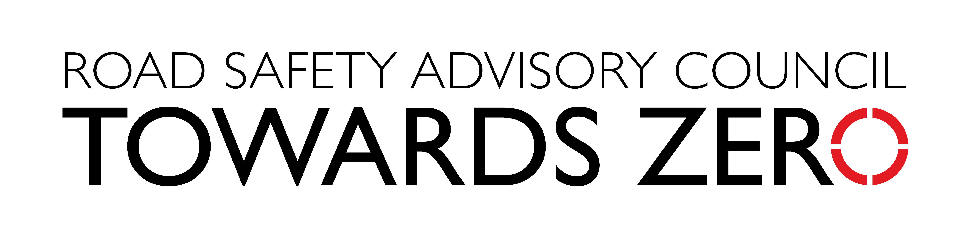

Media statement
XX October 2021

_________________________________________________________________________
You can’t beat Tassie Roads
If you’ve ever travelled around Tasmania by motorcycle, you’ll know that we have some of the world’s best roads to explore on two wheels, but no matter how good a rider you are, ‘you can’t beat Tassie roads’
That’s the message of our new motorcycle safety campaign that launched this week.
The campaign, which features a 30 second television commercial, social media and posters on popular motorcycle touring routes, speaks directly to motorcyclists to educate them about the risks of riding and how to better protect themselves
Road Safety Advisory Council Chair, Scott Tilyard said that Motorcycle riders need to be prepared for all types of conditions when riding on Tasmanian roads.
“Motorcycling is an exhilarating and challenging activity, but motorcyclists are vulnerable road users because they lack protection in the event of a crash.
“Tassie’s roads are unique and our motorcycling touring routes attract locals and visiting riders alike, but even riders with years of experience can come unstuck on our roads,” Mr Tilyard said.
“Our campaign highlights the pleasure and challenges of riding on Tasmanian roads but also aims to create awareness of the risks when riding and the importance of riding safely.
“Regardless of where you ride in Tasmania, motorcyclists should be prepared for sudden changes in weather conditions. Blue skies and sunshine can quickly change to grey clouds and rain.
“You should also be wary of damp patches in shaded bends and underneath tree canopies as roads can be slippery.
“Loose gravel could also be lying in wait around the next corner, so ride with caution and always be aware of changing road conditions.
“Research shows that almost two-thirds of serious casualty motorcycle crashes are actually single vehicle, which is why our campaign speaks directly to motorcyclists rather than other road users.
“However, road safety is a shared responsibility, and it is up to every one of us to take responsibility of our own behaviour on the road and be cautious of other road users.

This campaign is an initiative to encourage safer road use and promote safe behaviours under the current Towards Zero Action Plan 2020-2024, which identifies key priorities and initiatives to improve safety for motorcyclists.

Contact: Carly Zmendak
Phone: 0407 654 170

