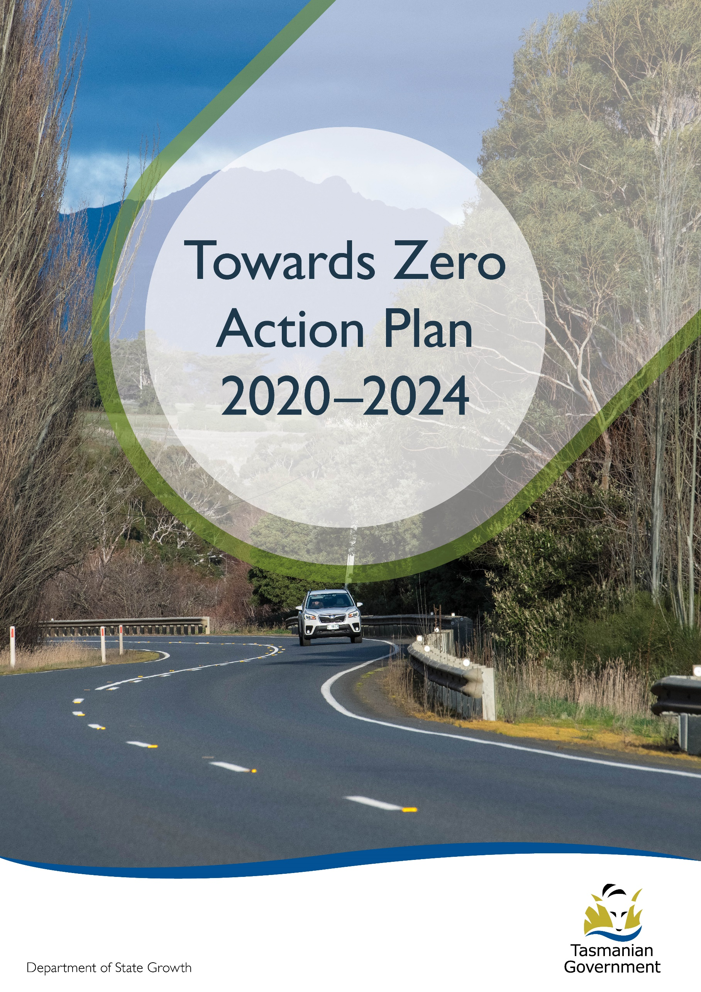
Quarterly Progress Report to RSAC as at 31 March 2021
Contents
Progress on meeting Towards Zero Strategy targets 3
Serious Casualties 3
Fatalities 3
2021 YTD 3
Serious Casualties Tasmania – Annual Count, Percentage Split by Quarter and Towards Zero Target 3
Annual fatalities – Rate per 100,000 population 4
Progress on meeting MAIB targets 5
Fatalities – 12 Month Rolling Total 5
Total Serious Claims – 12 Month Rolling Total 5
Statistics 6
Serious Casualties by Quarter by Age Group – 12 period moving average 6
Serious Casualties by Quarter by Sex – 12 period moving average 6
6
Serious Casualties by Quarter by Road User Type – 12 period moving average 7
Serious Casualties by Quarter by Speed Zone – 12 period moving average 7
Serious Casualties by Quarter by Crash Type (DCA) – 12 period moving average 8
Serious Casualties by Quarter by Urban/Non-Urban – 12 period moving average 8
Serious Casualty locations to 31 March 2021 (Black = Fatality, Red = Serious Injury) 9
Key themes and priority actions 2020-2024 10
Funding of key themes 10
Project status report 11
Progress on key themes 12
Rural roads grants program for local government 12
Infrastructure upgrades on low volume State roads 13
Motorcyclist safety on rural roads 13
Speed moderation and community engagement strategy 13
Safe system knowledge and skills training 14
Targeted infrastructure upgrades in high traffic urban areas 14
Vulnerable Road User Program 14
Community Road Safety Grants Program 15
Trial of innovative technologies 15
Innovative infrastructure treatment demonstrations 15
Learner Driver Mentor Program and Driver Mentoring Tasmania 17
Graduated Licensing System Project 17
Motorcyclist Graduated Licensing System review 18
Rotary Youth Driver Awareness Program (RYDA) 18
Driving for Jobs Program 18
RACT education initiatives 19
Real Mates media campaign 19
Bicycle Network bike education 19
Safety arounds schools 19
Kidsafe child restraint check program 20
Full Gear motorcycle safety project 20
Inattention and distraction 21
Safe behaviour campaigns 22
Mandatory Alcohol Interlock Program (MAIP) 22
Protective clothing for motorcyclists 22
Road safety penalties review 22
Speed enforcement strategy 23
Enforcement of high-risk behaviours 23
Automated Speed Enforcement Program 24
High-risk motorcycling enforcement 24
Road Rules Awareness 25
Tourist road safety signage program 26
Responsive electronic signage trial 26
Tourist education materials 26
Strategic partnerships 27
Tourist education at gateway entry points 27
Stakeholder alliances 27
Australasian New Car Assessment Program (ANCAP) 28
Safer cars for young drivers 28
Autonomous vehicle and crash avoidance readiness 28
Workplace driver safety 29
Light vehicle strategy 29

Progress on meeting Towards Zero Strategy targets
The key interim target for the Towards Zero – Tasmanian Road Safety Strategy 2017-2026 (Towards Zero Strategy) is to reduce the number of annual serious injuries and deaths on Tasmanian roads to fewer than 200 by 2026. This is an ambitious target of 100 fewer serious casualties per year than for the period 2012-2016 (annual average) and will move us towards the long-term goal of zero serious casualties on Tasmanian roads.

Serious Casualties
The number of serious casualties in 2020 was 319, compared to 278 in 2019, a 14.7 per cent increase. The 2020 figure of 319 is a 3.8 per cent increase on the five year serious casualty average of 307.4 (2015-2019).

Fatalities
In 2020, there were 36 fatalities on Tasmanian roads which is seven more than the number recorded in 2019. The figure of 36 fatalities in 2020 is an 11.1 per cent increase on the five year fatalities average of 32.4 (2015-2019).

2021 YTD
There have been 77 serious casualties (4 fatalities and 73 serious injuries) to 31 March 2021, 18 fewer than the number recorded at the same time last year (15 fatalities and 80 serious injuries) and a decrease of 17.2 per cent on the five year average of 93 serious casualties.

Serious Casualties Tasmania – Annual Count, Percentage Split by Quarter and Towards Zero Target
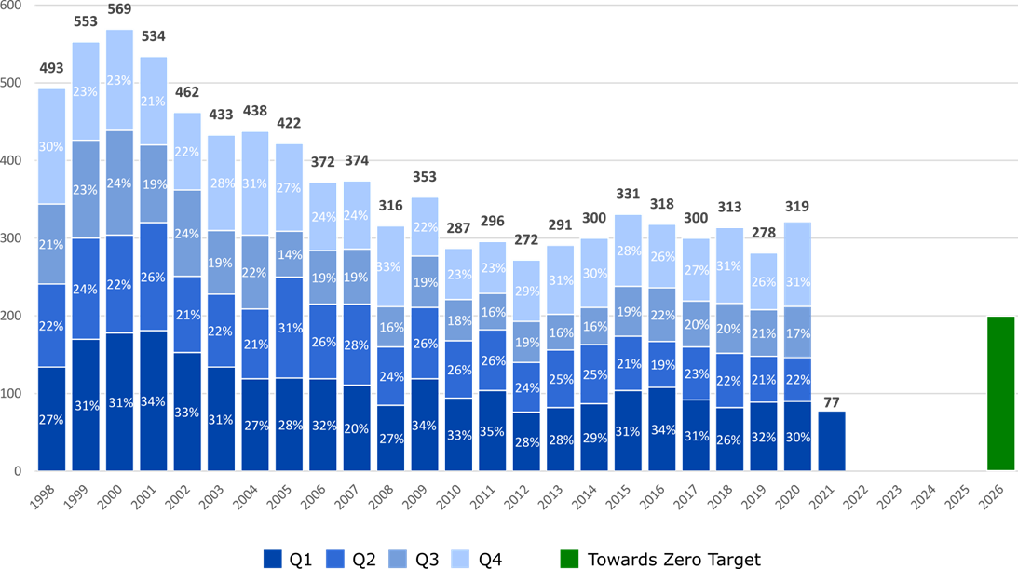

Annual fatalities – Rate per 100,000 population
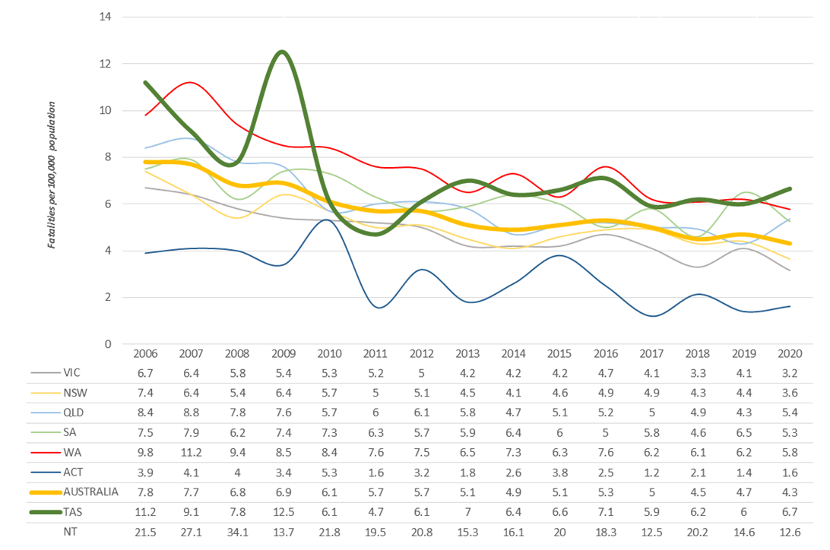

Note: NT omitted from chart for clarity purposes.

Progress on meeting MAIB targets
Motor Accidents Insurance Board (MAIB) injury statistics show the number of fatalities and the level of claims for serious injuries on our roads.
Various claim reduction targets are specified in the Memorandum of Understanding between the Department of State Growth (State Growth) and the MAIB. Progress against high level targets is shown below, expressed as 12 month moving totals

Fatalities – 12 Month Rolling Total
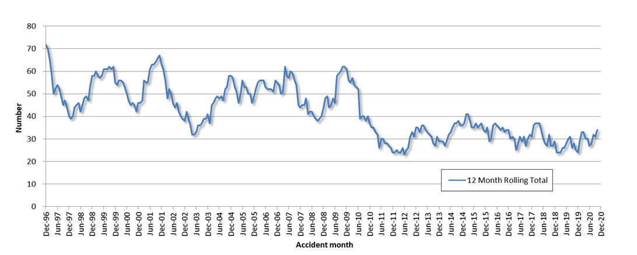

Total Serious Claims – 12 Month Rolling Total
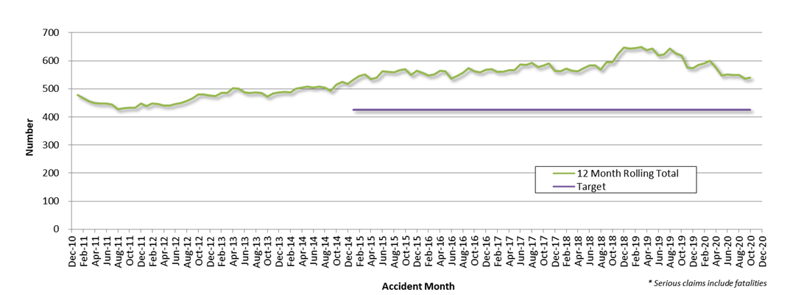

Statistics

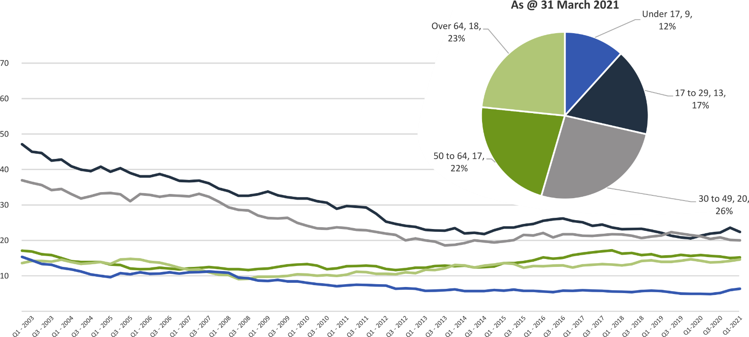
Serious Casualties by Quarter by Age Group – 12 period moving average

Serious Casualties by Quarter by Sex – 12 period moving average
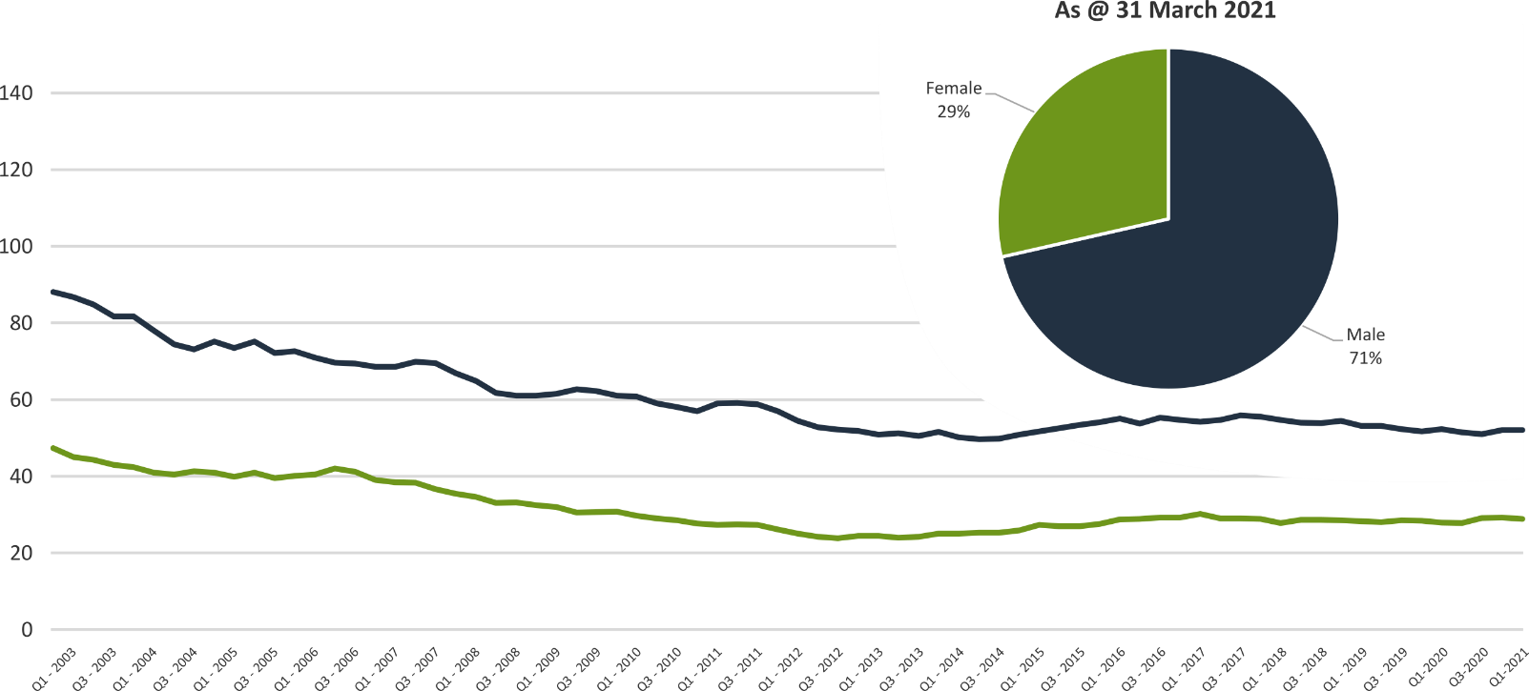

Serious Casualties by Quarter by Road User Type – 12 period moving average
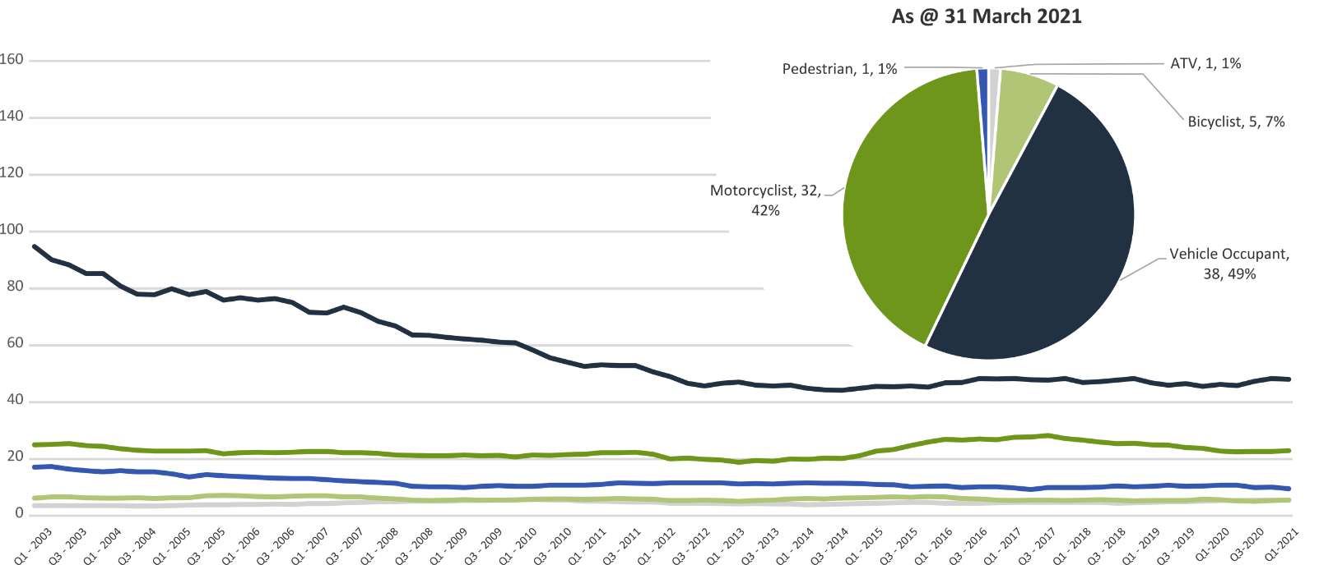

Serious Casualties by Quarter by Speed Zone – 12 period moving average
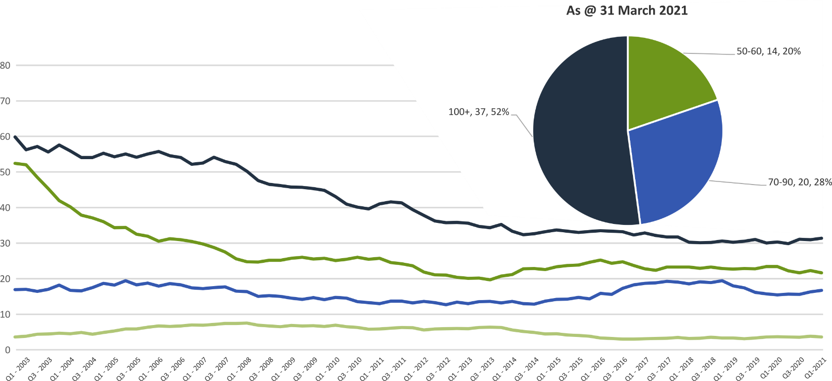

Pie chart excludes serious casualties where speed zone is recorded as ‘not known’

Serious Casualties by Quarter by Crash Type (DCA) – 12 period moving average
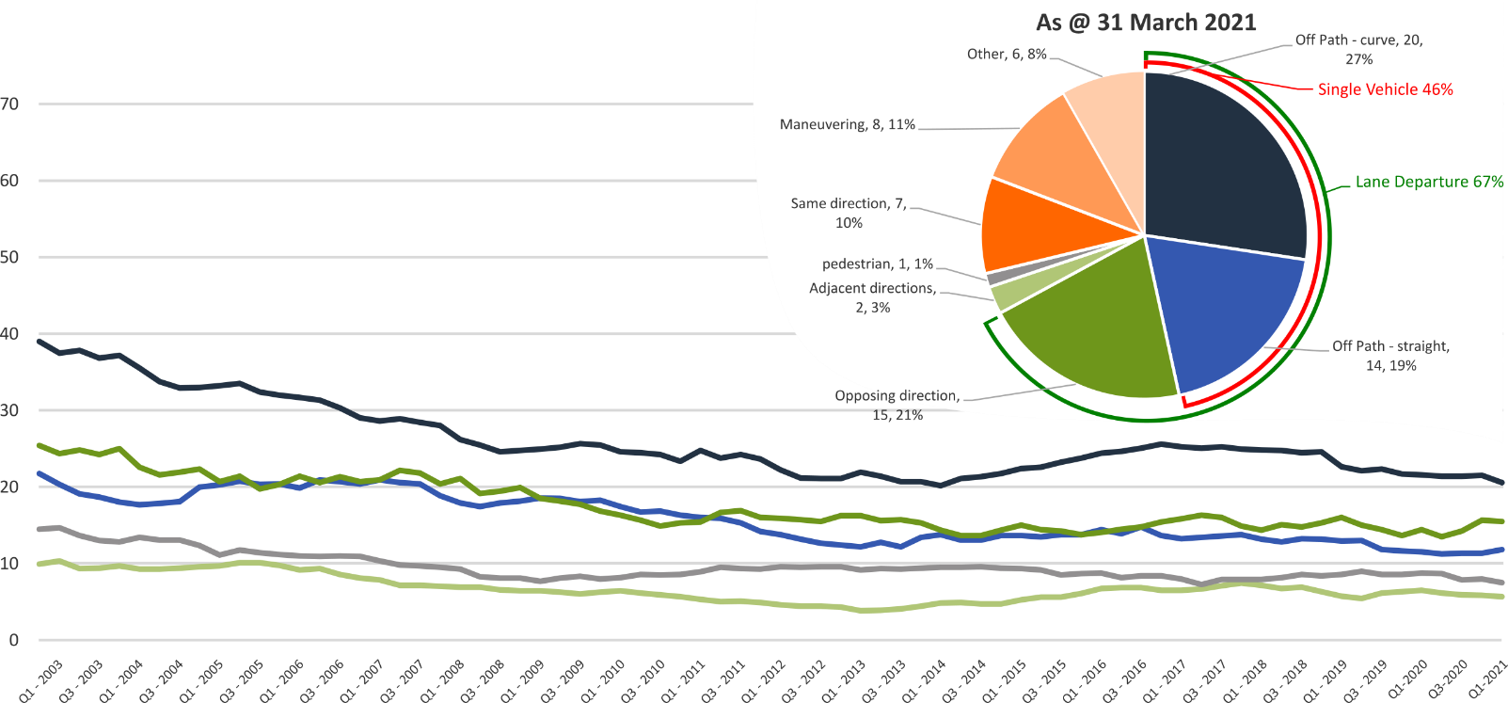

Other includes crash types: on-path (3%), overtaking (2%) & Passenger and Miscellaneous (3%).

Serious Casualties by Quarter by Urban/Non-Urban – 12 period moving average
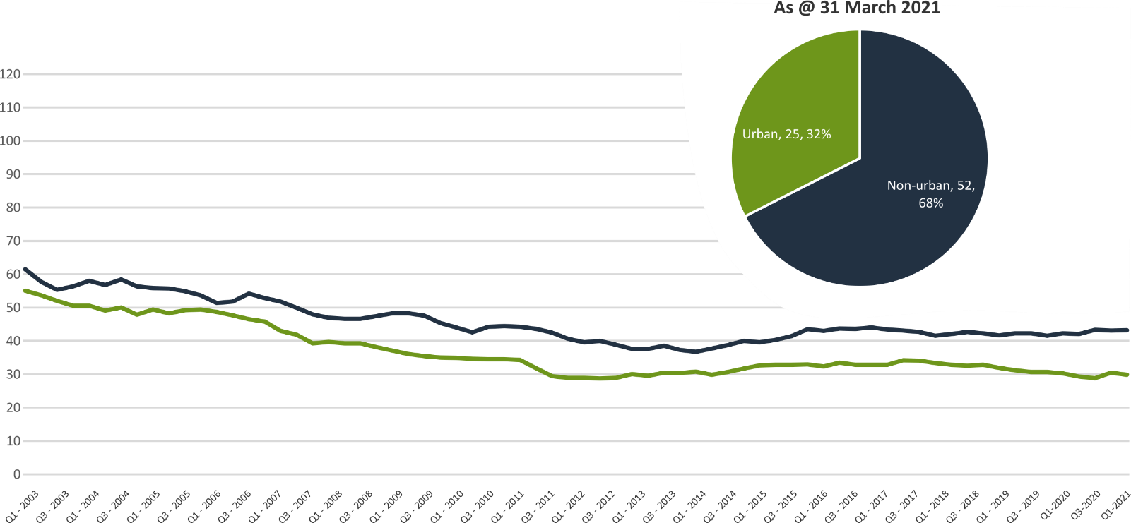

Based on the Australian Bureau of Statistics’ ‘significant urban area’ geographic definition.

Serious Casualty locations to 31 March 2021 (Black = Fatality, Red = Serious Injury)
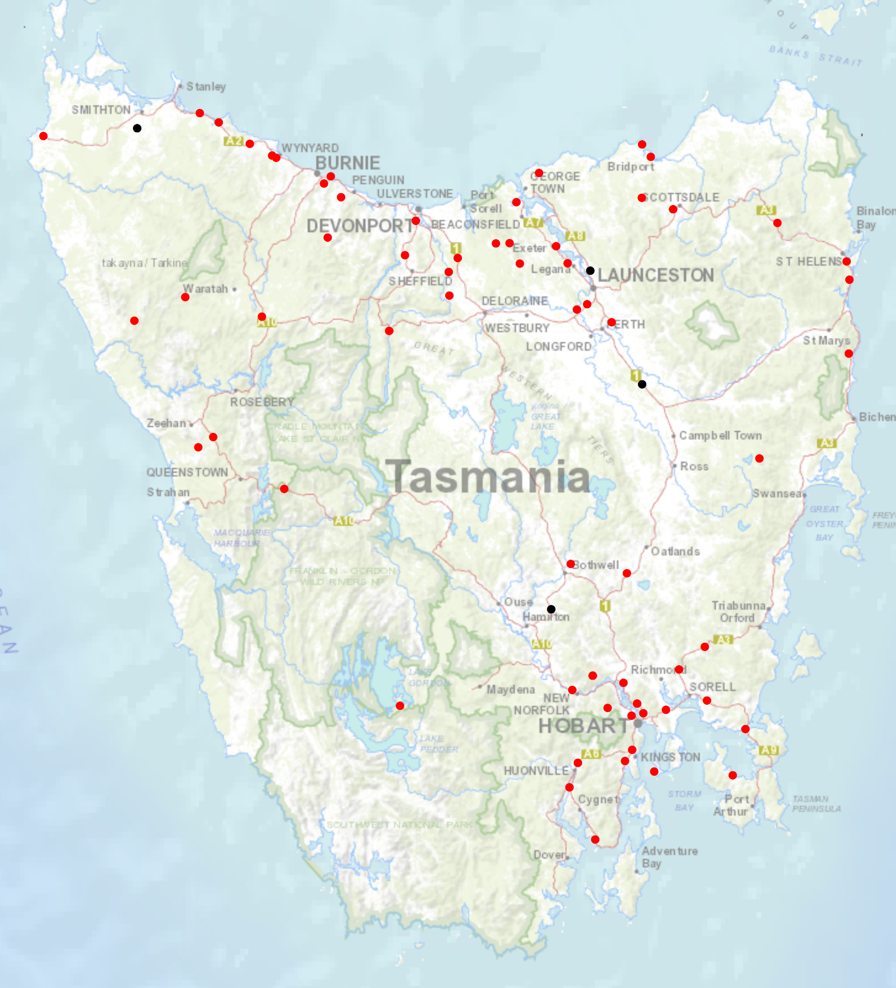

Key themes and priority actions 2020-2024
The Quarterly Progress Report details progress on key themes and priority actions under the Towards Zero Action Plan 2020-2024 and the Towards Zero – Tasmanian Road Safety Strategy 2017-2026.
The progress report should be read in conjunction with the Action Plan and understood in the context of the Towards Zero Strategy. These documents are available at: www.towardszero.tas.gov.au

Funding of key themes
Over $20 million Over $31 million
Over $12 million Over $4 million

$2 million Over $3 million

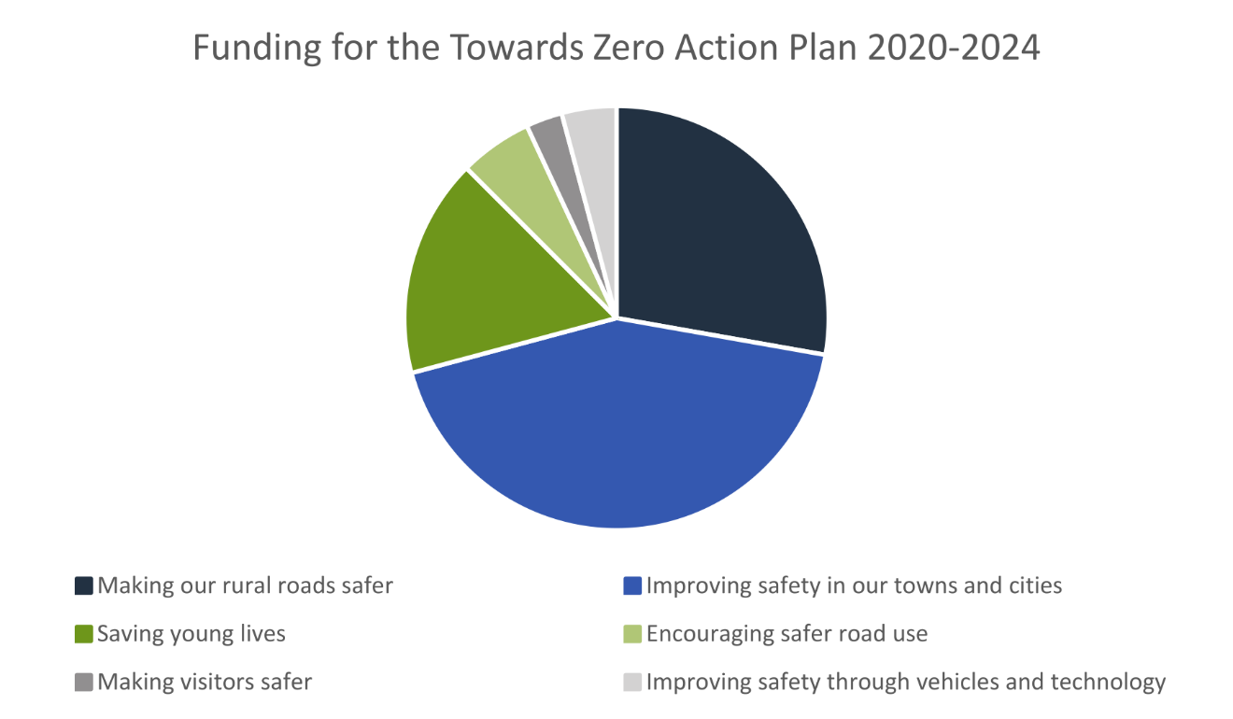

Project status report
Making our rural roads safer
Rural road grants program for local government | On schedule |  | Infrastructure upgrades on low volume State roads | On schedule
Motorcyclist safety on rural roads | On hold |  | Speed moderation and community engagement strategy | Not yet commenced
Safe system knowledge and skills training | On schedule
Improving safety in our cities and towns
Targeted infrastructure upgrades in high traffic urban areas | Not yet commenced |  | Vulnerable Road User Program | On schedule
Community Road Safety Program | On schedule |  | Trial of innovative technologies | On hold
Innovative infrastructure treatment demonstrations | On hold
Saving young lives
Learner Driver Mentor Program and Driver Mentoring Tasmania | On schedule |  | Graduated Licensing System Project for drivers | On schedule
Rotary Youth Driver Awareness Program | On schedule |  | Driving for Jobs Program | On schedule
RACT education initiatives | On schedule |  | Real Mates media campaign | On schedule
Bicycle Network bike education | On schedule |  | Safety around schools | On schedule
Kidsafe child restraint check program | On schedule |  | Full Gear motorcycle safety project | On schedule
Develop a Graduated Licensing System for motorcyclists | On schedule
Encouraging safer road use
Inattention and distraction | On schedule |  | Safe behaviour campaigns | On schedule
Mandatory Alcohol Interlock Program | Major delays |  | Protective clothing for motorcyclists | On schedule
Road safety penalties review | Complete |  | Speed enforcement strategy | On schedule
Enforcement of high-risk behaviours | On schedule |  | Automated Speed Enforcement Program | On schedule
High-risk motorcycling enforcement | Not yet commenced |  | Road Rules Awareness | On schedule
Making visitors safer
Tourist road safety signage program | On hold |  | Responsive electronic signage trial | On hold
Tourist education materials | Limited activity |  | Strategic partnerships | On hold
Tourist education at gateway entry points | Limited activity |  | Stakeholder alliances | On hold
Improving safety through vehicles and technology
ANCAP | On schedule |  | Safer cars for young drivers | Not yet commenced
Autonomous vehicle and crash avoidance readiness | On schedule |  | Workplace driver safety | Not yet commenced
Light vehicle strategy | Delayed

Progress on key themes
Progress on key themes is reported as:
Status | Major delays/on hold/high risk | Delayed/some issues/medium risk | On schedule/progressing/low risk | Not yet commenced

60 per cent of fatalities occur in rural areas

Rural roads grants program for local government
The Safer Rural Roads Program (SRRP) provides funding to councils to implement infrastructure treatments on rural road corridors to reduce lane departure crashes and lessen the harm when they do occur. An allocation of $10 million was made to the SRRP to be administered over five funding rounds of $2 million for the life of the Action Plan.
Comments
The Australian Government Road Safety Program (RSP) is the result of a $2 billion 2020-2021 budget commitment. Under the RSP, Tasmania was allocated up to $44 million in funding for small-scale road safety infrastructure projects, to be delivered over three 6-month funding tranches. Under tranche one of the RSP, which runs from 1 January 2021 until 30 June 2021, $33.3 million in funding was allocated to Tasmania. To secure the $33.3 million in funding, the Tasmanian Government was required to make a co-contribution of $12.3 million.
The RSP has provided valuable additional funding to the SRRP. As a result, two funding rounds have been held during the 2020-2021 financial year.
The first funding round closed in November 2020. 44 applications were received under the SRRP, and 42 of those received funding. The successful projects totalled approximately $6 million in value. This included Australian Government funding of $4 082 741, and Local Government co-contributions of $611 596.
As a result of the additional funding available under the RSP, a second round of the SRRP was opened in February 2021. The Strategy Oversight Committee (SOC) has approved the projects recommended for funding by the SRRP Assessment Committee, and councils will shortly be notified of the outcome of the grant round.

Status | risk |  | On schedule/progressing/low risk

Infrastructure upgrades on low volume State roads
This program will provide funding for lower volume State roads, where cost effective treatments such as shoulder sealing, pavement markings, curve warnings, road side hazard removal and safety barriers will achieve maximum value for money.
Current situation / comments
$6.95 million has been committed for infrastructure improvements on the Railton Main Road. $450 000 is required for the design and development stage and $6.5 million required for works in the delivery stage.
Status |  |  | On schedule/progressing/low risk

Motorcyclist safety on rural roads
Road safety audits will be conducted on high risk touring routes across Tasmania. This program will involve local motorcyclists and a safe system approach will inform audits. Findings will be shared with stakeholders to identify countermeasure that go beyond typical infrastructure solutions.
Current situation / comments
Safe System motorcycle road safety audits
Two audits have been completed and funding allocated. The Central Highlands Council has been provided with a grant deed up to $200 000, to undertake works on Hollow Tree Road, works have commenced.
Funding up to $350 000 has been allocated for State Growth to carry out low-cost infrastructure treatments to improve road safety for motorcyclists on Lake Leake Road, works are scheduled to commence in 2021.
Status | On hold

Speed moderation and community engagement strategy
Speed moderation requires a holistic strategy encompassing public education, road risk assessments, enforcement, speed limit setting, speed limit mapping and technology, penalties, KPIs and evaluation. This project will involve community engagement to inform and build support for action on safer speeds. A significant ongoing coordination effort will be required to support the strategy.
Current situation / comments
To commence 2021.
Status |  |  |  | Not yet commenced

Safe system knowledge and skills training
This program aims to improve Safe System knowledge for all those in a position to influence road safety outcomes and support Safe System infrastructure design and speed setting. It will include technical training sessions, workshops and forums across Tasmania.
Current situation / comments
$10 520 funding has been provided to the Tasmanian Bicycle Council to facilitate online training sessions for Tasmanian engineers and planners in designing Safe System compliant cycling lanes/paths.
Status |  |  | On schedule/progressing/low risk

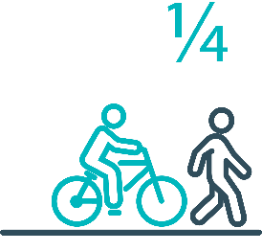

Pedestrians and cyclists are vulnerable and represent
one in four serious casualties in our towns and cities

Targeted infrastructure upgrades in high traffic urban areas
This program provides for delivery of a range of infrastructure safety upgrades to make our towns and cities safer. This will include shoulder sealing, intersection improvements, safety barriers and pavement marking at high traffic areas. This program targets high volume state roads that are not planned for major investment in the short term.
Current situation / comments
Not yet commenced.
Status |  |  |  | Not yet commenced

Vulnerable Road User Program
The Vulnerable Road User Program (VRUP) is an established grants program which assists local government with the costs of installing safety improvements in built up areas. The aim of the program is to reduce conflict between vehicles and vulnerable road users - cyclists, pedestrians and motorcyclists. The funding available under the VRUP was increased from $500 000 per year to $1 000 000 under the current Action Plan.
Current situation / comments
The Australian Government Road Safety Program (RSP) has provided valuable additional funding to the VRUP. As a result, three funding rounds have been held during 2020-2021. The first round of funding closed in April 2020. Twenty-eight applications were received, and funding of $831 941 was awarded to 20 projects.
The second funding round closed in November 2020. Forty-two applications were received, and 26 projects were awarded over $3 million in funding.
A third round of the VRUP was opened in February 2021. The SOC has approved the projects recommended for funding by the VRUP Assessment Committee, and councils will shortly be notified of the outcome of the grant round.
Status |  |  | On schedule/progressing/low risk

Community Road Safety Grants Program
The Community Road Safety Grants Program (CRSGP) is an established grants program that aims to build community engagement in addressing local road safety issues. The program supports local councils, schools, community groups, research institutions and charity organisations to promote road safety at the grass roots level.
Current situation / comments
The CRSGP is scheduled to open in July 2021. Planning has also commenced to conduct workshops, presentations and engagement activities with key Community Road Safety stakeholders in order to improve the quality and quantity of applications.
Status |  |  | On schedule/progressing/low risk

Trial of innovative technologies
This project will include monitoring, investigation and trialling of new and emerging technology based approaches to improving safety for vulnerable road users.
Current situation / comments
To commence 2021.
Status | On hold

Innovative infrastructure treatment demonstrations
This project will investigate, trial and demonstrate innovative Safe System urban infrastructure treatments to improve road safety in our urban areas. We will work with local councils to show how Tasmania’s cities and towns can be improved for the benefit of all road users, particularly cyclists and pedestrians.
Current situation / comments
To commence 2021.
Status | On hold

92 young people are seriously injured or killed on our
roads every year

Learner Driver Mentor Program and Driver Mentoring Tasmania
The Learner Driver Mentor Program (LDMP), supported by Driver Mentoring Tasmania (DMT) is a well-established program that supports disadvantaged learner drivers to gain their on-road supervised driving hours to gain a licence.
Current situation / comments
The 2021-22 LDMP grant funding round closes on 26 April. SmartyGrants, the Department’s grants application system is now being used as a performance management system to assist in monthly monitoring. It is expected that successful applicants will be announced in July.
Status |  |  | On schedule/progressing/low risk

Graduated Licensing System Project
Changes are being made to the Graduated Licensing System (GLS) for drivers to better protect young and novice drivers and improve the licensing pathway. Young drivers are overrepresented in crash statistics and most at risk when they first get their Ps and start driving solo. The changes to the GLS aim to address this risk, and improve road safety outcomes for both young and novice drivers.
Current situation / comments
The Tasmanian Government implemented policy changes to the GLS on 1 December 2020, which was supported by a public education campaign. Tasmania’s GLS now meets the enhanced model under the national framework.
Complementing the changes will be the new online learning platform which has been designed to improve learner driver education by focusing on developing safe behaviours and attitudes. It will ensure new drivers know the road rules and understand the impact of the fatal five road behaviours. The platform will be launched by the incoming Government and a second public education campaign will encourage take-up by promoting the convenience of the platform and being able to learn and take the test almost anywhere and at any time, as long as they have access to a device (mobile, tablet, computer) and the internet. Due to interdependencies between the platform and the online Hazard Perception Test, the test is not expected to be launched mid-2021.
An electronic logbook is also under development. It is envisaged that this will replace the existing hard copy logbook for many Tasmanian learners as it will provide a range of benefits and its ease of use will support an accurate reflection of supervised hours. The logbook is also expected to be released mid-2021.
Status |  |  | On schedule/progressing/low risk

Motorcyclist Graduated Licensing System review
This project will evaluate the benefits of a new Graduated Licensing System (GLS) for motorcyclists. This will include greater restrictions on learners that are gradually lifted as riders acquire skills and experience under conditions that reduce risk.
Current situation / comments
A review of the current Tasmanian Motorcycle GLS has commenced with a view to identifying options to ensure that motorcycle riders are appropriately experienced and capable before they are granted a full licence.
A gap analysis between the Tasmanian licensing regime and the best practice motorcycle GLS will be undertaken as part of the review, as well as a jurisdictional analysis. The findings of the review will be presented to the RSAC at its August meeting.
Status |  |  | On schedule/progressing/low risk

Rotary Youth Driver Awareness Program (RYDA)
RYDA is a one day road safety education program for year 10-12 students making them aware of the significant responsibility that comes with being a driver or passenger. Every year 4000 students take part in practical demonstrations and learn valuable road safety lessons from expert presenters and volunteers. RYDA is delivered by Rotary Tasmania.
Current situation / comments
Rotary has commenced planning for the delivery of the new iteration of the RYDA program for 2021, with training for volunteers being offered online.
Status |  |  | On schedule/progressing/low risk

Driving for Jobs Program
The Driving for Jobs (DfJ) Program aims to support disadvantaged students who would otherwise be unable to enter and progress through the Graduated Driver Licensing System (GLS). The program provides students at selected schools with the opportunity to increase their road safety knowledge whilst also improving their job readiness. Students undertake a personalised intensive program with a strong road safety focus including professional on-road driving lessons and participation in the Rotary Youth Driver Awareness Program.
Current situation / comments
The DfJ Program operates at Jordan River Learning Federation (JRLF) in the South and expanded to Launceston and Newstead Colleges in the North at the start of term one 2021. The DfJ Steering Committee determined in early 2021 that there are insufficient disadvantaged students at New Norfolk High School to justify the program this year. The Steering Committee is currently considering Claremont College as a second school in the South for the program to also operate from.
Status |  |  | On schedule/progressing/low risk

RACT education initiatives
The RACT delivers a range of in-class road safety education programs. This includes a program for years 10-12 students that focuses on the dangers of distraction and inattention. The program also teaches students how to progress through the GLS and about the specific rules that apply to L and P plate drivers.
Current situation / comments
The RACT continues to deliver safety programs, this now includes the delivery of the children’s safety book ‘Yippee’ to early childhood classes throughout Tasmania.
Status |  |  | On schedule/progressing/low risk

Real Mates media campaign
The MAIB-funded Real Mates campaign uses humour to engage with young men to encourage them to avoid the risks of drink driving by empowering them to speak up and stop a mate from driving after drinking.
Current situation / comments
The campaign’s latest phase was launched on 11 October. As an extension of this campaign a new partnership has been signed with the North West Football League for the 2021 football season. This will promote the Real Mates campaign to the players, members and spectators of the club, in particular the target audience of men aged between 17 and 25. The sponsorship marketing activities include collateral and permanent signs for football grounds, as well as naming rights to the Under 18 competition for the term of this agreement.
Status |  |  | On schedule/progressing/low risk

Bicycle Network bike education
The Bicycle Network delivers the Ride2School program to schools across Tasmania. Ride2School is for primary aged students and focuses on safe cycling, road safety and positive road sharing behaviour.
Current situation / comments
The Bicycle network has reported a record number of schools and school students participating in the Ride2school program. The Coordinator has produced a number of Active Maps with secondary schools, highlighting the safest route to travel to and from school when cycling. In March 2021, Minister for Infrastructure and Transport, Michael Ferguson MP, attended an event hosted by the Bicycle Network at Bowen Road Primary School to mark National Ride2School Day.
Status |  |  | On schedule/progressing/low risk

Safety arounds schools
Safety around schools is promoted through designated crossings, lower speed zones, more than 100 school crossing patrol officers and public education. The current Safety around Schools project, including the Love 40 campaign, encourages drivers to lower their speed and keep a look out for children in school zones and around buses.
Current situation / comments
The Love 40 program continues to be promoted to schools throughout Tasmania for 2021. Key initiatives include TVC, radio advertising, portable billboards in school zones and branding of school crossing officers’ uniform with the Love 40 logo. An evaluation of the Love 40 Campaign is planned for the latter half of 2021.
Status |  |  | On schedule/progressing/low risk

Kidsafe child restraint check program
Kidsafe Tasmania conducts free child restraint checking sessions to ensure that young children are safely and lawfully seated and restrained in cars. Kidsafe also distribute and promote educational materials to inform the public of the correct child restraint type for a child’s age and size.
Current situation / comments
Kidsafe continues to work with child and family centres targeting parents with English as a second language and grandparents who may be unfamiliar with new style restraints. Kidsafe has developed a suite of new flyers to aid with the correct fitting of child restraints. A digital resource will soon be available from the website.
Status |  |  | On schedule/progressing/low risk

Full Gear motorcycle safety project
The Glenorchy City Council, in partnership with Bucaan House, delivers its successful Full Gear motorcycle safety project which helps young motorcycle riders enter the licensing system and to adopt safe riding practices.
Current situation / comments
The Glenorchy City Council (GCC) has employed a project officer to coordinate the Full Gear program. The Project Officer is investigating opportunities for expansion into the Bridgewater and New Norfolk communities. The GCC has engaged an external provider to evaluate the Full Gear program. The evaluation methodology is being developed and will be sent to State Growth for review.
Status |  |  | On schedule/progressing/low risk

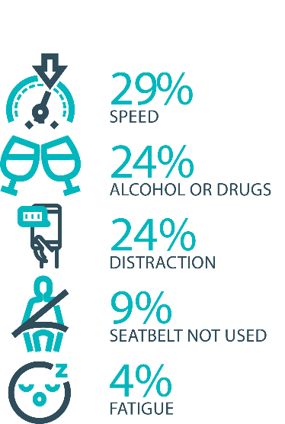

The fatal five behaviours contributing to serious
casualties

Inattention and distraction
Inattention and distraction are concerning causes of serious casualty crashes and may have a far greater impact than current data suggests. There are a number of research projects and enforcement initiatives that are being used to address this issue. This project will include consideration of emerging strategies for tacking distraction, encouraging compliance through enforcement and influencing driver behaviour through public education campaigns.
Current situation / comments
Enforcement
Tasmania Police introduced three unmarked motorcycles to increase the rate of detection and enforcement of illegal phone use whilst driving. These motorcycles operate across all districts and target the low speed road network and congested traffic conditions, utilising ‘lane filtering’ legislation to full advantage.
In an agency first, the riders are also fitted with helmet cameras to capture the offence, an initiative that has effectively nullified disputes. The introduction of unmarked motorcycles has proved to be incredibly successful with riders reporting high-level public support and a notable change in driver behaviour.
Tasmania Police has also conducted a technology demonstration with a commercial provider to test artificial intelligence based automated mobile phone detection. The technology is combined with speed detection and Automated Number Plate Recognition capabilities. Future use of such technology is now being considered as part of the Automated Speed Enforcement Project being led by the Department of State Growth.
Public education campaigns
A new phase of the ‘Leave Your Phone Alone’ campaign that warns drivers of the dangers of using a mobile phone while driving was launched on 21 December 2020.
Status |  |  | On schedule/progressing/low risk

Safe behaviour campaigns
Targeted media campaigns will continue to educate people about high-risk behaviours and to highlight the dangers of the ‘Fatal Five’.
Current situation / comments
The second iteration of the ‘Don’t Drive Blind’ distraction advertisement went to air in late December. It will be broadcast during the summer BBL season.
The concept for a pedestrian safety campaign was finalised in December. A ‘green man’ is to feature across the guerrilla style, in situ campaign, encouraging both pedestrians and drivers to look out for each other on the road. The campaign will be launched at the beginning of September 2021.
Status |  |  | On schedule/progressing/low risk

Mandatory Alcohol Interlock Program (MAIP)
The MAIP aims to have repeat and high-level drink driving offenders demonstrate they are able to separate their drinking from driving through the installation of an alcohol interlock in their vehicle. New measures will be introduced to increase participation in the MAIP.
Current situation / comments
Drafting instructions for the revised framework were provided to the Office of Parliamentary Counsel (OPC) in October 2019. Parliamentary priorities caused reprioritisation of OPC work, including COVID-19. First draft regulations have not been received by the department. Two Approved Providers have signed new contracts: negotiations continue with the third.
Status | Major delays/on hold/high risk

Protective clothing for motorcyclists
Motorcyclists are overrepresented in Tasmania’s road trauma figures. Motorcyclists are vulnerable road users due to a lack of physical protection. Protective clothing can reduce injury severity in the event of a crash. Tasmania is a funding member of MotoCAP. MotoCAP provides safety assessment star ratings for protective clothing and prepares education materials for motorcyclists.
Current situation / comments
Tasmania contributes around $8 000 per annum to participate in and support the activities of MotoCAP. In early 2021, several thousand public education brochures advising of clothing safety ratings for motorcycle wear were sent out to motorcycle retailers and relevant stakeholders across the state.
Status |  |  | On schedule/progressing/low risk

Road safety penalties review
For enforcement activities to improve safety on our roads, they need to be backed up with appropriate penalties. Tasmania’s road safety penalties will be reviewed to ensure they are up-to-date and provide an appropriate deterrence to those who break the rules and put themselves and others at risk.
Current situation / comments
Tasmania’s road safety penalties have been reviewed and updated and inter-jurisdictional analysis has been completed. Findings were submitted to RSAC for noting at its November 2020 meeting. RSAC determined that current penalties are appropriate and penalties will be reviewed towards the end of the current Action Plan.
Status | Complete

Speed enforcement strategy
Tasmania Police have prepared a speed enforcement strategy and will enact new speed enforcement techniques to increase the rate of detection and enforcement. Tasmania Police record speeding offences, however, there is no general monitoring of speed limit compliance. Improved reporting needs to be developed to better understand the issue of speeding.
Current situation / comments
Speed enforcement is one of five priority areas within Tasmania Police’s current Road Safety Strategy 2019-2021.
With regard to speed cameras, Tasmania Police has conducted several technology trials, including in-motion camera technology, where speed cameras are fitted to moving vehicles, and of mobile point-to-point speed detection, where average speed enforcement utilises two vehicles fitted with automatic numberplate recognition technology. In addition, Tasmania Police is working with the Department of State Growth to consider the future of automated speed enforcement in Tasmania.
Tasmania Police has implemented a Strategic Asset Management Plan (SAMP) for all speed detection devices. The SAMP provides for continual review of new and emerging technologies, includes provisions for regular replacement and upgrade of equipment and importantly supports long-term financial planning and budgeting. In line with the SAMP, Tasmania Police’s Southern Road and Public Order Services is also trialling a rear-facing radar on a patrol vehicle.
Tasmania Police has further implemented a new vehicle livery across the fleet, matching different livery designs to specific uses, for example general patrol, high-visibility patrol, and low-profile marked vehicles – all of which are relevant to different methodologies of speed reduction and enforcement. The strategy has also seen the introduction of unmarked highway patrol cars which have proved to be very successful and complement the use of overt policing tactics well.
In April 2020, Tasmania Police commenced the replacement of its marked police motorcycle fleet, with new livery for these bikes being implemented to heighten the visibility of police on the road network.

Status |  |  | On schedule/progressing/low risk

Enforcement of high-risk behaviours
To reduce high-risk behaviours and increase compliant road user behaviour, State Growth and Tasmania Police will work collaboratively to investigate and introduce new enforcement techniques and technologies to detect high-risk behaviours that address the ‘fatal five’, including mobile phone use, speeding and failure to wear a seatbelt.

Current situation / comments
Tasmania Police’s Road Policing Strategy focuses on the fatal five causes of serious and fatal crashes, which are the highest risk driver behaviours: speeding; alcohol and drugs; distraction and inattention; seatbelts; and fatigue. The strategy includes several priority areas under each theme and the strategy guides the deployment of operational policing resources.
Status |  |  | On schedule/progressing/low risk

Automated Speed Enforcement Program
Automated speed enforcement (ASE) (i.e. speed cameras) is relatively underutilised as a deterrence and enforcement mechanism in Tasmania. This project investigates proven and emerging speed camera technologies for use at high-risk locations and across the entire road network.
Current situation / comments
This project was paused due to COVID-19 but has now recommenced.
Initial analysis and modelling has been undertaken to determine the potential road safety benefits, expected costs, and projected infringement levels associated with an expanded ASE program. At its November 2020 meeting, RSAC received a full briefing on the activities undertaken to date, expected outcomes of an enhanced ASE program and potential next steps.
In collaboration with Tasmania Police, State Growth developed recommendations regarding the enhancement of Tasmania’s ASE program. RSAC endorsed the proposed approach at its 1 March 2021 meeting. The project team is now progressing with the development of a procurement plan, communication campaign and deployment strategy.
It has also been identified that there is a range of emerging automated enforcement technologies available in the market (implemented in NSW and being trialled in QLD and Vic) that are capable of enforcing illegal driving behaviours other than speeding (e.g. mobile phone, seatbelt and registration offences). These emerging technologies will be investigated further for as part of this project.

Status |  |  | On schedule/progressing/low risk

High-risk motorcycling enforcement
Speed is a factor in at least a quarter of motorcyclist serious casualties. Speed cameras offer no deterrence to motorcyclists, whose numberplates are mounted only on the back. Introduction of rear-facing speed cameras will improve detection and deterrence of speeding. This is being considered as part of the Automated Speed Enforcement project.
Current situation / comments
Tasmania Police investigated rotating the current fixed speed cameras 180 degrees to provide for rear-facing detection (to detect motorcycles). Technology limitations determined this was not a practical solution due to accuracy concerns. Upgrading the technology to support forward and rear-facing and multiple lane detection has now been subsumed into State Growth’s Automated Speed Enforcement Program.
Status |  |  |  | Not yet commenced

Road Rules Awareness
Compliance with Road Rules makes our behaviour on the roads predictable, improving safety for all road users. This initiative will ensure that user-friendly and tailored information resources are developed so that the Road Rules are easily understood and adhered to by all road users.
Current situation / comments
The Tasmanian Road Rules Handbook and the Misunderstood Road Rules series of pamphlets are distributed to Service Tasmania locations when required. The Tasmanian Road Rules Handbook was recently updated to incorporate changes to the graduated licensing system.
The Road Safety Branch is also developing an online learning platform as part of the Graduated Licensing System, and is exploring whether the content produced for that platform could be used to create a free online resource to educate the boarder community with respect to the Road Rules.
The evaluation of rule 79A of the Road Rules, which requires drivers to (among other things) slow to 40km/h when driving past or overtaking a slow-moving emergency vehicle, commenced in November 2020.
The results of the first stage of the evaluation (which aimed to ascertain the level of public awareness and effectiveness of the ‘See Red and Blue, Know What to Do’ communication campaign which accompanied the introduction of the rule in December 2019), were presented to RSAC at its first meeting of 2021.
The results of the second stage of the evaluation (which will assess the effectiveness and suitability of the rule itself to determine whether the rule is “fit for purpose” in Tasmania) will be presented to RSAC at its second meeting of 2021.
Status | Major delays/on hold/high risk |  | On schedule/progressing/low risk

11 per cent of all serious casualties on our
roads are non-Tasmanian residents

Tourist road safety signage program
This program will see the installation of tourist signage strategically placed across the road network. The signs will provide important road safety information, relevant to the area road users are travelling in. This program will be undertaken in collaboration with stakeholders, local government and State Roads.
Current situation / comments
This program is currently on hold.
Status | On hold |  | On schedule/progressing/low risk

Responsive electronic signage trial
This project will trial a responsive electronic sign with real time information at regional tourism gateways.
Current situation / comments
This project is currently on hold.
Status | On hold

Tourist education materials
A range of education materials developed using images, symbols and multi-lingual material delivered to specific audiences through targeted communications channels. This includes vehicle hangers, brochures, posters, roadside signs, editorial content, film and digital content.
Current situation / comments
Communications materials are being distributed upon request from stakeholders.
Status |  | Limited activity

Strategic partnerships
Developing strategic partnerships based on synergies with target audiences will enable the effective promotion of road safety messages and education.
Current situation / comments
This project is currently on hold.
Status | On hold

Tourist education at gateway entry points
As an island state, we have the opportunity to strategically place messaging at our gateway airports and seaports to reach visitors with important road safety messaging prior to them driving in Tasmania. This will include a range of educational materials, electronic and static signs and billboards.
Current situation / comments
Printed collateral is in stock at gateway locations.
Status |  | Limited activity

Stakeholder alliances
Sharing information and collaborating to develop effective strategies and tools to address road safety issues is vital. This project will develop formal and informal stakeholder alliances to encourage input and create opportunities to deliver joint initiatives.
Current situation / comments
This activity is currently on hold.
Status | On hold

The rate of fatal crashes is four times higher for vehicles 15+ years old than for vehicles made in the last five years

Australasian New Car Assessment Program (ANCAP)
Tasmania is a funding member of ANCAP. ANCAP plays a vital role in informing consumers about safety performance of new vehicles and advocates for improved vehicle safety design and specification through public education campaigns, advocacy activities and engagement with governments, corporate fleets, the media and consumers. Activities related to ANCAP will include promotion of safer vehicles and options for an annual vehicle fleet report.
Current situation / comments
Tasmania continues to support ANCAP with funding of $12 500 per annum.
Status |  |  | On schedule/progressing/low risk

Safer cars for young drivers
This project aims to increase awareness of the Used Car Safety Rating database amongst first time car buyers. This could be promoted through education materials and campaigns and may be able to integrate with the GLS online learning platform.
Current situation / comments
To commence in 2021.
Status |  |  |  | Not yet commenced

Autonomous vehicle and crash avoidance readiness
This project involves the monitoring and development of safety and autonomous vehicle technologies.
Current situation / comments
The regulation of autonomous vehicles is being considered at a national level and Tasmania is participating in that process.
Status |  |  | On schedule/progressing/low risk

Workplace driver safety
Vehicle use in road traffic is the most significant contributor to work-related traumatic injury. This project will aim to promote and encourage employers to adopt safe driving policies based on the Worksafe, ‘Vehicles as a workplace’ guide.
Current situation / comments
To commence 2021.
Status |  |  |  | Not yet commenced.

Light vehicle strategy
A light vehicle strategy will be developed to provide public education and undertake enforcement activities to enhance the safety standard of Tasmania’s vehicle fleet.
Current situation / comments
Initial research has been conducted by the Road Safety Branch and the development of a Light Vehicle Safety Strategy will now be progressed in conjunction with the Transport Safety and Inspection Unit.
Status |  | Delayed

Funding
Road Safety Levy Overview for the Financial Year 2020/21
As at 31 March 2021 (Quarter 3)
Road Safety Levy Opening Summary
Opening Balance as at 01 July 2020 |  |  | $ 19,239,486
Annual Allocation to Road Safety Operations |  |  | $ 2,600,000
Revenue Summary
 |  | Forecast (FY21) | Actual (Y.T.D.)
Motor Accident Insurance Board Funding |  | $ 1,300,000 | $ 973,273
Revenue Inflows from Registrations |  | $ 14,386,832 | $ 11,502,786
Funds Available for Distribution |  | $ 32,326,318 | $ 29,115,545
Expenditure Summary
Theme no. | Theme | Forecast (FY21) | Actual (Y.T.D.)
1 | Making our Rural Roads Safer | $ 7,135,343 | -$ 515,580
2 | Improving Safety in our Towns and Cities | $ 19,151,765 | $ 2,923,165
3 | Saving Young Lives | $ 5,286,659 | $ 3,860,534
4 | Encouraging Safer Road Use | $ 1,390,225 | $ 1,077,893
5 | Making Visitors Safer | $ 563,590 | $ 90,362
6 | Improving Safety Through Vehicles and Technology | $ 385,225 | $ 9,184
7 | General Support | $ 748,309 | $ 356,370
Budget and Expenditure by Category |  | Forecast (FY21) | Actual (Y.T.D.)
Infrastructure Expenditure* |  | $ 26,332,046 | $ 2,309,507
Policy & Projects Expenditure* |  | $ 8,682,842 | $ 5,648,171
Total Expenditure |  | $ 35,014,888 | $ 7,957,677
Balance as of 31 March 2021 |  | $ 12,782,472 | $ 21,157,868
Forecast Closing Balance of FY21 |  | -$ 2,688,570^
*Includes four ceasing activities not categorised by Action Plan 2020-24 themes

^The Levy will be supported by the department’s funding of associated projects, resulting in the Levy retaining a positive balance. The Levy is budgeted to retain its own positive balance under its dedicated funding model, with support from associated project funding assisting, where required, to meet funding demand.

MAIB Funding

As at 31 December 2020

2020/21 Financial Year | Budget  $ | Actual (ytd)  $ | Balance  $
Expenditure (State Growth)
Administration & Public Relations | 297 379 | 90 329 | 20 ,050
Public Education | 996 123 | 773 988 | 222 135
Research | 130 000 | (70 940) | 200 940
Subtotal | 1 423 502 | 793 377 | 630 125
Expenditure (Tasmania Police)
Salaries | 1 982 000 | 957 698 | 1 024 302
Operating Expenses | 190 000 | 67 398 | 122 602
Equipment | 453 000 | 144 541 | 308 459
Subtotal | 2 625 000 | 1 169 637 | 1 455 363
Total | 4 048 502 | 1 963 014 | 2 085 488
Includes Carried Forward of
$120 325 (State Growth)
$21 774 (Police)

