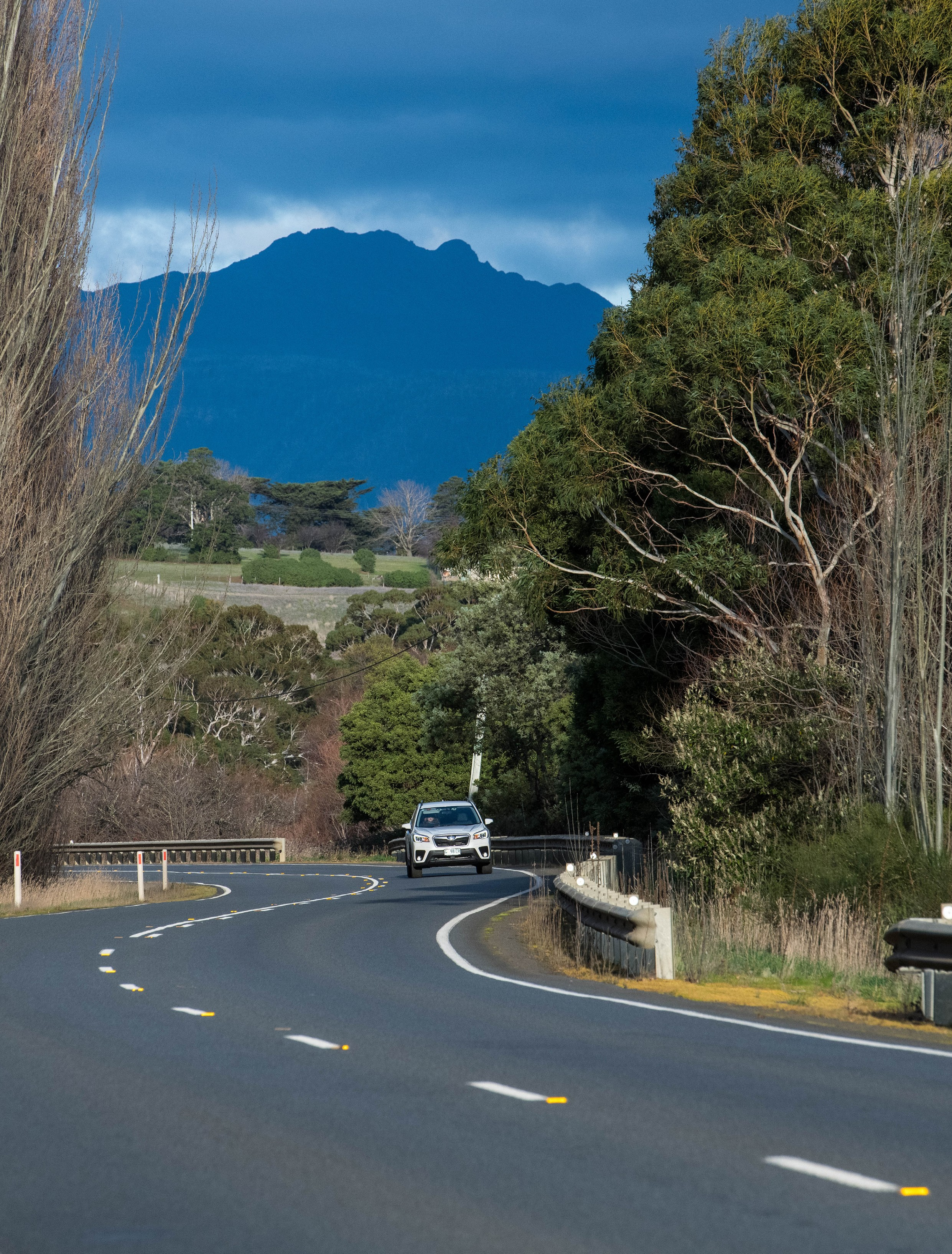

Towards Zero Action Plan 2020-2024

Department of State Growth

Contents
Minister’s message 3
Message from the Chair of the
Tasmanian Road Safety Advisory Council 4
The Action Plan at a glance 5
Our problem 6
Tasmania’s crash profile 7
Serious casualty crash map 8
The higher the speed, the greater the impact 9
The Safe System approach 10
Key themes 12
Making our rural roads safer 12
Improving safety in our towns and cities 14
Saving young lives 16
Encouraging safer road use 20
Making visitors safer 22
Improving safety through vehicles and technology 24
Looking ahead 26
Tackling inattention and distraction 26
Copyright notice and disclaimer 28

1

If nothing changes, we can expect 175 people to be
killed on Tasmania’s roads over the next five years.* BUT If Tasmania’s road safety performance matches the best in the nation, we can save
66 lives.

* No one can predict the future. But, based on the number of lives lost over the past five years, these are the numbers we
are likely to be faced with.

2

Minister’s message

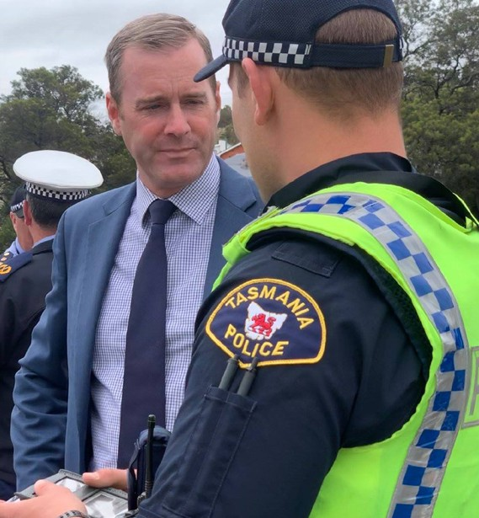
I am pleased to release the Towards Zero Action Plan 2020- 2024 (Action Plan), the State’s new road safety plan that outlines the Tasmanian Government’s commitment to improving safety on our roads over the next five years.
This Action Plan is the second under the Towards Zero – Tasmanian Road Safety Strategy 2017-2026.
Supporting our targeted road safety efforts, the Tasmanian and Australian Governments will invest $1.5 billion on major state road construction projects to improve efficiency and safety for all road users over the life of this Action Plan.
The Action Plan supplements this significant investment in road infrastructure and commits $75 million to support road safety policy and programs, public education, and safety improvements for all road users across all of our roads.
This is funded by the Road Safety Levy and by the
Motor Accidents Insurance Board’s commitment to public education.
I acknowledge the work of the Road Safety Advisory Council in developing the new Action Plan.
The Council provides the Government with advice about best practice initiatives proven to save lives and recommends how the Road Safety Levy should be used to reduce serious casualties on our roads.
We have made steady progress in reducing road trauma in Tasmania, from record highs of more than 1 400 serious casualties annually in the 1970s to the current rate of around 310 serious casualties per year.
As Minister, I don’t accept any level of road trauma in our state and ask all Tasmanians to recommit ourselves to doing even better.
Under the 10 year Strategy, we outlined our long-term vision of zero serious injuries and deaths on our roads.
This is what we aspire to. Our shorter-term target is for fewer than 200 serious casualties on our roads by 2026.
Our 2026 target is ambitious and will not be easy to accomplish. Achieving this goal will require all of us to be responsible, intelligent and considerate road users.
We will also need to heed the messages of road safety education campaigns and, where necessary, modify our behaviour.
Over the first twelve months of this Action Plan, we will be making every effort to improve road safety for our young road users. We will be taking action to improve driver licensing, supporting young people to gain a licence, and investing in road safety education campaigns and programs.
Gaining a licence is an important step in a young person’s life. It offers new freedoms, independence and can expand the opportunity for gaining employment. The improvements we are making strive to create a safer system for young drivers without creating unnecessary barriers.
Our other key priorities include:
» Making our rural roads safer – by targeting our rural roads through infrastructure safety improvements, capacity building, speed moderation and enforcement.
» Improving safety in our towns and cities – focusing on vulnerable road user safety, trialling new technologies, and community road safety.
» Encouraging safer road use – through public education to encourage safer driving, and enforcement and penalties to deter illegal and unsafe behaviours.
» Improving safety through vehicles and technology – supporting vehicle safety testing and encouraging all Tasmanians to drive the safest vehicle they can afford.
We will also continue to focus on the road safety of visitors to Tasmania.
It’s not possible to design our transport systems to prevent every crash, so we must work together as a community to improve driver abilities and ensure safest possible habits to get all road users safely to their destination.
If we all do that, we will achieve our target of saving lives.

Hon Michael Ferguson MP
Minister for Infrastructure and Transport

3

Message from the Chair of the Tasmanian Road Safety Advisory Council

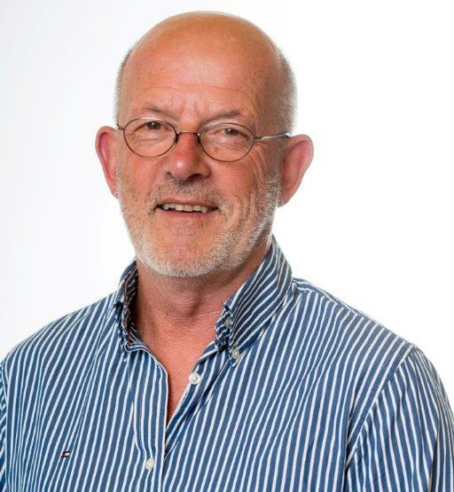
Around 170 Tasmanians could die on our roads over the next five years and more than 1 500 could be seriously injured.
That’s the unfortunate reality. That’s what the averages tell us from the past five years. After decades of falling rates of road trauma, this avoidable national tragedy is threatening to get worse, not better.
We have the tools to save more lives every year. What we need is the wider community to fully understand the problem, to understand the overwhelming weight of evidence behind the solutions to this crisis, and to support necessary and bold actions to stop the pain and suffering associated with road trauma.
Tasmania is striving to lift its performance in areas such as health outcomes, educational attainment and economic performance. We want to be the nation’s leader – we want to match or better the best performing Australian states.
The same should apply to road safety. Today, in terms of road fatalities per 100 000 population, we are lagging behind our national counterparts.
Our results are significantly above the national average and more than 60 per cent higher than Victoria, our closest neighbour and, on average, the best performing state.
We must aspire to be the best, but it will take every Tasmanian, including the 400 000 licensed drivers, to embrace the cause.
Road safety has come a long way but, year after year, we continue to face the same issues. Young drivers and males are still significantly over-represented in road trauma, as are motorcyclists.
Most of our road trauma continues to occur in higher speed zones and lane departure crashes (head-on and run-off-road crashes) are still the prevalent crash type.
High risk behaviours such as drink driving and speeding continue to put people at risk.
But we are also facing new challenges such as mobile phone distraction and drug driving.
Too many Tasmanians think that because we have made significant inroads into the “road toll” in the past 40 years that we should be happy with our progress.
Would the families and friends of the 33 Tasmanians who died in 2018 feel that way? Would the families and friends of the 288 seriously injured on our roads last year feel that way? These people’s lives have changed forever, in many cases catastrophically.
Death and injury is not the price anyone should pay for getting from A to B more quickly or more efficiently. That’s why we’re working towards zero road trauma.
It’s time our community confronted the tragic facts. It’s time for broad community support that’s committed to ending trauma on our roads and it’s my job to work closely with the community to realise our vision.
The Road Safety Advisory Council is proud to have contributed to the Tasmanian Government’s Towards Zero Action Plan 2020-2024.
We see it as an opportunity to build on what we have done successfully and as a blueprint for change, not just to meet the challenge of saving lives but to excel at doing so.
We believe this Action Plan is a fundamental building block in getting to a point where Tasmania can lead the nation.

Garry Bailey
Chair of the Tasmanian Road Safety Advisory Council

4

The Action Plan at a glance

Over the next five years, the Tasmanian Government will invest more than
$75 million in road safety improvements in six key areas.1

Over $20 million  Making our rural roads safer  60 per cent of fatalities occur in rural areas.  - Engage with the community, decision-makers and industry practitioners to increase road safety  knowledge and build support for speed moderation.  - Reduce the risk of run-off road and head-on crashes on high speed rural roads with cost effective, mass action infrastructure treatments.  - Conduct motorcycle road safety audits and consult with the motorcycling community to identify innovative safety solutions on popular touring routes. | Over $31 million  Improving safety in our towns and cities  Pedestrians and cyclists represent one in four serious casualties in our major towns and cities.  - Deliver targeted infrastructure upgrades at high traffic areas to reduce serious crashes in urban areas and to improve safety for vulnerable road user groups.  - Support community involvement in road safety through the Community Road Safety Grants Program.  - Investigate emerging technologies and demonstrate innovative low-cost infrastructure treatments in urban areas.
Over $12 million Saving young lives  92 young people are seriously injured or killed on our roads every year.  - Implement changes to the Graduated Licensing System for drivers and investigate improvements to motorcyclist training and licensing.  - Keep young children safe with child-restraint checks, school crossing patrol officers, road safety education programs in primary schools, and media campaigns.  - Support education and training initiatives to teach young people the right skills and attitudes, and assist disadvantaged young people to enter the licensing system. | Over $4 million Encouraging safer road use  We all have a responsibility to use the roads in ways that are safe for those around us.  - Investigate and implement enforcement strategies to reduce speeding, inattention, distraction and other high- risk driving behaviours.  - Ensure participation in the Mandatory Alcohol Interlock Program to prevent repeat offenders from driving while intoxicated.  - Improve motorcyclist safety by promoting protective clothing and increasing motorcycle-focused enforcement measures.
$2 million  Making visitors safer  11 per cent of all serious casualties on our roads are non-Tasmanian residents.  - Inform visitors of important road safety messages using strategically placed signs and trial the use of electronic signage to communicate in real-time.  - Utilise Tasmania’s limited entry points to distribute key road safety materials in multiple languages to visitors upon arrival.  - Secure and maintain strategic partnerships with relevant tourist industries, businesses and other stakeholders to better reach visitors. | Over $3 million  Improving safety through vehicles and technology  The rate of fatal crashes is four times higher for vehicles 15+ years old than for vehicles made in the last five years.  - Develop a Light Vehicle Safety Strategy to ensure all vehicles on our roads meet required safety standards.  - Investigate actions to improve safety for vehicles used as a workplace and ensure that the government vehicle fleet meets the highest safety standards.  - Continue to support vehicle safety testing, monitor new technological developments, and support all Tasmanians to purchase the safest vehicle they can afford.
- This figure includes funding for the delivery and administration of projects and to provide secretariat support to the Road Safety Advisory Council.

5

Our problem
1999–2003
508
2004–2008
384
2009–2013
300
2014–2018
314
2026 less than
200
ZERO
Around 300 people are seriously injured or killed on Tasmanian roads every year.
From the horrific days at the start of the 1970s, when the annual total was almost 1 500, we have steadily reduced serious injuries and deaths. But the lack of reductions in the last 10 years sounds warning bells.
While casualties per head of population and per registered vehicle continue to fall as more and more people use the roads, the total number of casualties has plateaued.
The current numbers of Tasmanians killed or seriously injured in their daily travel is totally unacceptable.
The Towards Zero Strategy establishes a road trauma target of fewer than 200 serious casualties by 2026.2 This target was informed by historical road trauma, crash data modelling, and the application of recommended road safety measures.
The road safety measures outlined in this Action Plan are underpinned by the 13 key
directions identified in the Towards Zero Strategy.
They are based on community consultation undertaken in the development of the Towards Zero Strategy, road safety expert advice, and review of the current Strategy and Action Plan 2017–2019 by the Road Safety Advisory Council.
Our target remains unchanged to reduce serious injuries and fatalities to fewer than 200 by 2026.

Tasmanian serious casualties 2001– 2018 and Towards Zero target

600

500

400

300

200

100

0
Fatalities Serious injuries Serious casualties (rolling 5 year average)

- A ‘serious casualty’ collectively describes fatalities and serious injuries as the result of a crash. A fatality is where a person dies up to 30 days after the crash. A serious injury involves a person being admitted to hospital for 24 hours or more after the crash.

6

Annual number of serious casualties (five year averages) in
Tasmania since 1999 and our future targets.

Tasmania’s crash profile
Between 2014 and 2018, an average of 281 people were seriously injured and 34 people killed on our roads. This equates to an annual fatality rate of 6.6 per 100 000 population, which is significantly higher than the national average of 5.0 during the same period. The best performing countries in road safety are achieving rates as low as 2.5, which demonstrates the potential improvements that we aspire to.

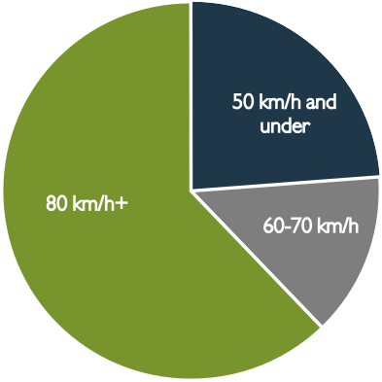Crash type Speed zone
50 km/h and under
80 km/h+
60-70 km/h

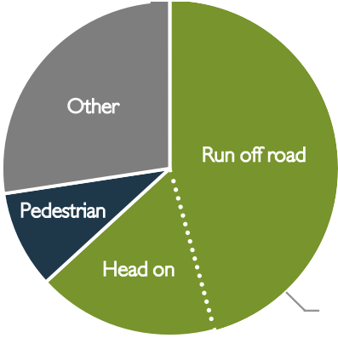
Other

Pedestrian

Run off road

Head on
Lane departure

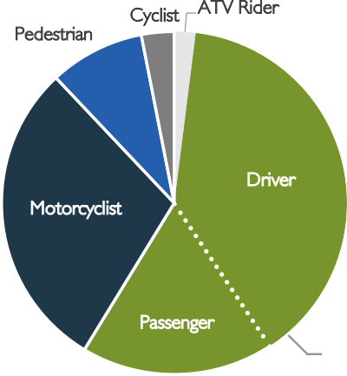
Road user type Urbanisation

Pedestrian

Cyclist
ATV Rider

Driver
Urban
Rural
Motorcyclist

Passenger

Vehicle occupant

Age Gender
75%
50%
25%
0%
Female
Male
75%
35%
30%
25%
20%
50%

Population

7
15%
10%
5%
0%
25%
0%
Female
Under 16
16-25
26-49
50-64
65+
Male
35%

30%

25%

20%
15%

10%

5%
0%
Under 16
16–25
Population
26–49
50–64
Serious casulties
65+
Serious casulties

Serious casualty crash map
As can be seen from the heat map below, serious casualties crashes are a state-wide issue. No longer can we target individual blackspots.
We must now be proactive and deliver mass action road safety treatments to improve our road network.
Mass action countermeasures include lane separation, improved delineation, audible edge lines, shoulder sealing, removal of roadside hazards, improved skid resistance, and improved junctions.

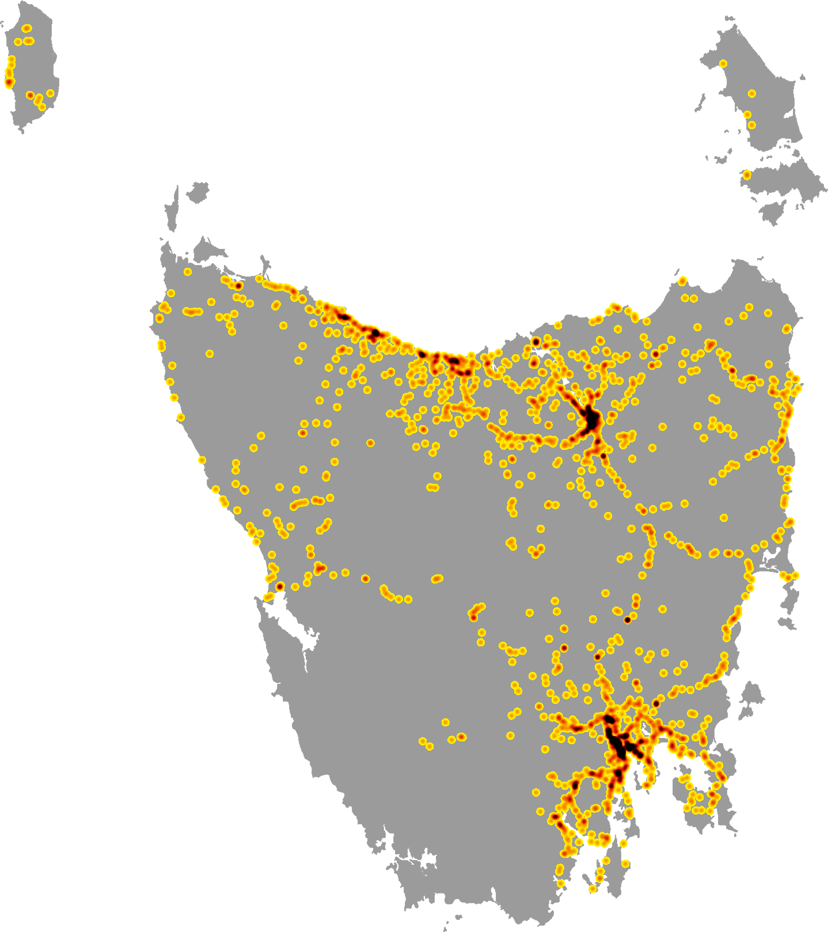

8

The higher the speed, the greater the impact
Speeding includes travelling above the speed limit as well as driving too fast for the conditions, and these are major contributors to both the number and severity of crashes in Tasmania.
As a vehicle's speed increases, so does the time it takes for the vehicle to come to a stop.
A small increase in speed can make a big difference in the likelihood of crashing and the seriousness of a crash.
Although vehicles are increasingly becoming safer, with better occupant protection, our bodies can only tolerate so much. It’s simple physics.
We will develop and implement a speed moderation strategy that combines public education campaigns, a review of speed related penalties, a new speed enforcement strategy, enhancing the automated speed enforcement program and establishment of speed limits that are more appropriate to the safety features of individual roads.

Human tolerance in crash situations

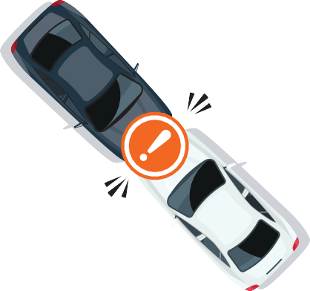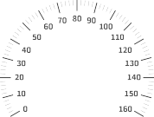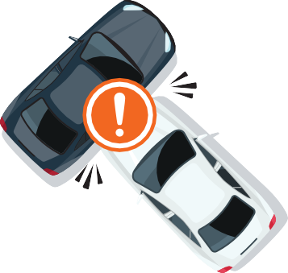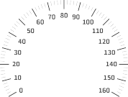
km/h
70
km/h
50

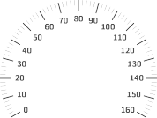Head-on 70km/h
km/h
30

Side impact with tree 30km/h
Side impact 50km/h
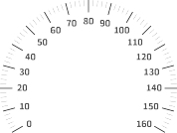
km/h
30
Impact with pedestrian 30km/h

9

The Safe System approach
We believe that no Tasmanian should be seriously injured or killed as a result of their daily travel on our roads.
Our vision is of a future with zero deaths and serious injuries. To get there we know we have to think and act differently.
We have adopted the European model of creating a Safe System by focusing squarely on safer infrastructure and traffic
management, as well as continuing to seek safer vehicles and extensive behavioural change.
A lot of our gains to date have come from protecting people when a crash occurs - seat belts, air bags, a raft of changes improving vehicle crashworthiness, motorcycle and bicycle helmets, reduced speed limits around schools and shopping strips, and so on. More recently, wire rope barrier has been introduced to minimise crash severity when a vehicle, for whatever reason, leaves the roadway.
These are applications of the first Safe System principle - as we are vulnerable beings, we can reduce casualties by reducing crash forces on the human body. Making our infrastructure safer is costly, but in the interim we can reduce crash forces by ensuring travel speeds do not exceed the level of safety inherent in our various roads.
For a very long time we have also focused our efforts on reducing the prevalence of high-risk behaviours by road users: risks such as speeding, drink and drug driving, driving fatigued, and so on. We have made gains in this area. For example, high intensity Random Breath Testing has substantially reduced the role of alcohol in serious crashes.
While we must continue our efforts to limit high risk and irresponsible behaviours, we must also look for other ways to supplement these efforts.
Extensive research has clearly demonstrated that much of the behaviour contributing to crashes is not irresponsible or negligent but the result of imperfect humans making everyday mistakes.
This is the second Safe System principle - we can change the design and operation of our system to reduce the likelihood of mistakes leading to serious crashes. Sealing gravel shoulders, improving sight distances, re-designing critical intersections, and tactile line markings are just some of the tools we have.
Our strategy has a target of reducing serious injuries and deaths to less than 200 by 2026. This is a big challenge and requires all of us to play our part.
Applying the principles of the Safe System means our approach to infrastructure has to continue to change, and we must redouble our efforts to achieve a moderation of travel speeds to match the level of safety built-in at present.
We must achieve all of this while engaging the community to play its part through responsible behaviour and consideration of all fellow road users.
This Action Plan outlines our journey and deserves everyone’s full support.

10

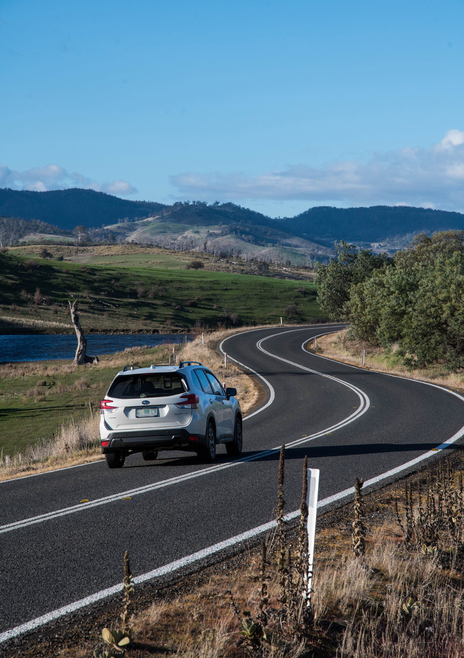

11

KEY THEME
MAKING OUR RURAL ROADS SAFER

60 per cent of fatalities in Tasmania occur in rural areas. We are investing over
$20 million to improve the safety of our rural roads.

Tasmania’s population is spread across the state and much of our travel necessarily occurs on high speed rural roads.
These roads connect us with our family and friends, provide access to sporting, social and economic activities.
Our rural roads are twisty and hilly. The frequent advisory sign warning us to slow down for an oncoming corner highlights the challenges of driving in Tasmania.
Misjudging a corner, or veering onto a gravel road shoulder can easily result in loss of control and collision with a roadside hazard or an oncoming vehicle.
The twists and turns also attract recreational motorcyclists, and sadly riders represent one in three of those seriously injured or killed on these roads.
Infrastructure treatments can help reduce the likelihood of these crashes and reduce crash harm. Much has been done to treat ‘blackspots’ and credit must go to the Australian Government for funding this program, and to state and local government traffic engineers for their work in reducing road trauma.
To be most effective, complete road corridors need to be improved to provide a consistent and predictable road
environment. However, infrastructure works are expensive and our rural roads don’t often attract priority funding due to their low traffic volumes.
We are establishing a new grants program to work collaboratively with councils on local roads. Funding will help councils assess and install low cost safety infrastructure solutions.

Nine out of 10 of those killed on rural roads are Tasmanian residents.

Simple delineation treatments, such as line marking, reflective pavement markers, guideposts, speed and curve warning advisory signage, all help to alert drivers about the road conditions ahead, day and night.
Removal of roadside hazards and the installation of safety barriers can also reduce the severity of run-off road crashes.
We will continue to engage our motorcycling community to address safety on popular touring routes.
Our plan is to conduct Safe System road safety audits and work with the motorcycling community and other stakeholders to identify innovative treatment options.
Ultimately, we must also tackle the issue of safe speeds on our roads. Travel speeds need to be aligned with the inherent safety features of the road, what we know about safe travel speeds, and traffic mix.
Enforcement and public education will play a key role in moderating travel speeds and help us arrive home safely.

“Tasmania’s rural road network is vast and links our communities. They also lead to some of the most popular destinations for visitors to the State. Many rural roads don’t have the safety features of higher
volume roads. All too often we see both locals and visitors to the State
run off the road and crash. These crashes have a significant impact on
local towns and improved roads with more safety treatments will go a long way to
reducing road trauma.”
Mick Tucker Mayor, Break O’Day Council

12

What we will do

Establish a rural roads grants program for local government
This program will fund councils to implement mass action infrastructure treatments on their high speed rural roads.
The aim of this program is to significantly reduce lane
departure crashes and lessen their harm when they do occur.

Conduct infrastructure upgrades on low volume State roads
We will continue to invest in State roads that have lower traffic volumes, where cost effective treatments such as shoulder sealing, pavement markings, curve warnings, road side hazard removal and safety barriers will achieve maximum value for money.

Improve motorcyclist safety on rural roads
To improve safety for all motorcyclists, we will conduct road safety audits on high risk touring routes across Tasmania.
A Safe System approach will inform these audits, where local motorcyclists are integral to the process of assessing the design and risks of a road. Audit findings will be shared with stakeholders to identify countermeasures that often go beyond typical infrastructure solutions.

Develop a speed moderation and community engagement strategy
We will engage with the community to inform and build support for action on safer speeds. As part of this process, we will consider how enforcement can more effectively increase compliance with speed limits.

Expand Safe System knowledge and skills
We will continue to facilitate training sessions, workshops and forums across Tasmania to improve the Safe System knowledge of all those in a position to influence road safety outcomes. This will increase the capacity of our state to build safety-improving road infrastructure that benefits everyone.

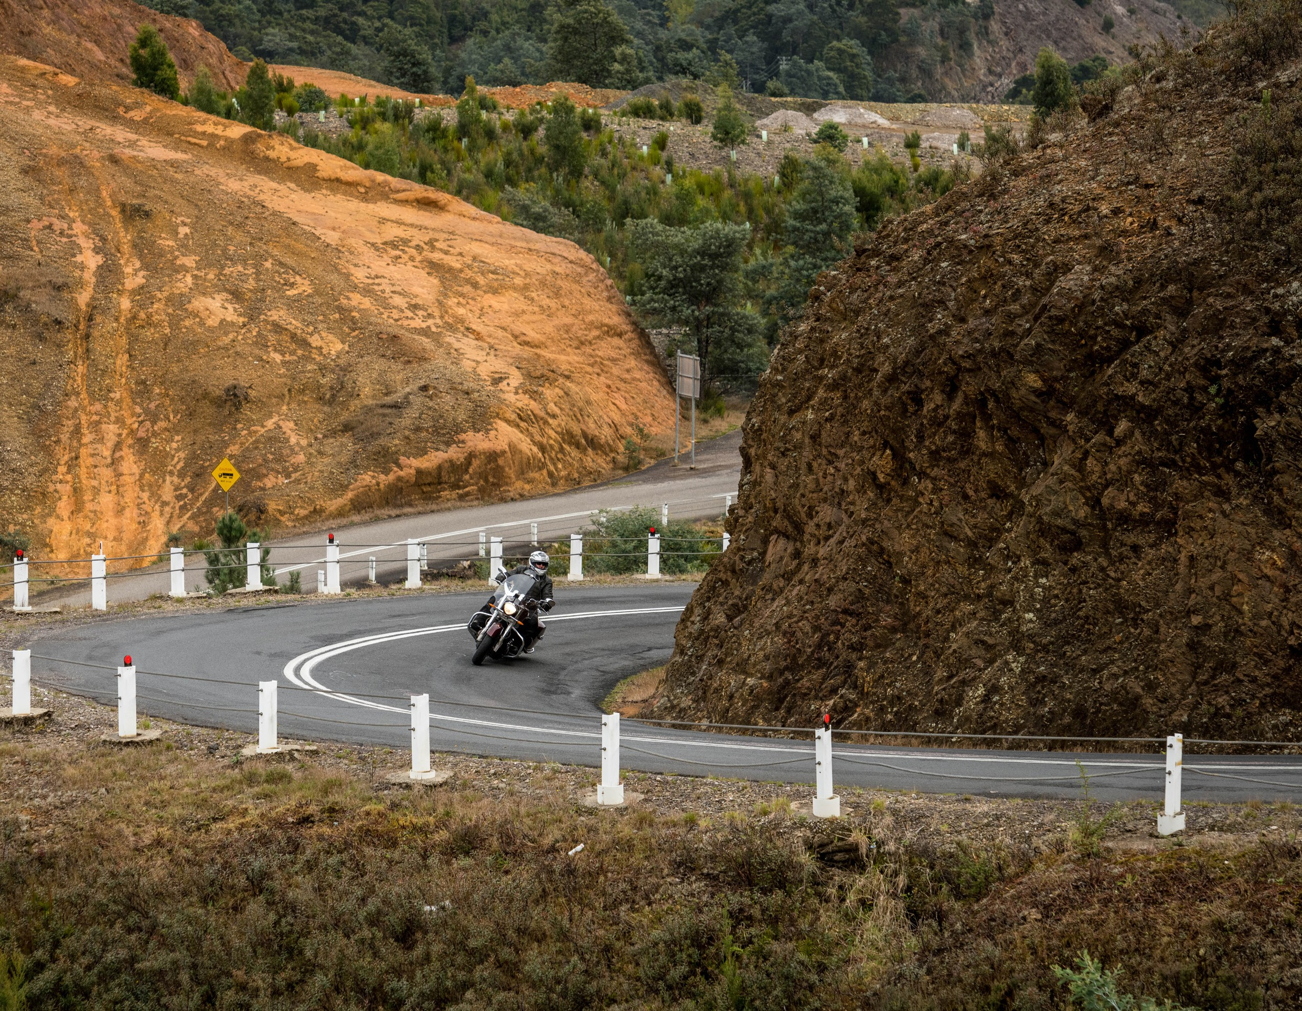
13

KEY THEME
IMPROVING SAFETY IN OUR TOWNS AND CITIES

Tasmania’s population is growing and our towns and cities are busier than ever. We are investing over $31 million in projects and programs to improve road safety in our towns and cities.

Almost one quarter of all serious injuries and deaths happen on city and local streets with a speed limit of 50km/h or less.
Over the last 20 years, the number of people seriously injured and killed on local and city streets has steadily declined. This achievement is the result of lowering the default urban speed limit to 50km/h in 2002, safer vehicles, and the progressive installation of safer road infrastructure.
In a crash, the human body can only tolerate a certain level of physical force before serious injury or death is inevitable. This is especially true for pedestrians and cyclists who have little or no protection in the event of a crash with a motor vehicle. That’s why setting safe speed limits, as well as ensuring drivers comply with these, is critical.
Cost-effective, small scale infrastructure treatments such as wombat crossings, pedestrian refuges, safety barrier,
and kerb outstands can also significantly improve vulnerable road user safety. Such treatments slow traffic, make pedestrians and cyclists more visible, and allow for staged crossing of roads.
We will continue to support local government with funding to provide infrastructure improvements to keep people safe around our schools, shopping centres, sporting facilities, and recreational areas, as well as on our local streets.
Councils are to be congratulated for their work in keeping road users safe in our towns and cities.

Pedestrians and cyclists are at high risk of serious injury or death if hit at speeds above 30km/h. In our major towns and cities, pedestrians and cyclists represent one in four serious casualties.

On busy State highways and arterial routes, we also know that shoulder sealing, safety barriers, line marking and signage can reduce the likelihood of lane departure crashes occurring and reduce their severity when they do.
This type of crash represents 40 per cent of serious casualty crashes in urban areas. Safer infrastructure can also help to reduce the 10 per cent of serious casualty crashes that occur at intersections.
We also need to encourage our community to take a strong lead in achieving our vision of zero road trauma on Tasmania’s roads. We will continue to support councils and community groups to deliver road safety education and programs at the local level.

“In small regional towns we encounter many different conditions and a variety of vehicles that travel our roads. It’s important to protect all road users especially those who are more vulnerable. Our “Look Out for Your Mates” road safety program is a huge part of keeping our
community safe.”
Deb Mainwaring Manager Connected Communities, Circular Head Council

14

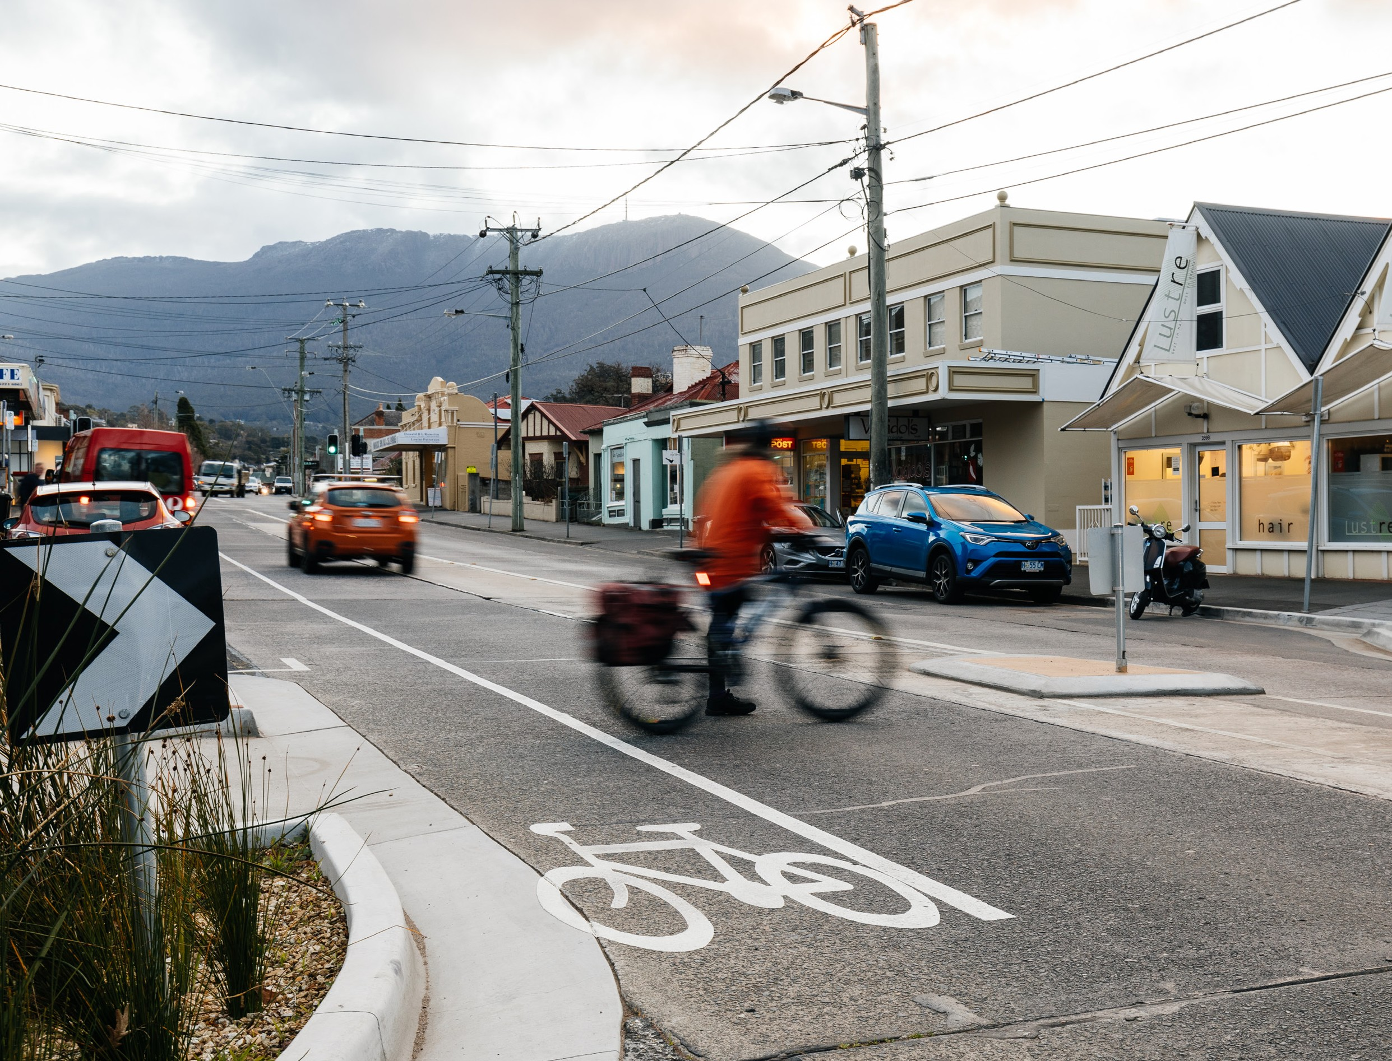What we will do

Deliver targeted safety improvements for state roads
We will deliver a range of infrastructure upgrades to make our towns and cities safer to live, walk and drive in.
This will include shoulder sealing, intersection improvements,
safety barriers and pavement markings at high traffic areas.
By targeting high volume roads that are not planned for major investment in the short term, we can achieve the maximum road safety benefit from the available funds.

Expand the Vulnerable Road User Program
Under this infrastructure program we will expand investment in road safety for pedestrians, cyclists and motorcyclists.
This annual grants program offers funding to councils to complete small-scale infrastructure treatments such as pedestrian crossings, dedicated bike lanes, upgraded footpaths, wombat crossings and other traffic calming measures.
These improvements make towns and cities across Tasmania safer and more accessible for all types of road users.

Expand the Community Road Safety Grants Program
We will continue to support community involvement in road safety through the Community Road Safety Grants Program.
This program supports local schools, community groups, councils, research institutions and charity organisations to promote and address road safety issues, making everyone more aware and involved in using our roads safely.

Investigate emerging technologies
New technological solutions can reduce the likelihood of crashes involving pedestrians and cyclists in our urban areas. We will monitor emerging technologies for suitability in the Tasmanian context and conduct trials where possible.

Demonstrate emerging infrastructure treatments
We will investigate opportunities to demonstrate innovative infrastructure treatments that can improve road safety in our urban areas. In cooperation with local councils, we want to show how Tasmania’s towns and cities can be transformed for the benefit of all road users, especially pedestrians and cyclists.

15

KEY THEME

SAVING YOUNG LIVES

On average, 92 young Tasmanians aged 25 or below are seriously injured or killed on our roads every year. This is 92 too many. We are investing over $12 million in programs and projects designed to reduce this harm.

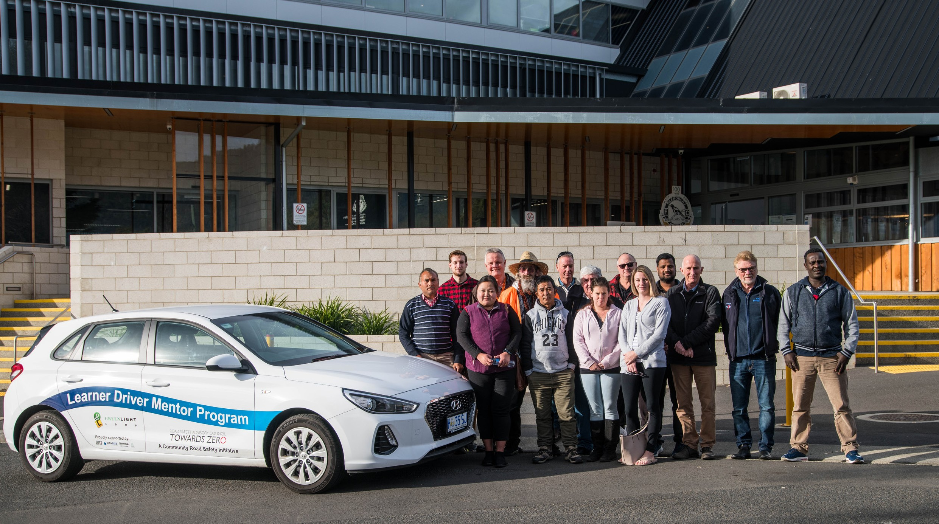Too many young Tasmanians die or suffer life changing injuries on our roads. They are being seriously injured and killed at a higher rate than any other age group.
16
This needs to change. To achieve this, we will make necessary reforms and continue to deliver programs that will improve road safety at every stage of young people’s lives. Our youngest Tasmanians, those in early childhood and primary school, are extremely vulnerable when using our roads.
This is especially true when not properly restrained in the car, when walking or riding a bike and when getting on and off the school bus.
We have a number of programs to help keep children safe, including the provision of school crossing patrol officers and campaigns to encourage lower speeds around schools and school buses.

Tragically, road trauma is the second leading cause of death for young Tasmanians aged 17 to 25.

We also provide support to community organisations to deliver bike and road safety education programs in schools and free child restraint checks across the State.
Later, as young people approach the age when they can get a licence, we support them through a range of programs
to educate them about safe driving and to assist them to progress through the licensing system.

Education and training initiatives such as the Rotary Youth Driver Awareness Program, the Royal Automobile Club of Tasmania’s (RACT) Ready for the Road course and the Full Gear motorcycle safety project will help to develop the skills of young road users and teach them how to use the road with the right attitude and sense of shared responsibility.
Gaining a provisional driver licence is a huge achievement in the life of a young person, offering them greater independence and improved access to social and economic
opportunities. Enabling young people to take this important step is one of our major priorities.
Sadly though, it’s at this time in their lives, having just graduated from their period of supervised learning, that they are at the greatest risk of being involved in a crash.
There are a number of reasons for this and, consequently, no single solution that will prevent it. That’s why we are pursuing a range of evidence-based policy changes. We are also investing in targeted training and assistance programs all around the State.
The implementation of an enhanced Graduated Licensing System (GLS) will support young people to become safer drivers by making sure they get more on-road supervised driving experience in a wider range of conditions and that they demonstrate the right skills before being allowed to drive without supervision.
The enhanced GLS will better protect provisional licence holders from distractions such as mobile phones and peer aged passengers.
A high percentage of Tasmania’s young people are already entering the licensing system. To further support young people, we will improve the tools and resources that drivers use to learn the Road Rules and track their progress through the GLS.
Importantly, we will also expand our support to disadvantaged young people through the Driving for Jobs and Learner Driver Mentor Programs.
For novice motorcyclists, recently introduced training requirements will equip young riders with improved skills and an awareness of their vulnerability on the road.
We will continue to monitor the outcomes of these changes while also exploring opportunities to improve the GLS for motorcyclists.
These ongoing initiatives and policy reforms aim to give all Tasmanians the opportunity to gain their licence with the right level of guidance and training to become safer drivers.

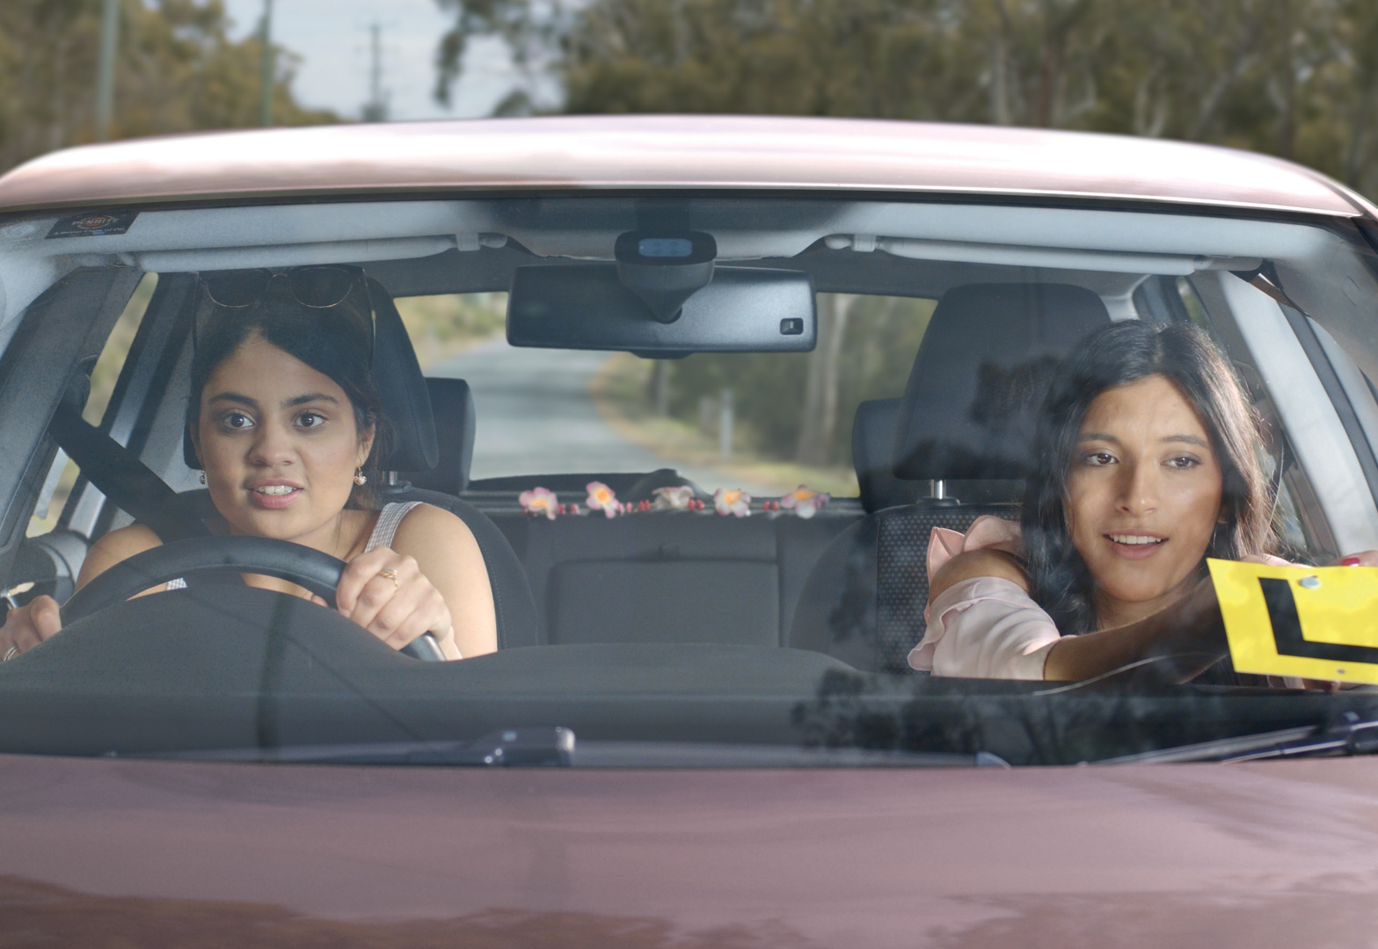
More practice. More conditions. More often.
17

What we will do

Expand the Learner Driver Mentor Program
We will continue to support disadvantaged learner drivers under the Learner Driver Mentor Program. This program helps fund community organisations across the state to match volunteer mentors with learner drivers who do not have access to a supervisor, a suitable car and the means to afford professional lessons.
Assisting these young people to meet their required supervised driving hours decreases the risk that they will drive without a licence, helps them connect with their community and improves their job prospects.

Improve the Graduated Licensing System
The Graduated Licensing System (GLS) will be enhanced to reduce crashes among young people and improve the pathway to a provisional driver licence.
A new digital learning platform will make it easier to learn the Road Rules and make getting a licence simpler. Learners will now get more experience in different environments before they graduate to their provisional licence, which is when they are at greatest risk. New safeguards will help protect provisional drivers from dangerous distractions.

Develop an improved GLS for motorcyclists
We will assess the options for a GLS for motorcyclists to ensure they are appropriately experienced and capable before they are granted a full licence. Greater safety is achieved by placing restrictions on learners that are gradually lifted as the rider gains experience and acquires skills under conditions of reduced risk.

Continue to support the Rotary Youth Driver Awareness Program (RYDA)
The RYDA program will continue to make students aware of the significant responsibility that comes with being a driver or passenger. Every year, more than 4 000 students in grades 10-12 take part in practical demonstrations and learn valuable road safety lessons from expert presenters and volunteers.

Continue the Driving for Jobs Program
The Driving for Jobs program will support students from highly disadvantaged areas to progress through the GLS and gain a greater awareness of road safety while also improving their job prospects.
Students undertake a personalised, intensive program with a strong road safety focus including professional on-road lessons and participation in RYDA.

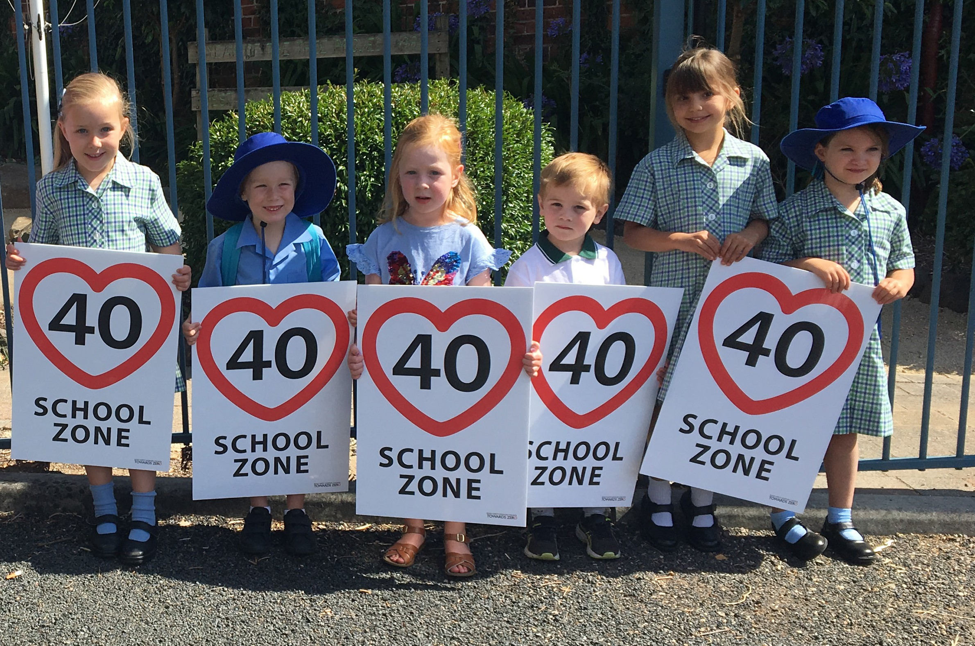

18

“Learning to drive on the road was one of the most challenging things I’ve ever done. In fact,
I found it more difficult than driving on the racetrack. It took lots of practice and a couple
of failed tests, but eventually I gained enough experience to get my licence and learned an important lesson – nobody is invincible on the road.”
Alex Peroni FIA Formula 3 Driver

Provide funding for RACT education initiatives
RACT will be supported to deliver a number of road safety education initiatives. This includes a program for years 10 to 12 students that focuses on the dangers of distraction and inattention.
In a controlled environment, students can drive through a course of traffic cones while attempting to send a text message or while wearing “beer goggles”.
The program also includes an in-class component that teaches students how to progress through the GLS and about the specific rules that apply to L and P plate drivers.

Continue the Real Mates media campaign
The Motor Accident Insurance Board-funded Real Mates campaign will continue to use humour to engage with young men and encourage them to avoid the risks of drink driving.
This successful campaign aims to empower young men to speak up and stop a mate from driving after drinking.

Support Bicycle Network Tasmania
The Bicycle Network will continue to promote bike education, road safety and positive road sharing behaviour to school students across Tasmania.

Keep school children safe on the roads
Over 100 school crossing patrol officers assist children and other pedestrians to safely cross the road at schools all around the State.
The Safety Around Schools project, including the Love 40 campaign, will also encourage drivers to lower their speed and keep a look out for children in school zones and around buses.

Support Kidsafe child restraint checks
Kidsafe Tasmania will continue to conduct free child restraint checking sessions to ensure that young children are safely and lawfully seated and restrained in cars. Kidsafe also distribute and promote educational material informing the public of the correct child restraint type for a child’s age and size.

Encourage safe and legal motorcycle riding
We will continue to support Glenorchy City Council, in
partnership with Bucaan House, to deliver its successful Full Gear motorcycle safety project.
This program helps young motorcycle riders enter the licensing system and adopt safe riding practices.

19

KEY THEME

ENCOURAGING SAFER ROAD USE

We all have a responsibility to use the roads in ways that are safe for those around us. We are committing over $4 million to improve the way we behave on our roads.

To encourage everyone to use our roads safely, we will strike the right balance between education and enforcement.
This means supporting people to drive safely, ensuring we all understand the harm that can result from breaking the road rules, and addressing high-risk and illegal behaviour through an effective deterrence regime.
While most crashes are the result of a simple mistake, we all have the opportunity to make safer choices to reduce our risk of crashing and injuring or killing innocent road users.
Purchasing the safest vehicle you can afford, driving to the road and weather conditions, obeying the speed limit, only driving while alert, and giving full attention to the road are all effective ways of improving the safety of yourself and those around you on the road.
Unfortunately, a number of serious casualty crashes are due to high risk and illegal behaviours such as speeding, inattention, mobile phone use, and driving under the influence of drugs or alcohol.
For some drivers, the most effective way of deterring extreme and illegal road use is through high visibility policing and enforcement backed by appropriate sanctions.

The Fatal Five – speeding, driving under the influence of drugs or alcohol, inattention, fatigue and failure to wear seatbelts – will continue to be a focus of road safety enforcement.

We will continue with a strong on road enforcement presence and, where possible, trial and implement new means of detecting illegal driving.
No one is a perfect driver. Every one of us will make mistakes on the road. We will keep improving our transport system so that serious injuries and fatalities are reduced. But to achieve our vision of a zero road toll, we need all road users to play their part, to follow the rules and consider their own safety and the safety of others.

Serious casualties attributed to the Fatal Five
Fatigue
4%
Distraction
24%
Seatbelt not used
9%
Alcohol or drugs
24%
Speed
29%

20

What we will do

Investigate strategies to address inattention and distraction
Inattention and distraction are concerning causes of serious casualty crashes. Strategies to address this growing issue, such as technologies that can detect the use of mobile phones by drivers, will be investigated and implemented.

Promote safe behaviours through campaigns
We will continue to educate and encourage people to use our roads safely through targeted media campaigns. This will include campaigns like Love 40, which reminds drivers of their responsibility to slow down in school zones and around buses to protect children.

Promote protective clothing for motorcyclists
Motorcyclists are significantly over-represented in Tasmania’s road trauma figures. One of the reasons for this is that riders are more likely to be injured in a crash due to a lack of physical protection. We will continue to work to reduce the risks to motorcyclists through a range of actions, including supporting the work of MotoCAP to promote the use of protective clothing.

Ensure participation in the Mandatory Alcohol Interlock Program
Drink driving is a significant factor in serious casualty crashes on our roads. We will introduce supporting measures to increase participation in the Mandatory Alcohol Interlock Program. This will mean that more drink driving offenders will be required to demonstrate that they can separate their drinking from their driving, reducing the chance of alcohol related crashes.

Review the penalties for putting others at risk
For enforcement activities to improve safety on our roads, they need to be backed up with the right penalties.
Tasmania’s road safety focused penalties will be reviewed to ensure they are up–to–date and provide an appropriate deterrence to those who break the rules.

Implement a new speed enforcement strategy
Tasmania Police will enact new speed enforcement techniques to increase the rate of detection and enforcement and increase the perception that offending drivers and motorcyclists will be caught.

Improve enforcement of high–risk behaviours
Following a successful and widely supported trial, Tasmania Police will expand its use of unmarked motorcycles to detect and intercept high-risk traffic offences in busy areas across the State. Helmet mounted cameras assist to capture evidence of illegal mobile phone use, speeding, blocking of intersections, failure to wear seatbelts and failure to comply with red and amber traffic signals. We will continue to investigate innovative new ways of detecting and enforcing these kinds of high-risk and inattention-type offences.

Investigate an enhanced automated speed enforcement program
Speed cameras are relatively underutilised as a deterrence and enforcement mechanism in Tasmania. In other states and territories, enhanced speed camera programs have resulted in significant reductions in serious injuries and fatalities on the road. We will investigate a range of proven and emerging speed camera technologies and assess their potential to reduce speeding and save lives at high–risk locations and across the entire road network.

Improve enforcement of high–risk riding
Speed is a factor in at least one quarter of motorcyclist serious casualties. Unfortunately, our speed cameras are only equipped to capture the number plates of oncoming traffic.
This means that our speed cameras offer no deterrence to motorcyclists, whose number plates are mounted only on the back. We will introduce rear-facing speed cameras to address this issue and investigate other techniques
for enforcing speed and other high–risk behaviours for motorcyclists.

Continue to promote the Road Rules
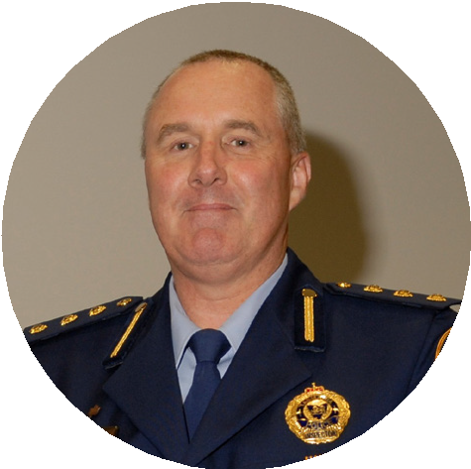The Road Rules are designed to make our roads safe. Compliance with the Rules makes our behaviour on the roads predictable, improving safety for all road users. We will continue to develop user-friendly and tailored information resources so that the Road Rules are easily understood and adhered to by all road users.

“Tasmania Police recently trialled the use of unmarked motorcycles within the Hobart CBD. In just three months, we detected over 1 000 high-risk traffic offences including 246 people using their phone while driving. We will now be using unmarked motorcycles state-wide to reduce serious injuries and fatalities caused by these behaviours.”
Inspector John Ward Tasmania Police

21

KEY THEME

MAKING VISITORS SAFER

168 visitors to Tasmania have been seriously injured or killed on our roads in the past five years. We are investing $2 million in initiatives to support the education and safety of visiting drivers and motorcyclists.

To encourage the growth of our visitor economy, the Tasmanian Government has set a goal of attracting
1.5 million visitors to Tasmania annually by 2020.
New strategies have been introduced to encourage visitors to travel outside of traditional peak seasons, stay longer and travel further into regional areas.
One outcome resulting from this growth is an increasing number of visitors on Tasmanian roads.
Targeted road safety education is essential for visiting drivers and motorcyclists, and those who are new to Tasmania (seasonal workers, international students and new migrants).
These groups tend to have a higher crash risk or low awareness of driving conditions and our road rules.
Tasmania is a destination of choice for those who enjoy exploring at their own pace on self-drive holidays.
A growing number of these visitors are from left-hand drive countries and are unfamiliar with our road rules and roads, particularly gravel and rural roads.
In motorcycling circles, Tasmania is known for having some of the best touring roads in the world. Sadly, visiting
motorcyclists represent nearly 50 per cent of non-Tasmanian serious causalities on our roads.

11 per cent of all serious casualties on our roads are non-Tasmanian residents.

The majority of visiting motorcyclists who crash are from interstate and crashes tend to happen on our scenic touring routes.Seasonal workers, migrants, and international students, attracted by the lifestyle, employment and educational opportunities Tasmania offers, are also at risk from being unfamiliar with our road environment.
We will continue to build on the work already delivered through the Tourist Road Safety Strategy to improve safety for visitors to our state.
New initiatives will be developed, taking an evidence-based practical approach, in consultation and collaboration with a wide range of stakeholders.

“As an industry, we take driver safety very seriously. It is important that we do everything we can to ensure our visitors have a safe and enjoyable journey whilst in Tasmania. Together, we can do this by providing up-to-date and consistent messaging around the Road Rules and how to be safe whilst driving in Tasmania.”

Brigitte Schroeder

State Operations Manager, Europcar

22

What we will do

Complete installation of the tourist road safety signage network
We will install tourist road safety signage across the road network. These strategically placed signs provide road users with important road safety information relevant to the area they are travelling in.
Messaging and placement of the signs will be determined in collaboration with stakeholders, local government and State Roads.

Trial responsive electronic signage
We will trial responsive electronic signage at a regional tourism gateway. This technology provides the opportunity to present a variety of real time road safety messages to travellers.
It also allows them to alter their route due to weather
conditions, fires or other situations if necessary.

Develop effective and engaging education materials
We will develop education materials using imagery, symbols and multi-lingual material (written and audio translations) to promote important road safety messages through targeted communication channels.
Education materials include hangers in vehicles, keep left stickers, road safety maps, posters, brochures, a webpage, film clips, roadside signs, editorial content, digital material, print and online advertising along with billboards and
LED screens.

Secure strategic partnerships
Securing strategic partnerships is crucial in ensuring that we can provide reach of message, create original promotional opportunities and strengthen our distribution network.
Organisations and groups such as the Tasmanian hire and drive industry, the Tasmanian Visitor Information Network, the Spirit of Tasmania and airports play a crucial role in enabling us to effectively reach visiting drivers and motorcyclists. We will also actively seek out non-traditional partnerships, based on synergies with our target audiences to create appealing and creative ways to promote road safety messages.

Attract visitors’ attention by focusing activity on gateway entry points
The benefit of being an island state is that visitors must enter through our airports and sea ports. This provides the perfect opportunity to reach them with important road safety messages on arrival to the State. Commercial distribution channels, hire and drive companies, the Spirit of Tasmania, visitor networks, airports and tourism operators are key to the successful distribution of materials and the promotion of important road safety messages to visitors.

Build stakeholder alliances
Stakeholders are key to improving safety for visiting drivers. We can achieve much more if we cooperate with stakeholders, providing education about road safety issues, encouraging their input and creating opportunities to deliver joint initiatives. We will continue to collaborate with our national and international road safety colleagues, sharing insights and information while contributing to the development of effective strategies and tools to address road safety issues relating to visiting drivers and motorcyclists. We value the diversity of our stakeholders, their opinions, and the central role they play in helping make our roads safer.

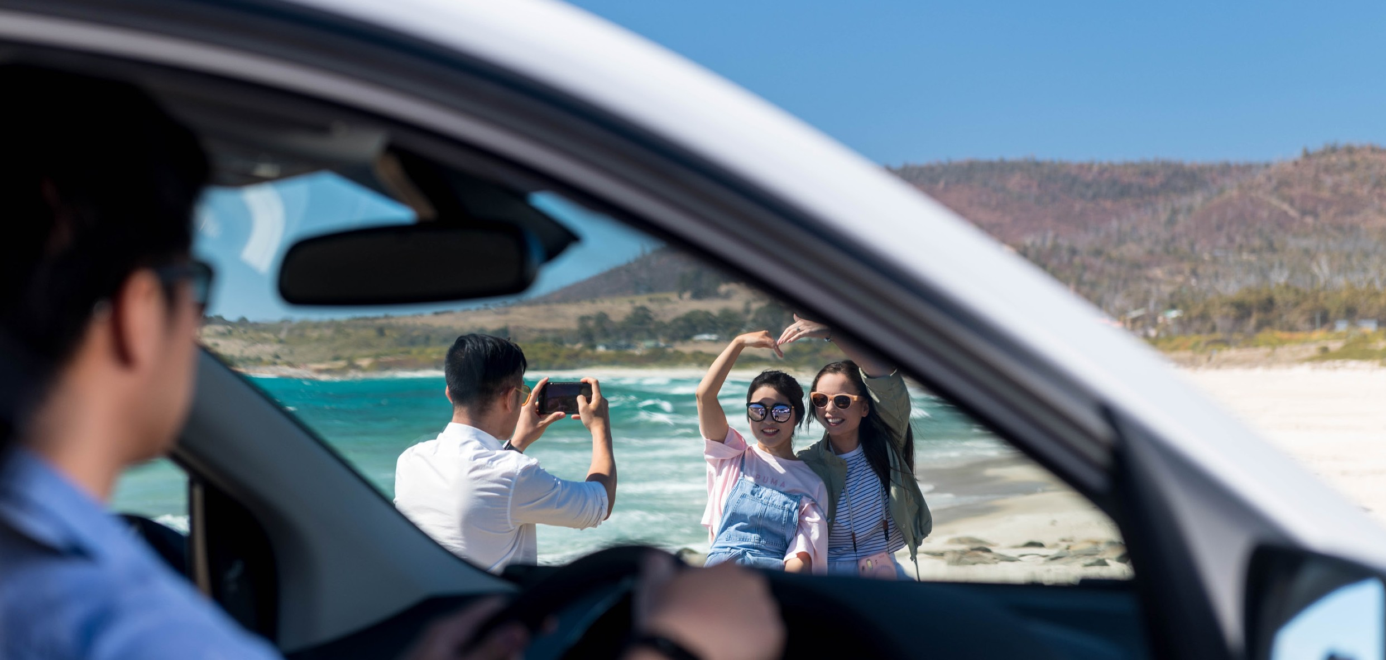

23

KEY THEME
IMPROVING SAFETY THROUGH VEHICLES AND TECHNOLOGY

Advances in vehicle design and technology are helping to prevent crashes from occurring and better protecting all road users in Tasmania. We are committing over
$3 million to support and encourage Tasmanians to drive safer vehicles.

Under the Safe System approach, we know that we will make mistakes – it is a part of being human. To achieve our vision of zero road trauma, we must take advantage of the latest vehicle and crash avoidance technologies and ensure that more Tasmanians are travelling in safer vehicles.
New vehicles are increasingly becoming safer with ongoing improvements in minimum safety standards. Modern vehicles provide superior occupant protection in crashes and are increasingly equipped with active collision avoidance technologies.
A challenge for Tasmania is that it has the oldest vehicle fleet in the country with an average age of 12.8 years. This means more time and resources must be expended maintaining the roadworthiness of Tasmania’s older vehicles. This means that many Tasmanians are not benefiting from the latest safety features.
Active collision avoidance technologies are now recognised in the ANCAP vehicle safety testing. These technologies alert the driver to potential hazards, give the driver more control in emergency situations and act autonomously to prevent
a collision. New features also help drivers to adhere to the speed limit, minimise blind spots, reduce distraction and monitor signs of driver fatigue.
We will continue to support ANCAP in its work, crash testing and publishing new vehicle safety ratings. ANCAP plays an important role in influencing manufacturers to build safer vehicles, while also informing consumer choices both online and at the point of sale.

The rate of fatal crashes per registered vehicle is four times higher for vehicles aged 15 years or older than for vehicles aged five years old or less.

Many Tasmanians purchase their vehicles second hand.
Like ANCAP, the Used Car Safety Ratings website helps consumers to choose the safest vehicle within their budget.
The majority of new cars are purchased by fleet buyers. We know that we can improve road safety by ensuring that fleet managers, both in government and the private sector, buy vehicles with the highest safety ratings.
Not only will this improve the safety of people who use the roads for work, it also introduces a greater number of safer vehicles into the second hand market.
Automating the driving task and collision avoidance technologies are in their infancy, but they are evolving rapidly and have enormous potential to reduce road trauma.

“Always choose the safest car available within your budget. Explore the Used Car Safety Ratings website to compare makes and models by price range. And if you have a newer car let your son or daughter borrow it. Don’t think about the extra insurance cost. Your children
will be far better protected in a crash.”
Ian Johnston Road Safety Expert, Tasmanian Road Safety Advisory Council

24

The image above shows the Toyota Hilux, Australia’s highest selling vehicle, undergoing ANCAP testing of its Autonomous Emergency Braking (AEB). AEB is a crash avoidance technology that enables the vehicle to constantly monitor the road environment and independently apply the brakes if it detects an oncoming collision with another vehicle, pedestrian or cyclist.
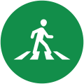These types of ‘safety assist’ technologies, which are becoming increasingly commonplace in new vehicles, have the potential to deliver significant road trauma reductions for both vehicle occupants and vulnerable road users.

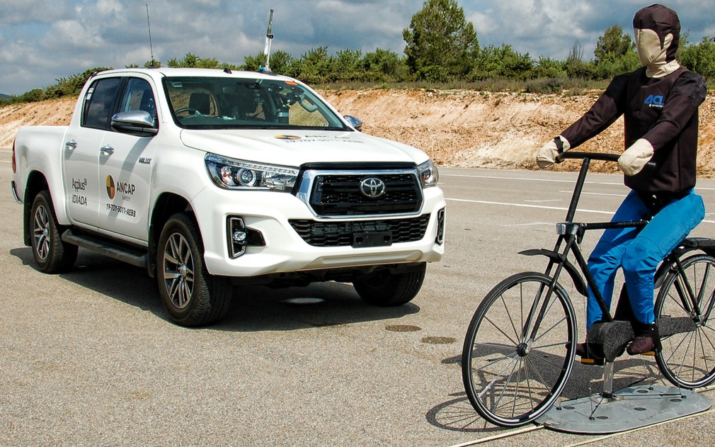
What we will do
Ensure that the vehicles on our roads are roadworthy
The Transport Safety and Investigation Unit will perform a range of important road safety roles, including public education on vehicle usage and public passenger vehicle
compliance and enforcement. We will develop a Light Vehicle Safety Strategy to improve road safety by ensuring all vehicles in use on our roads meet required safety standards.
Continue to support ANCAP
We will continue to provide funding to the Australasian New Car Assessment Program (ANCAP) and assist in the promotion of its work testing and advocating for the purchase of safer vehicles.

25

Assist young drivers to buy safer vehicles
Young drivers are one of the highest risk groups on our roads, yet they often drive older and less safe vehicles. We will investigate and implement ways of assisting young drivers to buy the safest vehicle they can afford.

Improve safety for workplace drivers
We will investigate opportunities to improve the safety of the large number of Tasmanians whose work involves driving on our roads.
This includes implementing higher standards for government fleets and encouraging the private sector to purchase safer vehicles.

Monitor developments in vehicle technology
We will monitor autonomous vehicle and crash avoidance readiness in Tasmania to make sure that our infrastructure, communication devices and laws are compatible with emerging technologies.

LOOKING AHEAD
TACKLING INATTENTION AND DISTRACTION

The community is becoming increasingly concerned about driver inattention and distraction, especially from mobile phone use. Although not a key theme, we recognise the need for action and are undertaking a number of programs and projects designed to reduce this problem and protect drivers and passengers in the event of a crash.

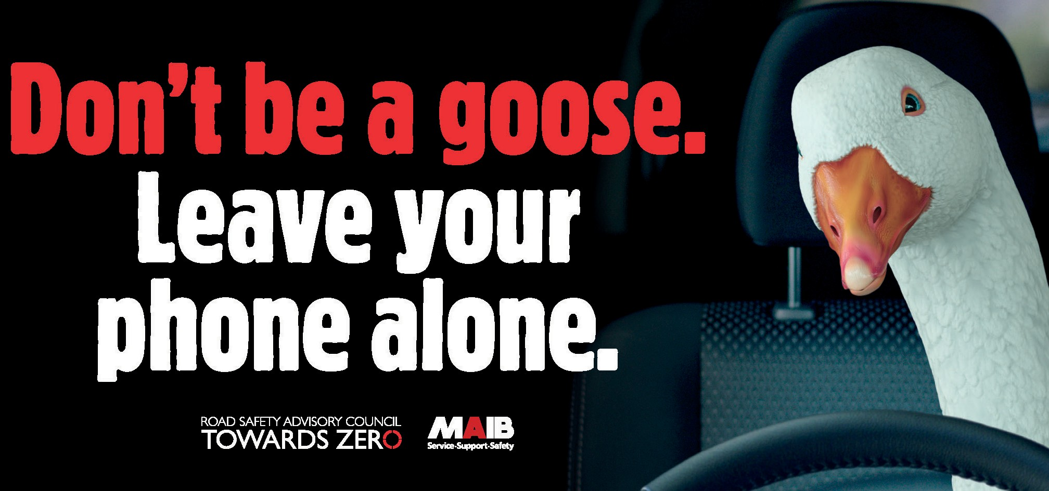Driving is a complex task and one that demands our full attention. However, keeping drivers’ minds on the job is easier said than done.
26
All drivers engage in distracting activities while they are driving. Changing a song, drinking a coffee, refereeing the kids in the backseat or checking your mobile phone – these are all activities that distract us and interfere with safe driving.
Distraction occurs when a driver, either willingly or unwillingly, engages in a secondary activity that interferes with performance of the primary task of driving the vehicle.
Distraction can be visual (taking your eyes off the road), physical (taking your hands off the steering wheel) or cognitive (taking your mind off the driving task), or a combination of these.
Addressing inattention and distraction is a challenge for authorities.
There are two main things we can do – try to stop the behaviour and reduce the harm if the behaviour causes a crash.
We try to reduce the incidence of distraction through public education and enforcement. Increasingly, new technologies are also helping to tackle the problem.
In addition, infrastructure safety improvements described under key themes in the Action Plan help alert the driver to focus on driving (audible line marking) and reduce the injuries sustained if a crash does occur (wire rope barrier).
Distraction affects driver performance and safety. It decreases our ability to control speed and following distance, makes it difficult to maintain our position on the road, reduces our awareness of surrounding traffic, events, traffic signals and signs, and makes our responses to hazards slower.

What we will do

Unmarked motorcycle enforcement
In 2019 Tasmania Police trialled the use of unmarked motorcycles in urban areas around the State to allow police to use lane filtering in traffic and increase the detection of mobile phone use.
The immediacy of detection, with drivers being caught in the act and the evidence recorded by a helmet mounted
camera, is a powerful deterrent to both the driver and other drivers in the vicinity. The use of unmarked motorcycles will be expanded to tackle distraction and inattention in urban areas.

Trial mobile phone use detection technology
New technologies are being developed all the time. We will trial new camera technologies that can detect mobile phone use to increase enforcement of inattention and to deter people from using their mobile phone while driving.

Mobile phone ban for L and P platers
Changes to the Graduated Licensing System (GLS) mean that all learner (L1 and L2) and provisional (P1 and P2) licence holders will be banned from any mobile phone use, including hands-free and speaker mode.
Young drivers have limited experience and need to devote their attention to driving. Removing distractions like mobile phones is a proven way to help reduce distractions and protect new drivers.

Continue to support the Rotary Youth Driver Awareness Program (RYDA)
The RYDA program will continue to make students aware of the significant responsibility of being a driver or passenger and help them to have an appropriate attitude when they’re in a vehicle.
The program promotes the importance of concentrating on the driving task and the dangers of distraction.

Develop inattention/distraction campaigns
Building on the success of the ‘Don’t be a goose - leave your phone alone’ campaign, we will continue to develop new inattention/distraction campaigns to educate the public about the dangers of driving distracted and using a mobile phone while driving.
As well as using television, radio, print and digital media channels, we will use signage and billboards to remind drivers when they are on the road and undertaking the driving task.

Infrastructure safety improvements
The majority of our serious injuries and deaths are due to lane departures resulting in head on and run-off road
crashes. Safety treatments such as audio tactile line marking (rumble strips) help to alert the motorist when they are straying off their path and get them back on track before a crash occurs. Signage can advise of the need for caution and to reduce speed.
Sealing road shoulders gives drivers more leeway to correct if they find themselves distracted and reduces the likelihood of loss of control. Installation of centre and side barriers and hazard removal will help to reduce the severity of crashes and keep vehicles from colliding with other vehicles, trees and other solid objects.
Under the themes of Making our Rural Roads Safer and Improving Safety in our Towns and Cities, we have allocated around $50 million over five years to install infrastructure safety improvements and, in doing so, will help to combat inattention and distraction.

Vehicle Technologies
We will encourage Tasmanians to buy the safest car they can afford. Safety features such as crumple zones and airbags reduce the severity of injury when a crash occurs.
Active safety assist technologies like biometric sensors, blind spot sensors, lane-keep technology and emergency braking help drivers to avoid crashes. The majority of crashes involve human error. Vehicle technologies will help to reduce both the incidence and severity of crashes.

ACT CANdrive trial
We are actively monitoring developments in automated vehicle technology which has the potential to remove the human error element on our roads.
More than 30 Canberra drivers are participating in a world first trial to improve safety in automated vehicles using Seeing Machines’ driver monitoring technology. Vehicle automation is progressing rapidly and promises many benefits for road users.
The increase of automation in cars promises increased levels of safety, but a key identified risk is driver inattention. The ACT Government CANdrive automated vehicle trial has been designed to collect driver engagement data in both automated and non–automated driving conditions.
The project has helped Seeing Machines develop and validate its algorithms related to driver engagement and has demonstrated that driver monitoring can help mitigate the risk of driver inattention.

27

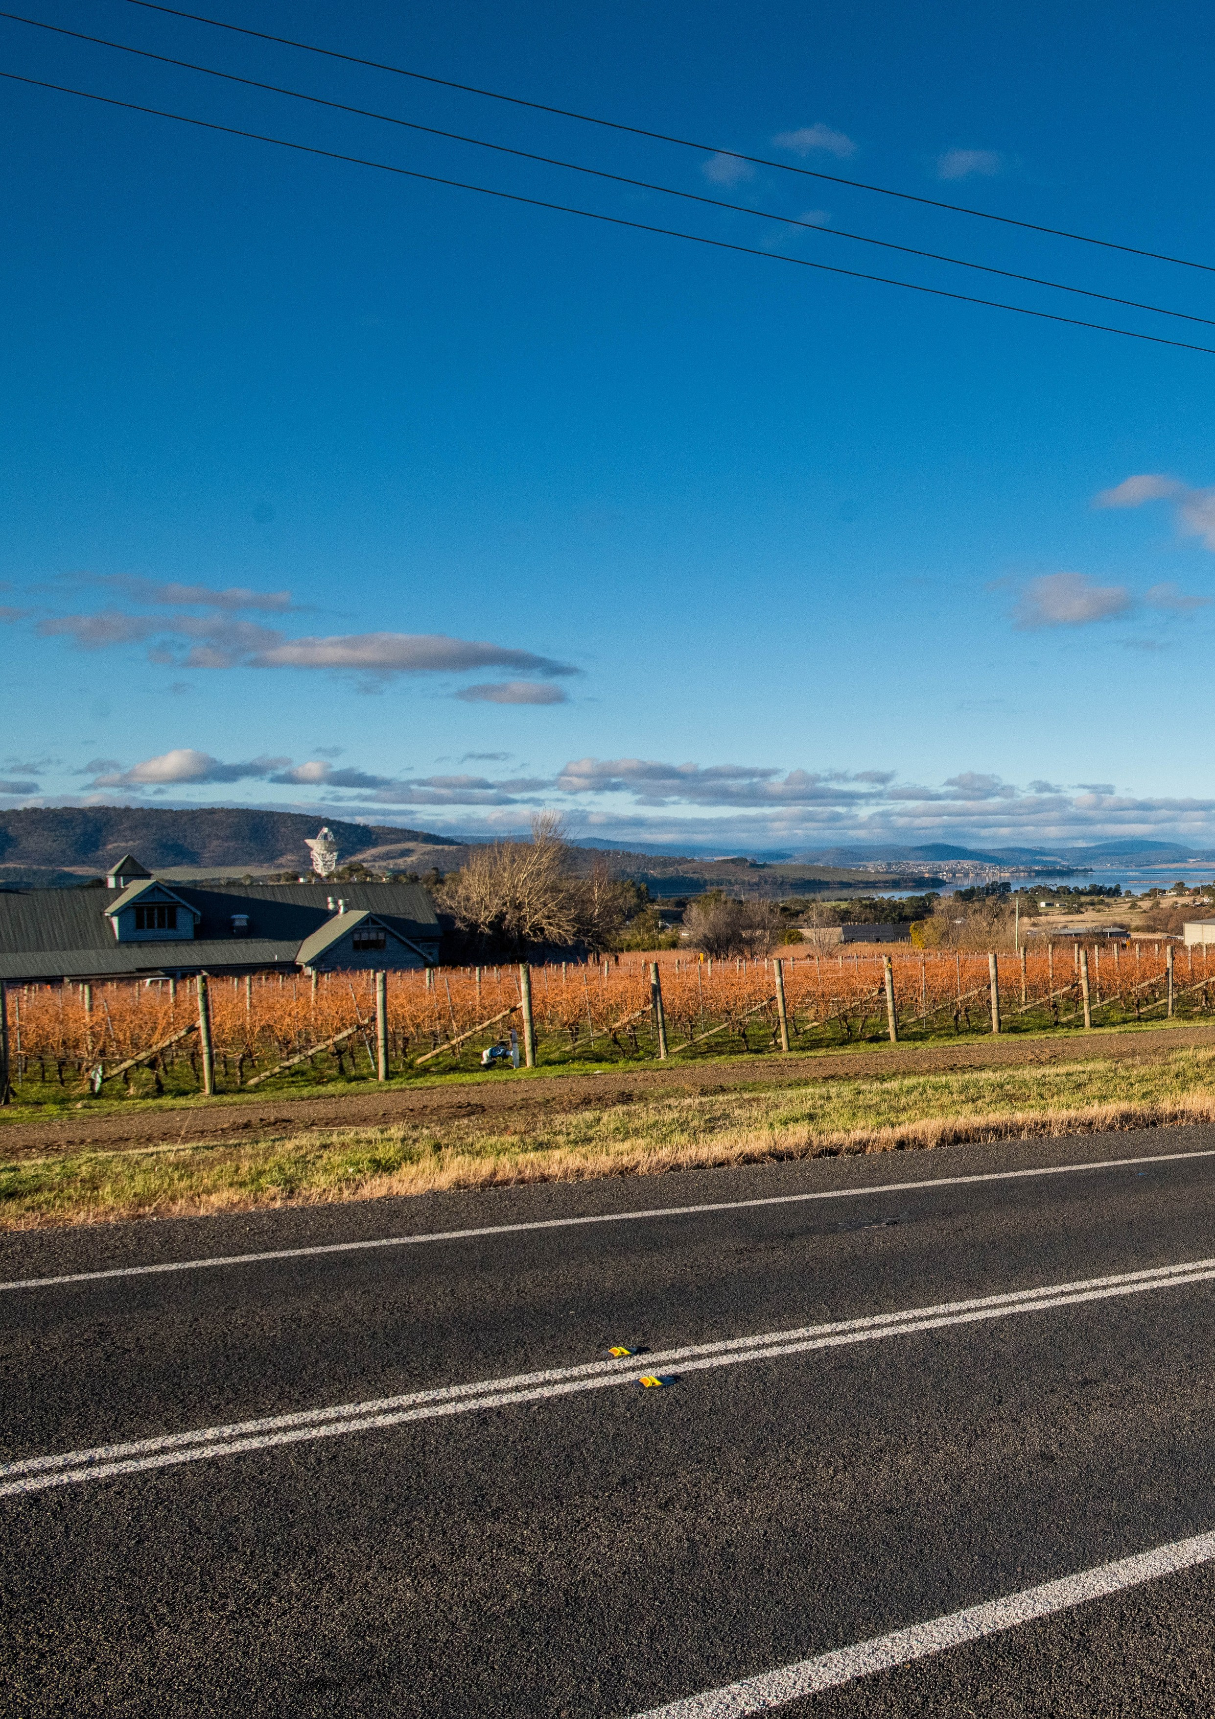

Copyright notice and disclaimer
Copyright in this publication is owned by the Crown in Right of Tasmania, represented by the Department of State Growth.
Information in this publication is intended for general information only and does not constitute professional advice and should not be relied upon as such. No representation or warranty is made as to the accuracy, reliability
or completeness of any information in this publication. Readers should make their own enquiries and seek independent professional advice before acting on or relying upon any of the information provided.
The Crown, its officers, employees and agents do not accept liability however arising, including liability for
negligence, for any loss resulting from the use of or reliance upon information in this publication. Images used within this publication remain the property of the copyright holder.
Images courtesy of the Tasmanian Government, Tourism Tasmania, Stuart Gibson, Alastair Bett, Formula Motorsport Limited, Break O’Day Council, Circular Head Council, Europcar, and ANCAP.
© State of Tasmania October 2019

28

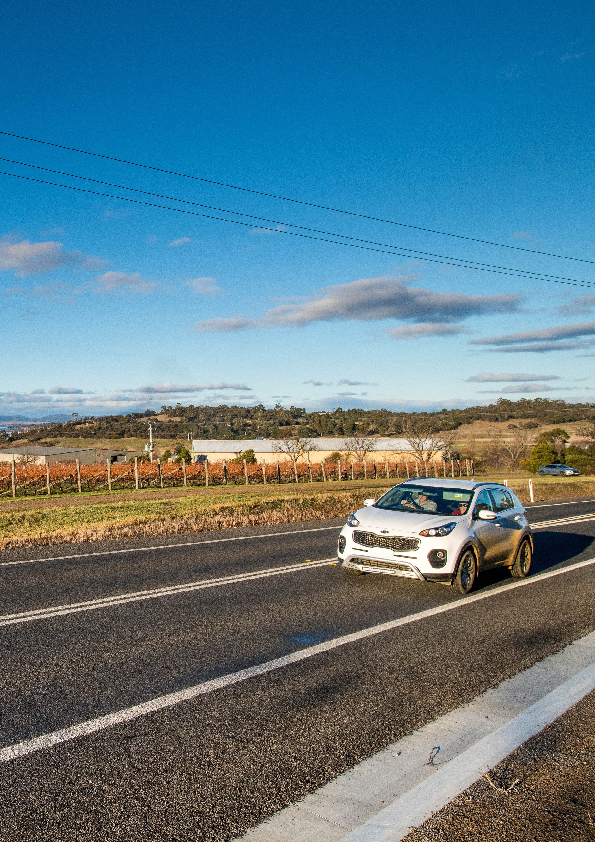

29

Department of State Growth Road Safety Branch
Towards Zero Action Plan 2020-2024
GPO Box 536
Hobart TAS 7001 Australia Phone: 1300 135 513
Email: rsac@stategrowth.tas.gov.au Web: www.towardszero.tas.gov.au

© State of Tasmania October 2019

