Fewer than 200 serious injuries and deaths on our roads by 2026

Towards Zero Tasmanian Road Safety Strategy 2017–2026

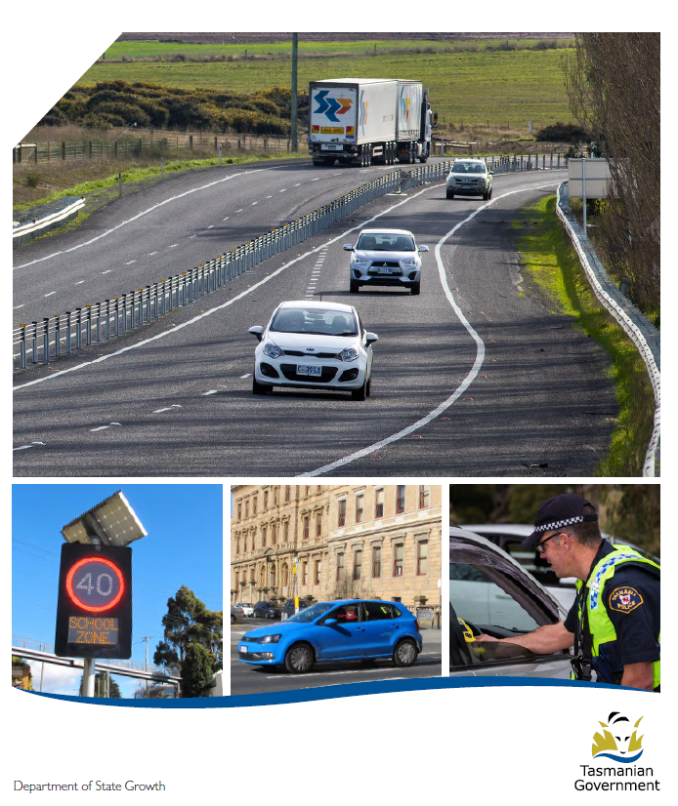

Quarterly Progress Report to RSAC
as at 30 September 2019

Progress on meeting Towards Zero Strategy targets
The key interim target for the Towards Zero – Tasmanian Road Safety Strategy 2017-2026 (Towards Zero Strategy) is to reduce the number of annual serious injuries and deaths on Tasmanian roads to fewer than 200 by 2026. This is an ambitious target of 100 fewer serious casualties per year than for the period 2012-2016 (annual average) and will move us towards the long-term goal of zero serious casualties on Tasmanian roads.
Serious Casualties
The number of serious casualties in 2018 was 314, compared to 301 in 2017, a 4.3 per cent increase. The 2018 figure of 314 is a 1.9 per cent increase on the five year serious casualty average of 308 (2013-2017).

Fatalities
In 2018, there were 33 fatalities on Tasmanian roads which is one more than the number recorded in 2017. The figure of 33 fatalities in 2018 is a 2.4 per cent decrease on the five year fatalities average of 33.8 (2013-2017).
2019 YTD
There have been 207 serious casualties (25 fatalities and 182 serious injuries) to 30 September 2019, a decrease of 4.6 per cent on the same period last year of 216 serious casualties (26 fatalities and 190 serious injuries) and a decrease of 7.7 per cent on the five year average of 224 serious casualties.
Serious Casualties Tasmania – Annual Count, Percentage Split by Quarter and Towards Zero Target

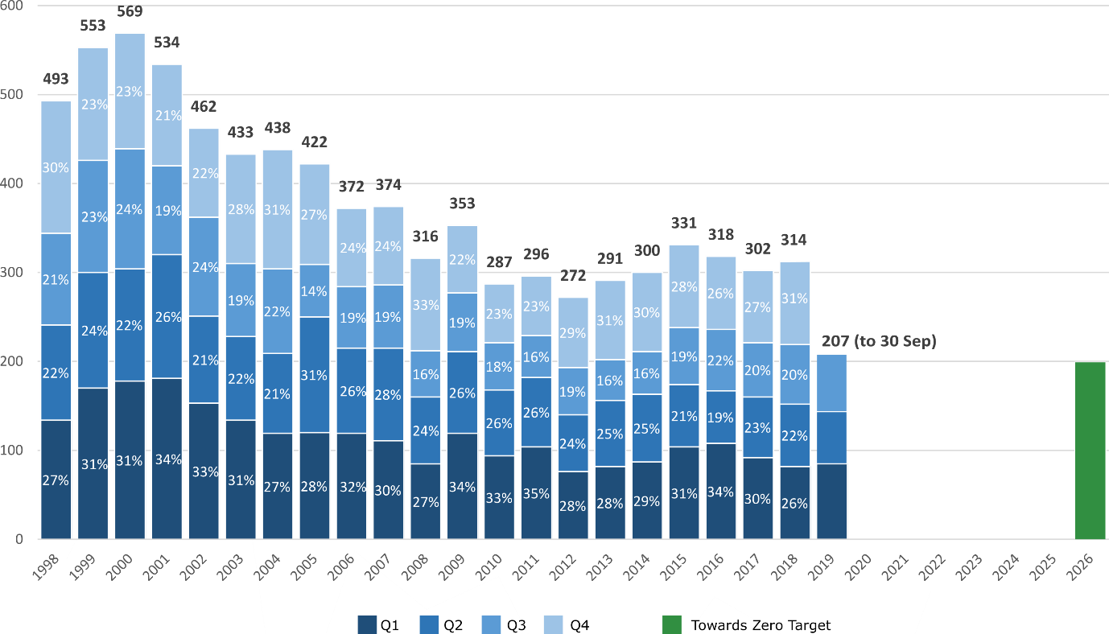
Annual fatalities – Rate per 100,000 population
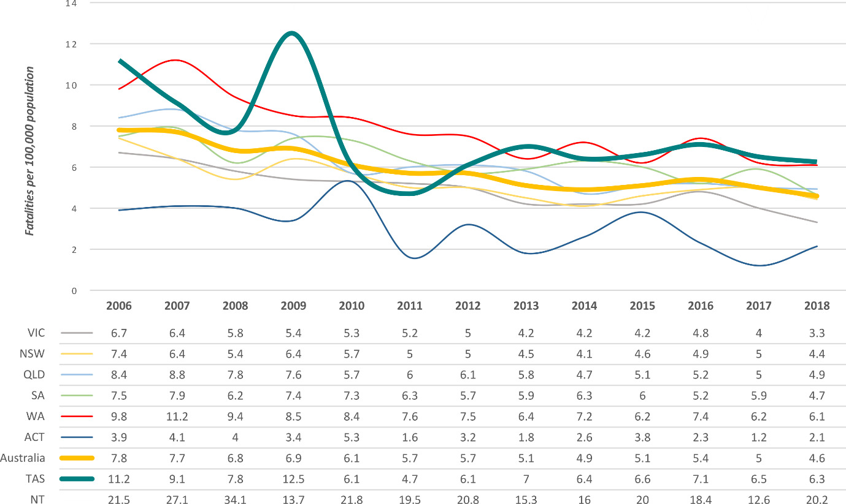
Note: NT omitted from chart for clarity purposes.

Progress on meeting MAIB targets

Motor Accidents Insurance Board (MAIB) injury statistics show the number of fatalities and the level of claims for serious injuries on our roads.
Various claim reduction targets are specified in the Memorandum of Understanding between the Department of State Growth (State Growth) and the MAIB. Progress against high level targets is shown below, expressed as 12 month moving totals.

Fatalities – 12 Month Rolling Total

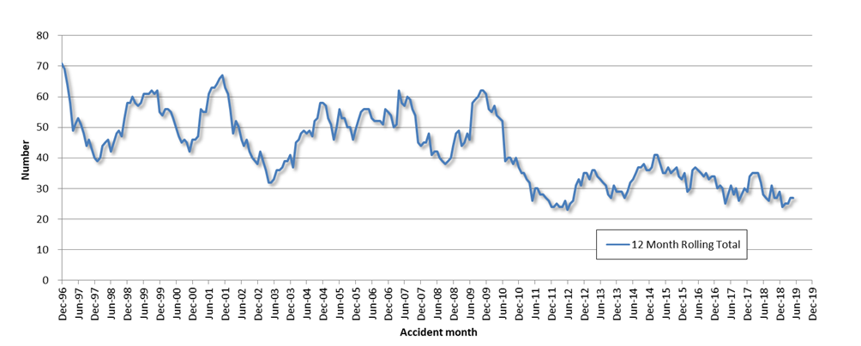

Total Serious Claims – 12 Month Rolling Total

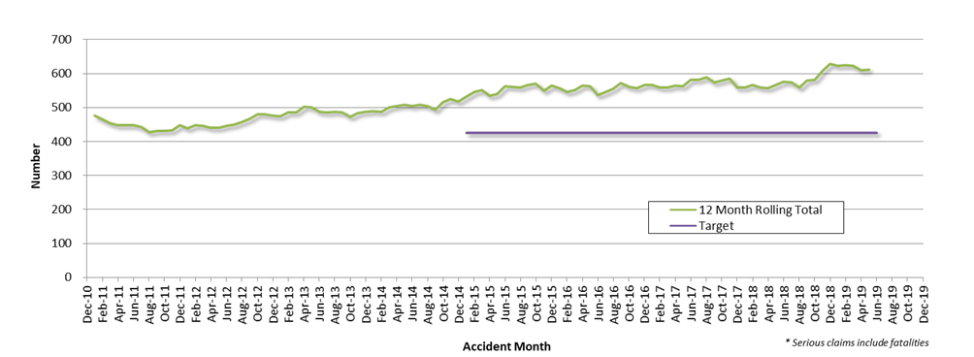
Statistics
Serious Casualties by Quarter by Age Group – 12 period moving average

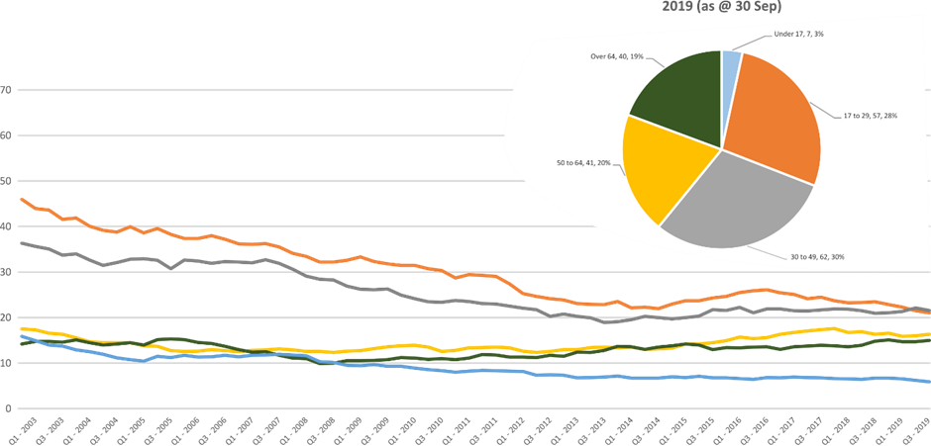

Serious Casualties by Quarter by Sex – 12 period moving average

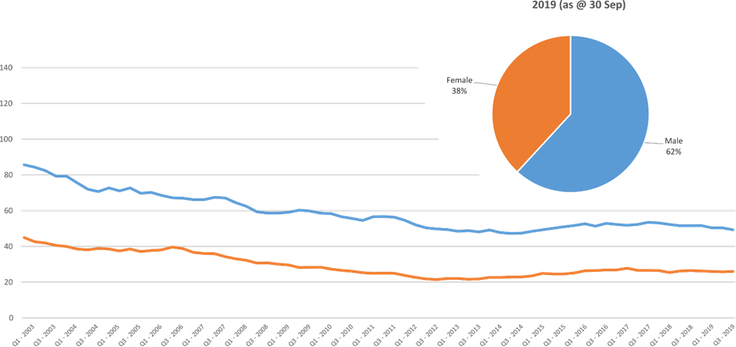

Serious Casualties by Quarter by Road User Type – 12 period moving average

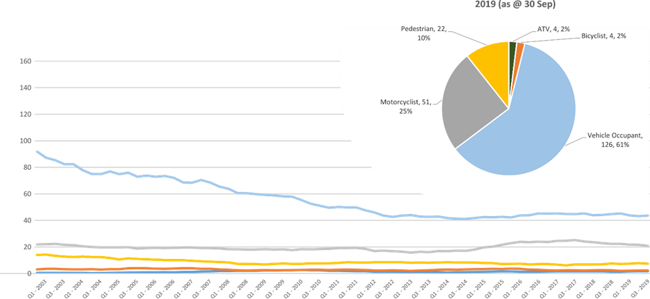

Serious Casualties by Quarter by Speed Zone – 12 period moving average

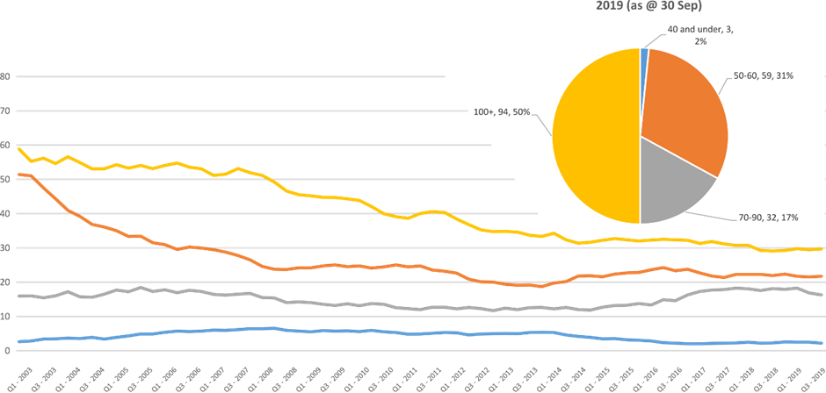
Pie chart excludes serious casualties where speed zone is recorded as ‘not known’

Serious Casualties by Quarter by Crash Type (DCA) – 12 period moving average

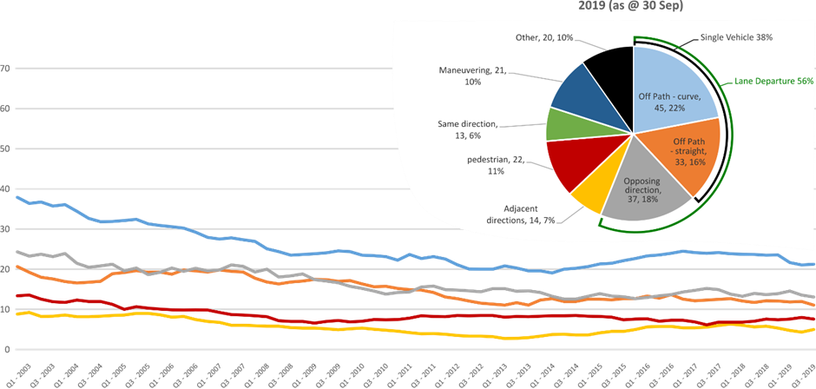
Other includes crash types: on-path (2%) & overtaking (2%).

Serious Casualties by Quarter by Urban/Non-Urban – 12 period moving average

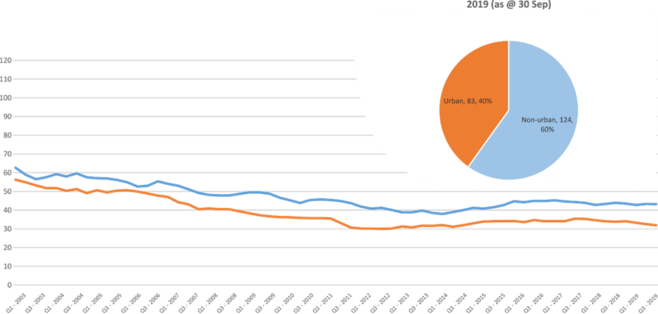
Based on the Australian Bureau of Statistics’ ‘significant urban area’ geographic definition.

Serious Casualty locations to 30 September 2019 (Black = Fatality, Red = Serious Injury)
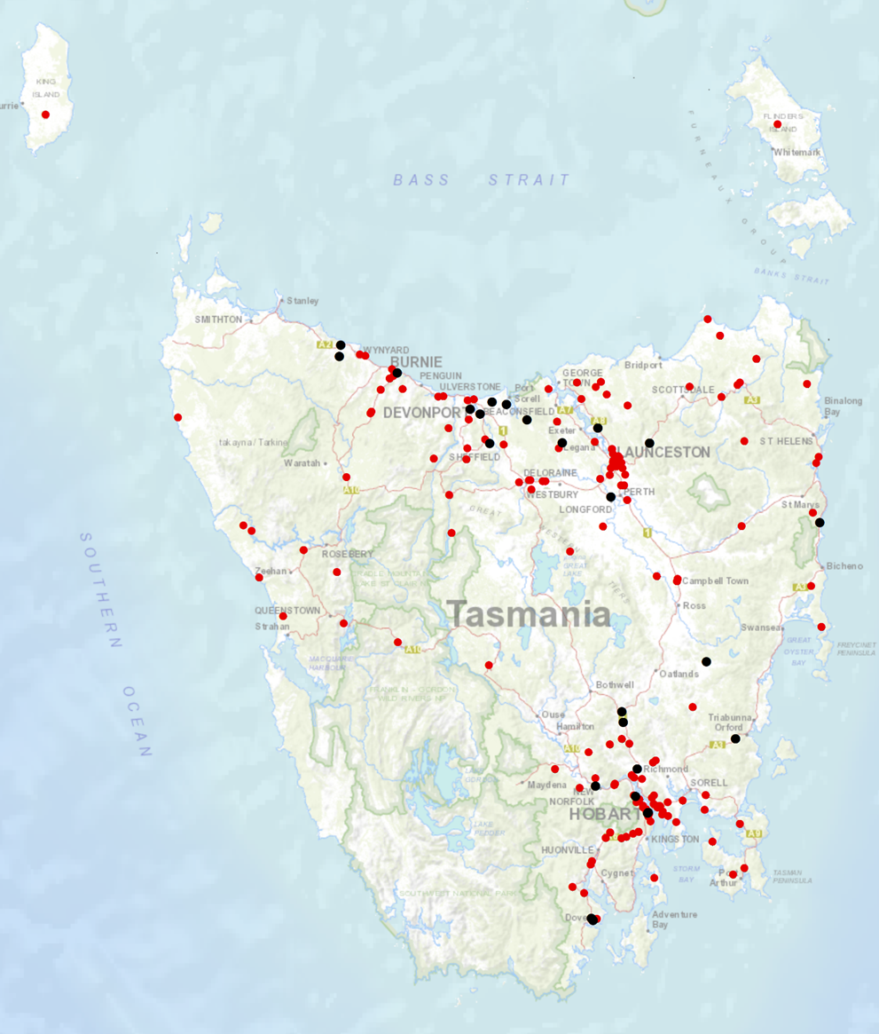

Priority Actions 2017-2019

Safe Road Users

- Improve the Graduated Licensing System to reduce serious casualties for young road users (17-25 year olds).
- Introduce safety initiatives to reduce motorcyclist serious casualties.
- Promote safer road user behaviour through education and enforcement.

Safe Roads and Roadsides
-
- Reduce run-off-road and head-on crashes through improved infrastructure.
- Reduce the severity of intersection crashes through improved infrastructure treatments.
- Embrace safe system thinking in road design.
- Reduce serious casualties through improved delineation such as line marking.

Safe Vehicles

- Improve the star rating of Tasmania’s vehicle fleet to include vehicles with better safety features.
- Increase the number of motorcycles with ABS.

Safe Speeds

- Introduce more appropriate speed limits to reduce serious casualties.
- Increase enforcement through technology to reduce speed related serious casualty crashes.

Progress on projects
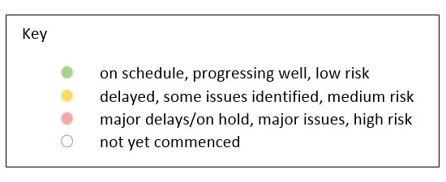
Action Plan 2017-2019
Safe Road Users
Project | Responsibility | Status |  |  | Milestones achieved | Milestones planned |  |  |  |  | Comments |  |  |  | Budget  Life of project  $ |  |  |  |  | YTD  2019/20  $
GLS Implementation  Following on from GLS Review | Road Safety, State Growth |  |  |  | On 5 May 2019 GLS changes were announced. Following this, a pre-awareness campaign commenced including a television commercial and billboards in public carparks – known as ‘strings’.  On 5 July 2019, the Request for Proposal (RFP) closed that sought a business to create a digital platform and public education campaign to support the changes to the GLS.  The20 was engaged to develop the next pre-awareness campaign to support learner and supervisory drivers getting more on-road hours.  The Project Manager has been engaging with community stakeholders (TasCOSS and YNOT) to develop an engagement framework and methodology for consulting with young people on their views about getting a driver licence in Tasmania.  This will form part of the evaluation package.  In August 2019, the new Minister for Infrastructure, the Hon. Michael Ferguson was briefed on the GLS changes. | The Minister will launch the ‘Quality Time’ pre-awareness campaign in late October 2019. This was developed by The20 in consultation with the project team and encourages more on-road supervised driving experience. Printed collateral will be circulated to Service Tasmania, schools and key stakeholders to support the campaign.  The RFP process is expected to be finalised and a contract awarded by December 2019.  A Request for Quotation is being prepared to seek a qualified institution to undertake the evaluation package. This will include: stakeholder consultation framework; pre and post implementation surveys; and intermediate and final outcomes evaluation.  An institution is expected to be contracted by December 2019, to begin pre-implementation work by early 2020.  This work will help to inform project implementation activities including the development of the digital platform and other GLS resources. |  |  |  |  | The Project Team is closely monitoring all stakeholder contact following the public announcement, including Ministerial correspondence and direct emails to the Project. A large proportion of stakeholder contact has been supportive of the GLS changes.  The Project Team will continue to work with the Minister’s Office to keep them informed on implementation progress and opportunities for media activities in the lead up to the GLS changes. |  |  |  | 3 000 000 |  |  |  |  | 75 950
New motorcycle training and assessment program | Registration & Licensing, State Growth |  |  |  | The progressive roll out of the new Motorcycle and Assessment Program has concluded with the commencement of the Program in the North on 8 January 2018.  A transitional training program has been implemented in all regions.  The new training film demonstrating the safety benefits of the new Program and the top 5 motorcycle crashes has been developed and released.  A communication strategy has been implemented to ensure all existing motorcycle learner licence holders affected by the transitional arrangements are notified. | Finalise the development of the auditing and compliance monitoring framework including the resourcing requirements, structure and governance.  Commence scoping the Longitudinal Study that will look to evaluate the new Program and any potential linkages to crash statistics in the future.  Implementation of the electronic results portal has been trialled and was released to the external provider for a progressive implementation from March 2019. The results portal interacts directly with the Motor Registry System to enable instant result reporting for licencing upgrades and provides real time confirmation of licensing eligibility. |  |  |  |  | Implementation Project complete.  The Grant Deed established to fund the transitional arrangements is ongoing until end 2019.  Demand for the new motorcycle training and assessment program is significantly lower than the previous training regime. As at the end of September 2019 in the North and South were around 70%, however are significantly less in the North West at 37%, compared to previous years.  A review of the financial sustainability of the existing business model has been finalised by an independent financial advisor. The Department has analysed the findings of this report and is currently working with the external provider to finalise the financial model developed to support the delivery of the program during the low demand. |  |  |  | 810 000 |  |  |  |  | 714 713  (Life of project)
Towards Zero Enforcement Project - Increased enforcement of high-risk behaviours | Tasmania Police |  |  |  | Continued to implement the Road Safety Strategy 2019-21  Development of Road Safety Project Plan | Deliver In-Vehicle and In-Motion Speed Enforcement Demonstration (Sensys-Gatso Australia).
Promote safe behaviours through media campaigns –  Mobile phones | EESC,  Road Safety, State Growth |  |  |  | Concept approved. To be launched in conjunction with the Action Plan in December. | Campaign to discourage mobile phone use while driving. |  |  |  |  | Funding approved by EESC. |  |  |  | MAIB funding  $100 000 (excluding media buy)
Promote safe behaviours through media campaigns – learner drivers | Road Safety, State Growth |  |  |  | Launched by Minister Ferguson on 23 October. | Campaign to encourage getting as much driving practice before getting a licence. |  |  |  |  | Funding approved by RSAC. |  |  |  | RSAC funding $110 000 production.  MAIB funding $14 000 media buy
MAIP Implementation | Road Safety, State Growth |  |  |  |  | Drafting instructions to OPC.  Interim contracts to providers, procurement action completed. |  |  |  |  | Interim contracts with Crown Solicitor.  Most policy decisions approved by RUS. |  |  |  | State Growth funded |  |  |  |  | 52 160
Tourist road safety campaign – Phase 2 (2017-2019) | Road Safety, State Growth |  |  |  | New look and feel developed and updated material in market from November 2018.  New Z-card map produced as the result of feedback from stakeholders and tourists.  Animated outdoor electronic signs operational at Hobart and Launceston Airports. |  |  |  |  |  | Two new animated films in production to be run in Hobart Airport and through stakeholder networks.  New materials produced for ‘new to Tasmania’ audiences, launch date TBC.  Ongoing engagement with stakeholders including Local Government, industry associations and community groups.  Strategic workshop on visiting motorcyclists being planned. |  |  |  | 650 000 |  |  |  |  | 62 858
Community Road Safety Grants Program | Road Safety, State Growth |  |  |  | The 2019-20 CRSG Program attracted 23 applications. The Funding Assessment Panel recommend 12 projects totalling $198 791. Successful projects included the purchase of Variable Message Boards, child restraint checks and funding to improve the road safety component of the Driving For Jobs program. | Workshops for potential CRSG applicants to assist them to develop project proposals will be planned towards the end of 2019 in preparation for the 2020-21 funding round. |  |  |  |  | Program improvements have been made for the application process and will be reviewed prior to planning next round of CRSG. |  |  |  | 200 000  p/a |  |  |  |  | 167 263
Learner Driver Mentor Program and Driver Mentoring Tasmania | Road Safety, State Growth |  |  |  | Sixteen organisations were successful for funding in the 2019-20 LDMP funding round totalling $756 424. Driver Mentoring Tasmania has been allocated $145 120. $100 000 has been allocated for the New Vehicle Replacement Program will continue to ensure the LDMP fleet has a minimum 4-star ANCAP safety rating. | State Growth and DMT will launch a mentor recruitment campaign around September to encourage more mentors to join LDMPs. |  |  |  |  | The Department continues to work with programs and the DMT coordinator to implement business improvements recommended in the 2017 evaluation report. |  |  |  | 500 000  p/a  702,000 approved for 2017/18. |  |  |  |  | 1 025 065
RYDA program | Road Safety, State Growth |  |  |  | Funding of $100 000 has been provided to Rotary to deliver the RYDA program in 2019-20.  RYDA was held from 26 August to 6 September for 2019. |  |  |  |  |  | Community Road Safety will attend RYDA and work with Rotary to identify opportunities for program improvements. |  |  |  | 100 000 |  |  |  |  | 100 000
RACT and Bicycle Network | Road Safety, State Growth |  |  |  | The RACT and Bicycle Network have been provided with $100 000 and $90 000 per annum respectively to deliver a suite of road safety programs and for cycling safety in schools. |  |  |  |  |  |  |  |  |  | 190 000 |  |  |  |  | 190 000
Safety around Schools | Road Safety, State Growth |  |  |  | The Love40 campaign was launched on Friday 1 February 2019 and ran again at the beginning of Term 2.  The campaign started the week before school returned and included TV and radio advertisement, digital video, print media, bus backs, a mobile billboard and a trial of Love40 bumper stickers provided to select schools.  A short survey was sent to schools that received bumper stickers. A small number of responses indicated positive support for the Love 40 campaign. | The campaign will be repeated at the start of each term throughout 2019. |  |  |  |  | The campaign encourages drivers to slow down in school zones and around school buses.  Iterations of the campaign will continue for three calendar years and planning for 2020 will begin towards the end of 2019. |  |  |  | $300 000 p.a.  2019 - 2021 |  |  |  |  | 0
Reduced speeds around emergency vehicles | Road Safety, State Growth |  |  |  | Key milestones achieved:  - a survey of emergency service personnel on the risks associated with working by roadsides is complete – findings have been circulated to key stakeholders.  - key stakeholders reviewed and approved the creative concept for the campaign – preparation of the campaign creative continues, which went live on 29 September 2019  - the Road Rules 2019 (including this new road rule) have been approved by Cabinet and ExCo, and will be tabled in Parliament in November 2019  - the Minister has approved an additional $100 000 from the Road Safety Levy to continue to promote the new rule/campaign, and to complete an evaluation, in 2020. This brings the total budget to $250 000. | Key remaining milestones:  - coordinate launch of new road rule in late November 2019 with Minister and emergency services  - prepare bus backs and bill boards to promote the new rule from 1 December 2019 ($30 000 of new budget)  - promote the new rule again in February 2020 using radio, TV and press ($15 000 of new budget)  commence post-implementation evaluation, including both a campaign evaluation and road rule evaluation ($55,000 of new budget). |  |  |  |  | Stage One of the evaluation survey (2019) was funded through the Road Safety Levy, discretionary activities fund. Funding for Stage Two (2020) of the evaluation has been approved for as part of this project budget. |  |  |  | $250 000 |  |  |  |  | 67 869
Safe Roads and Roadsides
Project | Responsibility | Status | Milestones achieved |  |  | Milestones planned |  |  | Comments |  |  |  |  | Budget  Life of project  $ |  |  | YTD  2018/19  $
Capacity Building Strategy and Action plan | Road Safety, State Growth |  | In March 2019, RSAC endorsed the funding request of $50 000 to engage a consultant to develop a capacity building strategy to support the next iteration of the Action Plan for 2020-24.  In May 2019, a consultant was engaged to undertake the capacity review and develop an action plan.  From June to July 2019, a range of interviews with key influential road safety stakeholders were undertaken. |  |  | The consultant is expected to deliver a capacity building review report and action plan by November 2019.  A presentation on the report and action plan will be provided to RSAC at the November 2019 meeting.  Following this, the Road Safety Branch will consider the recommendations of the capacity review and implementation to support the Action Plan 2020-2024. |  |  | The review will inform the work of the Road Safety Branch to build capacity to deliver on priorities identified in the Action Plan 2020-2024. This will include avenues to increase knowledge and technical skills in Tasmania. |  |  |  |  | 50 000 |  |  | No expenditure under 2019-20 financial year.
Vulnerable Road User Program (VRUP) | Road Safety,  State Growth |  | On 4 March 2019 applications closed for the VRUP 2019-20 funding round.  20 applications were received. The VRUP Assessment Committee recommended 14 for funding equating to $523 360.  SOC approved successful applications in April. |  |  | Advice provided to the Minister on the outcome of the 2019-20 funding round with a supporting media release.  Following this, local councils were advised of whether or not their application was successful.  Grant deeds are being signed with councils.  The Road Safety Branch continues to administer the program, which involves monitoring projects, providing support to council and disbursing funds for competed works. |  |  | The future funding allocation for VRUP post 2019-20 is being considered as part of the redevelopment of the next Action Plan for 2020-24. |  |  |  |  | 750 000  (allocated to the 2018-19 funding round) |  |  | N/A  Projects are paid on completion. Year to date figure is not accurate reflection of project value as payment occurs irregularly.
Infrastructure Risk Rating (IRR) Analysis | Road Safety,  State Growth |  | IRR analysis tool has been developed. The Road Safety Branch is procuring speed profile data to integrate into the IRR analysis tool. |  |  | Implementation of Speed profiles into risk analysis of the IRR analysis tool. |  |  | Speed profile data may also inform other initiatives other than just infrastructure treatments. |  |  |  |  | 80 000 |  |  |  | 0
2018-19 pavement marking maintenance program – local government | State Roads, State Growth |  | A significant proportion of the 2018-19 shoulder sealing program has been completed. A small amount of funding remains. |  |  | Support local government to optimise the safety performance of road markings (such as through the use of long life, highly visible materials). |  |  | Funding endorsed by RSAC at August 2018 meeting. Additional funding subsequently approved by Minister. Includes up to $90 000 for school crossing pavement marking. |  |  |  |  | 770 000 |  |  |  | 0
2018-19 Shoulder sealing program | State Roads, State Growth |  | A small proportion of shoulder sealing projects has progressed. The remainder of projects will continue to be implemented throughout 2019/20. |  |  | Program of shoulder sealing road safety infrastructure improvements to be undertaken.  Priority sections of key routes to be targeted.  Works expected to continue into 2019-20. |  |  | Funding endorsed by RSAC at August 2018 meeting.  Additional funding of $2 million endorsed by RSAC at its March 2019 meeting. Funding request to be approved by Minister. |  |  |  |  | 9 million |  |  |  | 62 496
School Electronic Speed Limit Signs –replacement | State Roads, State Growth |  |  |  |  | Scope and specification of replacement program to be developed.  Phased replacement of existing signs. |  |  | As noted at the RSAC meeting of 20 August 2019 this project will be managed and funded by the State Roads Division of State Growth. The $100 000 previously endorsed by RSAC for preliminary scoping and design of the replacement program for school electronic speed limit signs is no longer required. |  |  |  |  | 0 |  |  |  | 5 967
Safe Vehicles
Project | Responsibility | Status | Milestones achieved |  |  |  | Milestones planned |  |  |  |  | Comments |  |  | Budget  Life of project  $ |  |  |  |  |  | YTD
Government Business Enterprise (GBE) and State Owned Company (SOC) Fleet Review | Road Safety, State Growth |  | Project planning and scoping complete.  Initial desktop analysis of fleet structure complete. Policy options and recommendations drafted.  Engaged with GBE and SOC fleet managers in partnership with Treasury. |  |  |  | Analysis of findings of GBE/SOC fleet feedback.  Policy paper to be finalised. |  |  |  |  | Consideration will be given to this body of work in respect of priorities under the new Action Plan 2020-2024. |  |  | 0 |  |  |  |  |  | NA
Promote vehicle fleet safety standards for commercial fleets | Road Safety, State Growth |  | Road Safety Branch attended the LGAT Conference in July 2018 and promoted Government policy and vehicle safety to attendees.  Road Safety Branch supported the National Road Safety Partnership (NRSPP) to present on the vehicle as a workplace at the 2018 WorkSafe Conference. |  |  |  | Continued collaboration with NRSPP and investigation of opportunities to further promote vehicle fleet safety in the commercial sector. |  |  |  |  | Consideration will be given to this body of work in respect of priorities under the new Action Plan 2020-2024. |  |  | 0 |  |  |  |  |  | NA
ANCAP support | Road Safety, State Growth |  |  |  |  |  | An ANCAP kiosk is to be provided to Motors Pty Ltd on a trial basis. The kiosk will house an I-pad with the ANCAP app installed and will be available for buyers to browse and inform their purchases. The kiosk will be co-branded between the RACT, Tasmanian Government and ANCAP. |  |  |  |  |  |  |  | 12 000 p/a |  |  |  |  |  | 12 254
MOTOCAP | Road Safety,  State Growth |  | The MOTOCAP website launched in September 2018. The Chair of RSAC released a media statement supporting and promoting the website.  A Road Safety Branch representative attended the March 2019 meeting at Deakin University crash test lab in Geelong, VIC.  A demonstration was given of the crash test equipment. Discussion was also had on stakeholder engagement and how to promote the website further. |  |  |  | The website is updated as additional safety ratings for motorcycle clothing are published.  The current contract between State Growth and MOTOCAP expires on 30 June 2020. The next 12 month fee is $8 200.  The Road Safety Branch will continue to actively participate in the group and execute another agreement in the coming months.  MOTOCAP will soon be looking to engage a company to develop a stakeholder and engagement plan. |  |  |  |  | MOTOCAP aims to test 10 per cent of the motorcycle protective clothing market and star rate them on protection and comfort.  Deakin University is the current contractor testing and rating the clothing. |  |  | 8 200 |  |  |  |  |  | 8 200
Safe Speeds
Project | Responsibility | Status |  | Milestones achieved |  |  |  | Milestones planned |  |  |  |  | Comments |  |  | Budget  Life of project  $ |  |  |  |  |  | YTD  $
Development of speed limit setting guidelines | Road Safety, State Growth
Assessment of speed limits on 100km/h roads | Road Safety, State Roads, State Growth
Towards Zero Enforcement Project - Review of point to point (P2P) speed cameras on high risk rural roads | Tasmania Police |  |  | Mobile P2P trial design complete. One provider – Tess Solutions Australia. Trial will be performed in urban and rural environments. |  |  |  | Receipt and acceptance of demonstration report.  Summary of demonstration and findings to be presented to ASEP Steering Committee (date TBC) by the provider and to RSAC in November by Project Manager. |  |  |  |  | Demonstration will inform Stage One of the Automated Speed Enforcement Project. |  |  | 132 000  To review 5 projects |  |  |  |  |  | 32 500
Automated Speed Enforcement Project | Road Safety, State Growth / Tasmania Police |  |  | Consultants have been appointed and contracts have been finalised.  Independent research is underway to inform the expansion of ASE in Tasmania.  First progress report submitted by consultants. |  |  |  | Consultants to deliver a draft literature review on 25 October 2019.  Presentation to RSAC on 19 November 2019. |  |  |  |  |  |  |  | Funded by Road Safety Branch
Reducing Urban Arterial Speed Limits in Tasmania from 60km/h to 50km/h. | Road Safety State Growth |  |  | Project planning and scoping completed. |  |  |  |  |  |  |  |  | Remaining roads are low volume (aside from urban arterials) and may have less community support.  Road safety benefit not immediate, but would be long term.  On hold as not a priority project, but will be progressed as a demonstration of appropriate speeds. |  |  | TBC
Speed Moderation Strategy | Road Safety, State Growth

Other
Project | Responsibility | Status | Milestones achieved | Milestones planned | Comments | Budget  Life of project  $ | YTD  $
RSAC and Towards Zero Strategy support | Road Safety, State Growth |  | Funding for Manager RSAC Secretariat, Chair and Expert sitting fees and operation of RSAC.  Funding to support development and implementation of Strategy and supporting Action Plans. |  |  | Up to 400 000  p/a | 46 499
MAIP Transitional arrangements | Registration & Licensing, State Growth |  | Support for fee waiver. |  |  | 3 300 000 | 2 399 800  Fee Waiver  2 451 959  (Life of project)
Discretionary Activities Fund | Road Safety, State Growth |  | Activities include:  Commissioner for Children and Young People event engagement  Development of the Action Plan 2020-24  Emergency Vehicles Survey Research  Grant Delivery Support |  |  | 250 000 | 26 563

Funding

Road Safety Levy Overview
As at 30 September 2019
2019/20 Financial Year
Opening balance as at 1 July 2019 |  | $19 628 925
Revenue 2018/19 | Forecast (ytd) | Actual (ytd)
Road safety levy collected | $3 500 219 | $3 915 060
Funds available for distribution | $900 219 | $1 315 060
Total funds available for distribution | $20 529 144 | $20 943 985
Expenditure |  | Actual (ytd)
Roads and Roadsides |  | $158 720
Policy and Projects |  | $1 917 197
Total Expenditure |  | $2 075 917
Balance | Forecast | Actual as of 30 September
Closing balance | $18 453 227 | $18 868 068
Funding of Expenditure (2018/19)
Remaining allocated funding
Safe Roads and Roadsides | $12 878 518
Policy and Projects | $5 615 345
Total remaining allocated funding | $18 493 863
Remaining unallocated funding
Safe Roads and Roadsides | $0
Policy and Projects | $0
Total remaining unallocated funding | $0

MAIB Funding
As at 30 September 2019
2019/20 Financial Year | Budget  $ | Actual (ytd)  $ | Balance  $
Expenditure (State Growth)
Administration & Public Relations | 348 276 | 85 145 | 263 131
Public Education | 1 030 386 | 226 094 | 804 292
Research | 143 815 | 27 000 | 116 815
Subtotal | 1 522 477 | 338 239 | 1 184 238
Expenditure (Tasmania Police)
Salaries | 1 942 700 | 553 622 | 1 389 078
Operating Expenses | 186 000 | 87 651 | 98 349
Equipment | 390 000 | 261 188 | 128 812
Subtotal | 2 518 700 | 902 461 | 1 616 239
Total | 4 041 177 | 1 240 700 | 2 800 477
Includes Carried Forward of
$196 853 (State Growth)
$-54 306 (Police)

