Fewer than 200 serious injuries and deaths on our roads by 2026
AGENDA ITEM 18

Towards Zero Tasmanian Road Safety Strategy 2017–2026

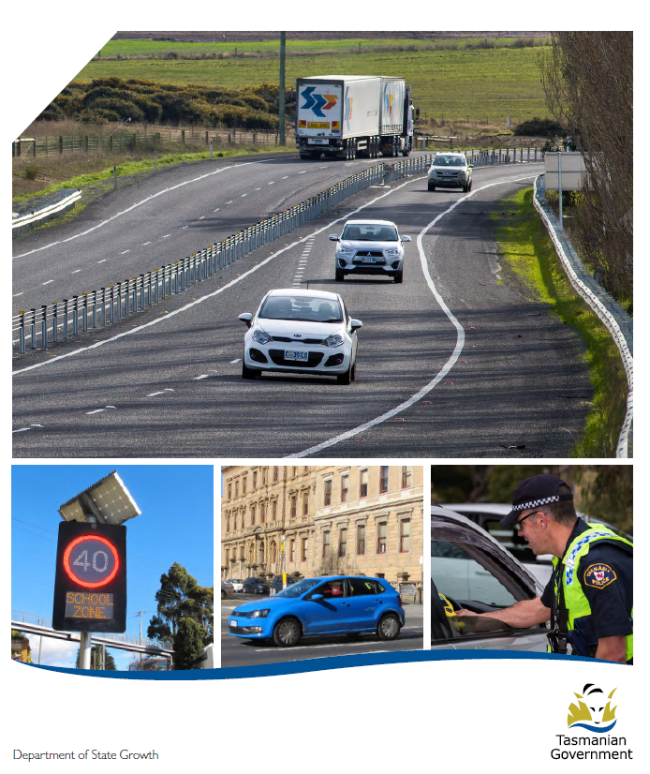

Quarterly Progress Report to RSAC
as at 31 March 2019

Progress on meeting Towards Zero Strategy targets
The key interim target for the Towards Zero – Tasmanian Road Safety Strategy 2017-2026 (Towards Zero Strategy) is to reduce the number of annual serious injuries and deaths on Tasmanian roads to fewer than 200 by 2026. This is an ambitious target of 100 fewer serious casualties per year than for the period 2012-2016 (annual average) and will move us towards the long-term goal of zero serious casualties on Tasmanian roads.
Serious Casualties
The number of serious casualties in 2018 was 324, compared to 302 in 2017, a 7.3 per cent increase. The 2018 figure of 324 is a 5.1 per cent increase on the five year serious casualty average of 308.4 (2013-2017).

Fatalities
In 2018, there were 33 fatalities on Tasmanian roads which is one fewer than the number recorded in 2017. The figure of 33 fatalities in 2018 is a 3.5 per cent decrease on the five year fatalities average of 34.2 (2013-2017).
In 2018, there were 33 fatalities on Tasmanian roads which is one fewer than the number recorded in 2017. The figure of 33 fatalities in 2018 is a 3.5 per cent decrease on the five year fatalities average of 34.2 (2013-2017).

Serious Casualties Tasmania – Annual Count, Percentage Split by Quarter and Towards Zero Target

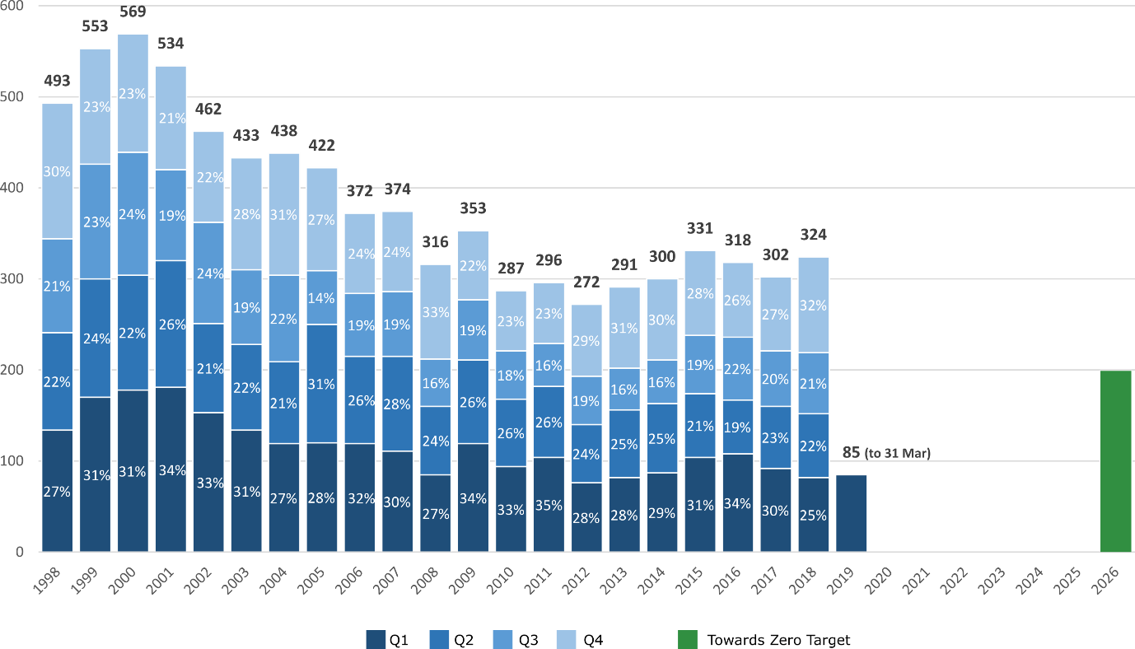

Note: The serious casualty figure for 2018 of 311 reported in the Quarterly Progress Report for December 2018 has been amended to 324 to include crash reports received subsequent to the preparation of that report.

Annual fatalities – Rate per 100,000 population
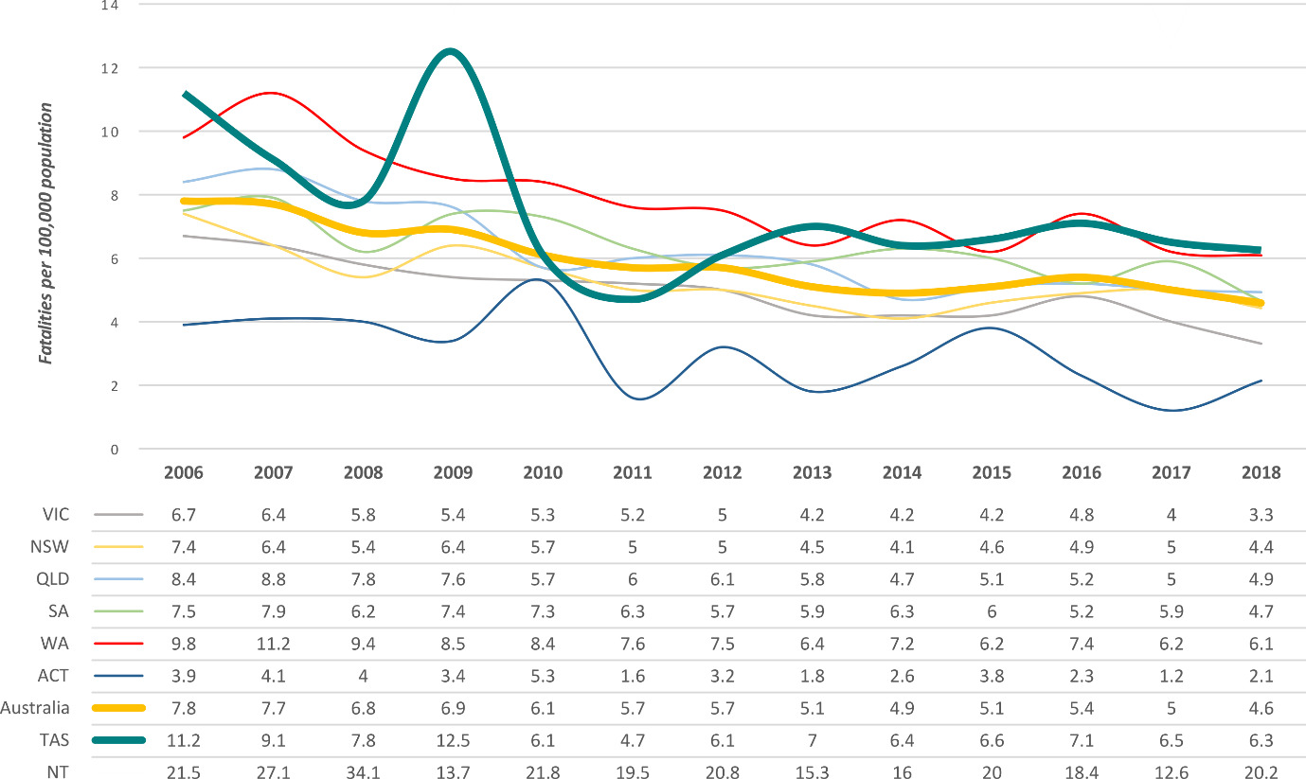
Note: NT omitted from chart for clarity purposes.

Progress on meeting MAIB targets

Motor Accidents Insurance Board (MAIB) injury statistics show the number of fatalities and the level of claims for serious injuries on our roads.
Various claim reduction targets are specified in the Memorandum of Understanding between the Department of State Growth (State Growth) and the MAIB. Progress against high level targets is shown below, expressed as 12 month moving totals.

Fatalities – 12 Month Rolling Total
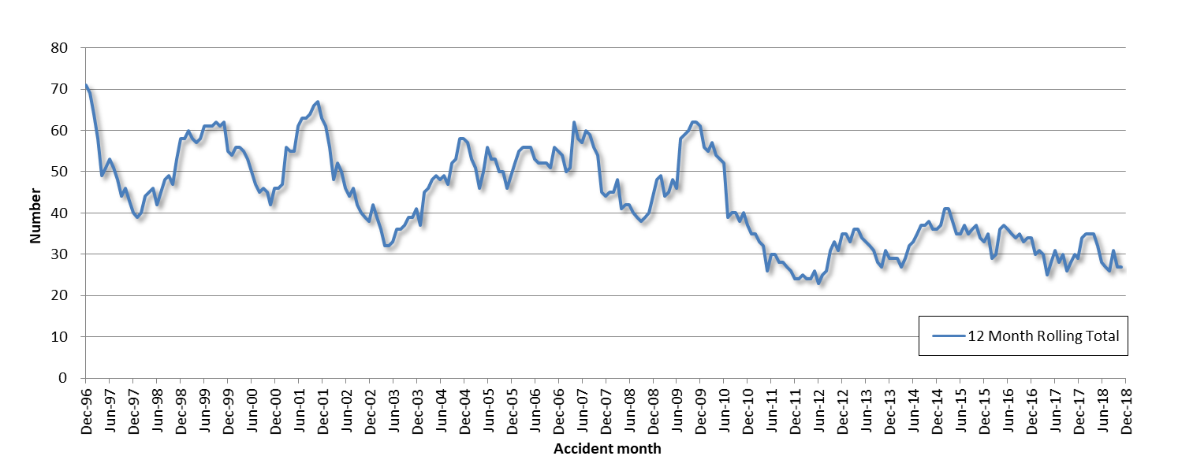

Total Serious Claims – 12 Month Rolling Total
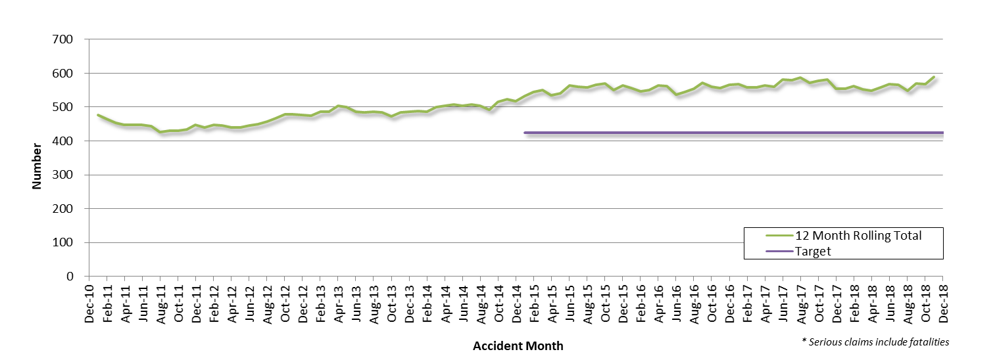
Statistics
Serious Casualties by Quarter by Age Group – 12 period moving average

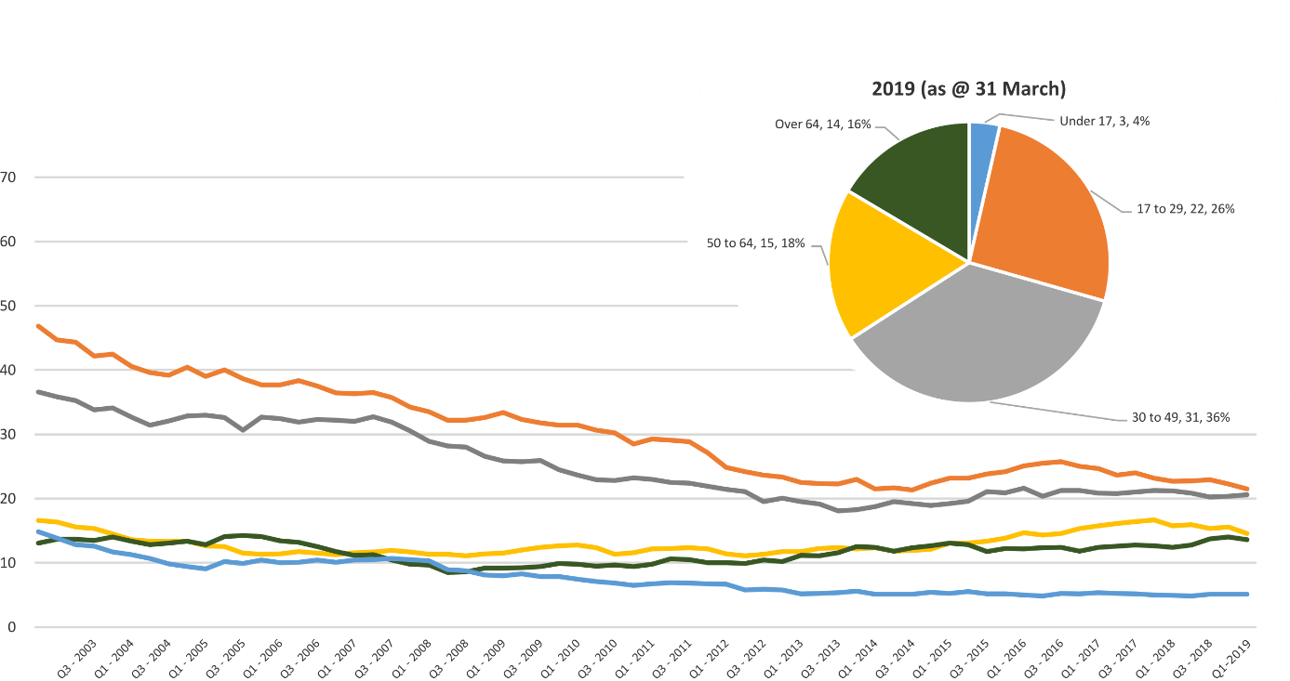

Serious Casualties by Quarter by Gender – 12 period moving average

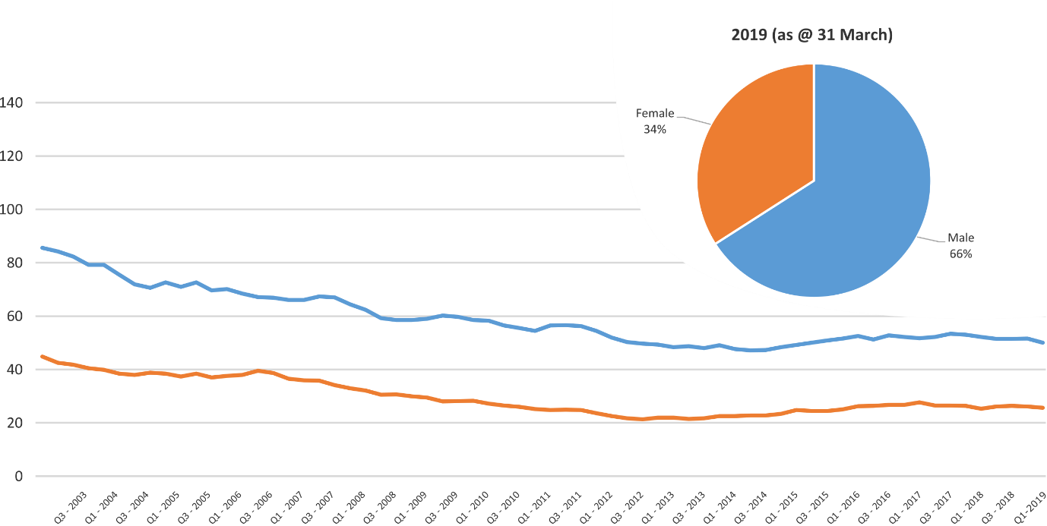

Serious Casualties by Quarter by Road User Type – 12 period moving average

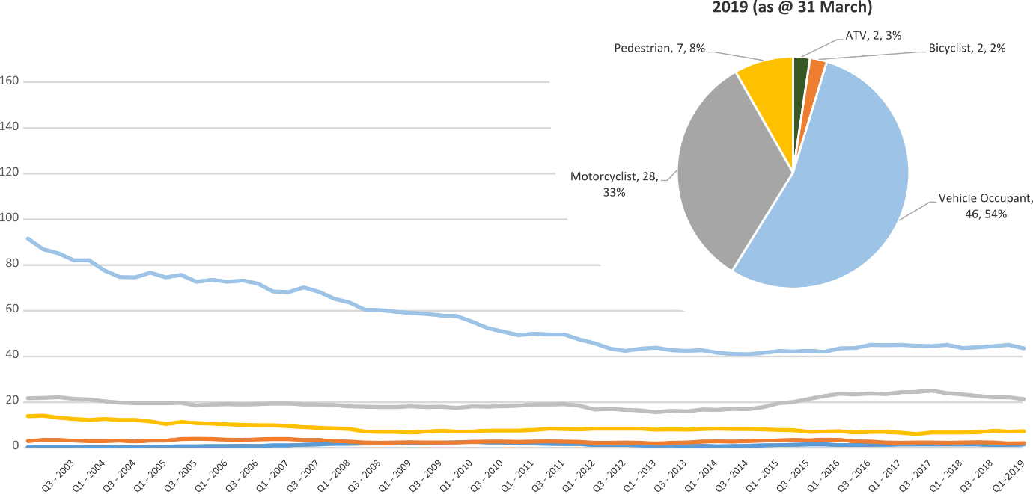

Serious Casualties by Quarter by Speed Zone – 12 period moving average

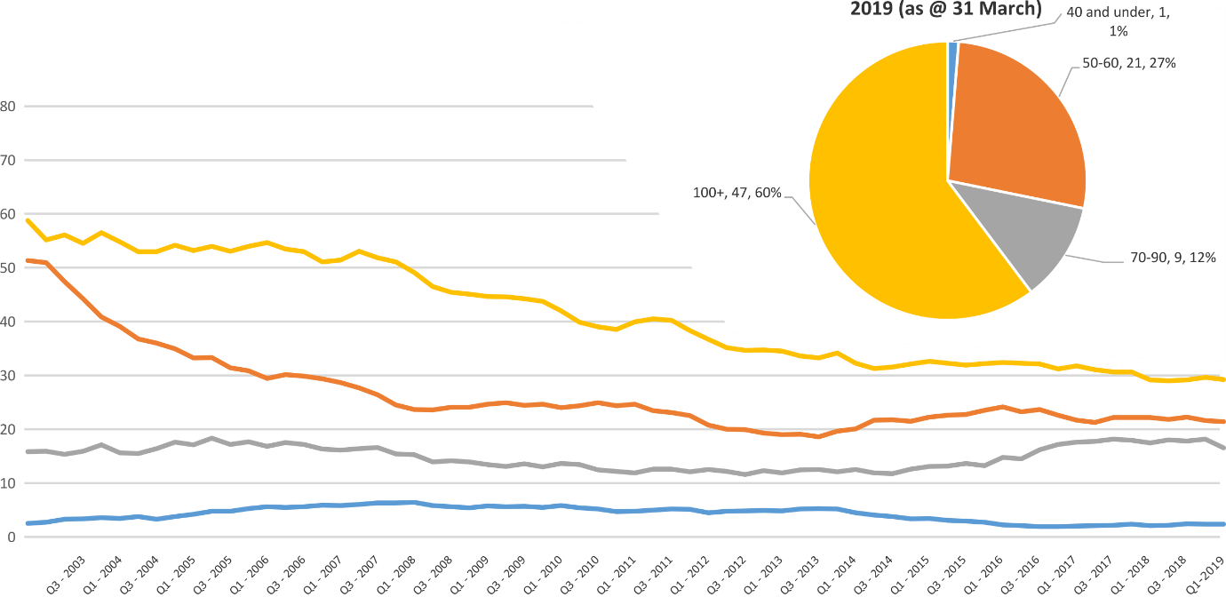
Pie chart excludes serious casualties where speed zone is recorded as ‘not known’

Serious Casualties by Quarter by Crash Type (DCA) – 12 period moving average

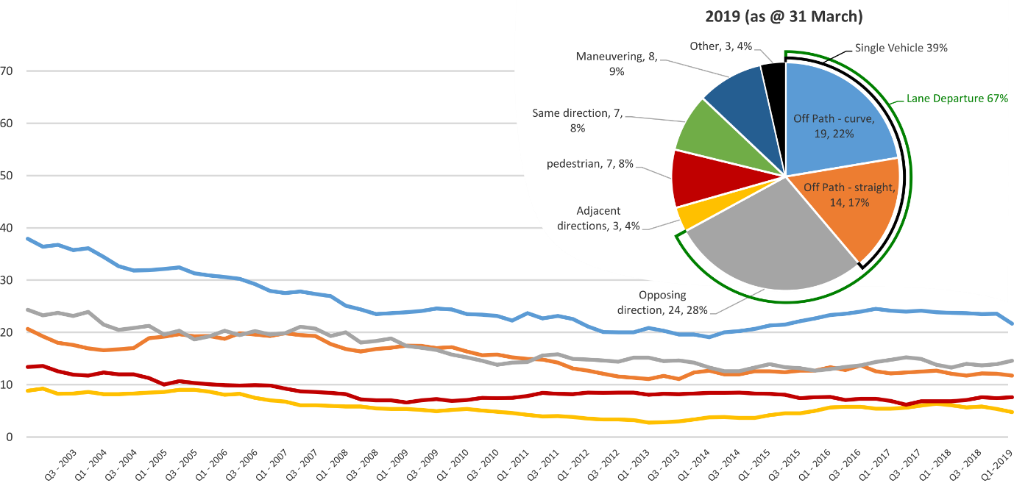
Other includes crash types: on-path (2%) & overtaking (2%).

Serious Casualties by Quarter by Urban/Non-Urban – 12 period moving average

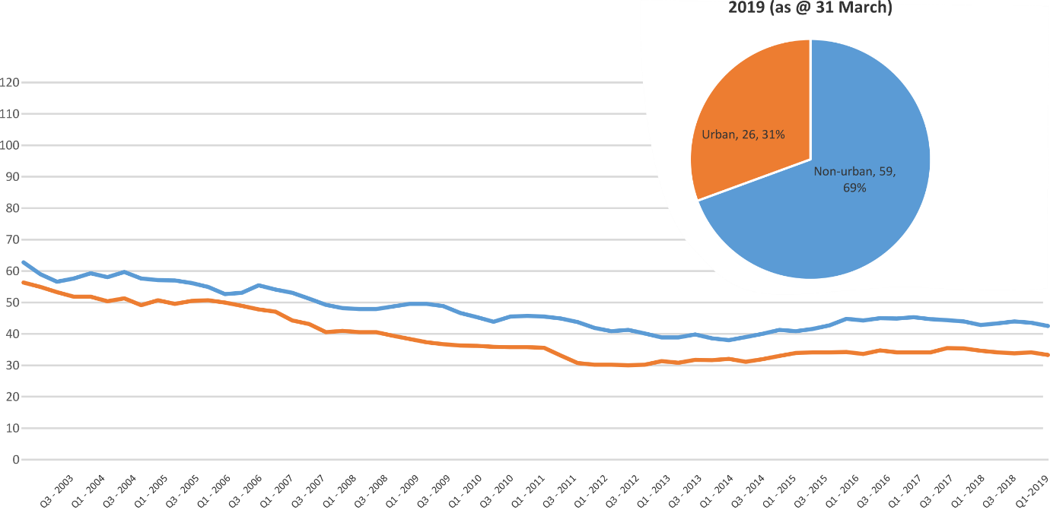
Based on the Australian Bureau of Statistics’ ‘significant urban area’ geographic definition.

Serious Casualty locations to March 2019 (Black = Fatality, Red = Serious Injury)
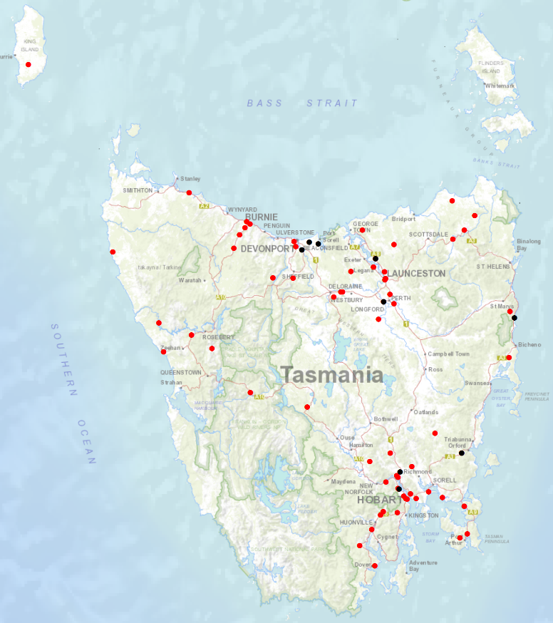

Priority Actions 2017-2019

Safe Road Users

- Improve the Graduated Licensing System to reduce serious casualties for young road users (17-25 year olds).
- Introduce safety initiatives to reduce motorcyclist serious casualties.
- Promote safer road user behaviour through education and enforcement.

Safe Roads and Roadsides

- Reduce run-off-road and head-on crashes through improved infrastructure.
- Reduce the severity of intersection crashes through improved infrastructure treatments.
- Embrace safe system thinking in road design.
- Reduce serious casualties through improved delineation such as line marking.

Safe Vehicles

- Improve the star rating of Tasmania’s vehicle fleet to include vehicles with better safety features.
- Increase the number of motorcycles with ABS.

Safe Speeds

- Introduce more appropriate speed limits to reduce serious casualties.
- Increase enforcement through technology to reduce speed related serious casualty crashes.

Progress on projects
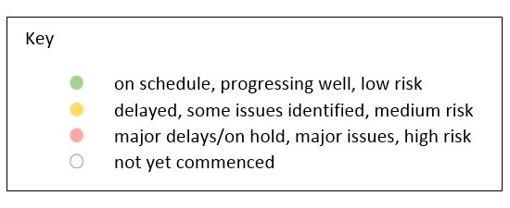
Action Plan 2017-2019
Safe Road Users
Project | Responsibility | Status | Milestones achieved | Milestones planned |  | Comments | Budget  Life of project  $ | YTD  2018/19  $
GLS Implementation  Following on from GLS Review | Road Safety, State Growth |  | The Process Review recommendations were endorsed by the Steering Committee.  The Request for Proposal (RFP) has been finalised and is ready to be released along with the public announcement.  On 26 March 2019 Cabinet approved the changes to the GLS as recommended by RSAC. This included introduction of a Hazard Perception Test, increase to learner logbook hours, peer passenger restrictions and a ban on any mobile phone use. | A public announcement will be made by the Government in late April. The RFP will also be released at the same time on the Tasmanian Government Tenders website. This will be open for eight weeks, with a contract expected to be awarded in September 2019.  The Project Team will engage with key stakeholders advising them of the changes to the GLS at officer level and when their input will be sought in the redevelopment of GLS resources.  Project planning on implementation and change management will be the focus following the announcement. |  | The Project Team is planning implementation and change management tasks.  Consideration is also being given to implementing the recommendations of the Process Review. | 3,000,000 | 64, 470

New motorcycle training and assessment program | Registration & Licensing, State Growth |  | The progressive roll out of the new Motorcycle and Assessment Program has concluded with the commencement of the Program in the North on 8 January 2018.  A transitional training program has been implemented in all regions.  The new training film demonstrating the safety benefits of the new Program and the top 5 motorcycle crashes has been developed and released.  A communication strategy has been implemented to ensure all existing motorcycle learner licence holders affected by the transitional arrangements are notified. | Finalise the development of the auditing and compliance monitoring framework including the resourcing requirements, structure and governance.  Commence scoping the Longitudinal Study that will look to evaluate the new Program and any potential linkages to crash statistics in the future.  Implementation of the electronic results portal has been trialled and was released to the external provider for a progressive implementation from March 2019. The results portal interacts directly with the Motor Registry System to enable instant result reporting for licencing upgrades and provides real time confirmation of licensing eligibility. | Implementation Project complete.  The Grant Deed established to fund the transitional arrangements is ongoing until end 2019.  Demand for the new motorcycle training and assessment program is significantly lower than the previous training regime. As at the end of March 2019, the average figures for the 2018/2019 FY in the North and South are improving at around 85%, however are significantly less in the North West at 41%, compared to previous years.  A review of the financial sustainability of the existing business model has been finalised by an independent financial advisor. The Department is currently analysing the findings of this report and developing a detailed response which is likely to have financial implications. | 810,000 | 714,060  (Life of project)

Towards Zero Enforcement Project - Introduce rear-facing automated speed cameras |  |  | Tasmania Police |  |  |  | Not progressed this quarter |  | Not progressed this quarter |  | Not progressed this quarter |  | 132,000  To review 5 projects |  | 3,632
Towards Zero Enforcement Project - Increased motorcycle-focused enforcement |  | Tasmania Police |  |  |  |  | Draft Road Safety Strategy completed  Draft Road Patrol Strategy completed |  | Finalise and implement strategies  Refine and reissue the draft Motorcycle Enforcement & Engagement Strategy |  | The strategies provide the framework necessary to support the expansion of programs that will increase motorcycle enforcement.
Towards Zero Enforcement Project - Increased enforcement of high-risk behaviours |  | Tasmania Police |  |  |  |  | Unmarked motorcycle trial continued and expanded to three motorcycles and whole of state coverage  Draft Road Safety Strategy completed  Draft Road Patrol Strategy completed |  | Motorcycles procured and operational  Finalise and implement strategies  Refine and reissue the draft Motorcycle Enforcement & Engagement Strategy |  | Towards Zero Enforcement Project - Increased enforcement of high-risk behaviours
Promote safe behaviours through media campaigns |  | EESC,  Road Safety, State Growth |  |  |  |  |  |  | I’ve Been Everywhere campaign used in holiday periods updated. New content focuses on speeding motorists and motorcyclists.  Billboard collateral will support the Police’s new “anywhere, anytime in anything” strategy. |  | Funding approved by RSAC in May 2017. |  | Road Safety Levy funding  $100,000 (excluding media buy)
 |  |  |  |  |  |  |  |  | Campaign to discourage mobile phone use while driving.  Awaiting Queensland research. |  | Funding approved by EESC. |  | MAIB funding  $100,000 (excluding media buy)
 |  |  |  |  |  |  |  |  | New anti-drink-driving Real Mates campaign targeted at men aged between 17 and 25 was launched on 21 March. |  | Funding approved by EESC. |  | MAIB funding  $80,000 (excluding media buy)
 |  |  |  |  |  |  |  |  | TAC-produced campaign about modelling driver behaviour started on 20 April to support changes to the Graduated Licensing System |  | Funding approved by EESC. |  | MAIB funding  $40,000
 |  |  |  |  |  |  |  |  | TAC-produced anti-drink-driving campaign to start in June. |  | Funding approved by EESC. |  | MAIB funding  $40,000
MAIP Implementation |  | Road Safety, State Growth |  |  |  |  |  |  | Drafting instructions to OPC. |  | Drafting of interim contracts complete, with GM, RUS for review before submission to procurement.  Rewrite legislative framework within the DLVR remake approved by GM RUS.  Obtaining endorsement of policy decisions prior to creating drafting instructions. |  | State Growth funded |  | 57,621
Distance makes the Difference campaign Stage 2 |  | Road Safety, State Growth |  |  |  |  |  |  |  |  | Campaign activity complete. |  | 400,000 |  | 385,618  (Life of project)
Tourist road safety campaign – Phase 2 (2017-2019) |  |  | Road Safety, State Growth |  |  |  | New look and feel developed and updated material in market from November 2018.  New Z-card map produced as the result of feedback from stakeholders and tourists.  Animated outdoor electronic signs operational at Hobart and Launceston Airports. |  |  |  | Two new animated films in production to be run in Hobart Airport and through stakeholder networks.  New materials produced for ‘new to Tasmania’ audiences, launch date TBC.  Ongoing engagement with stakeholders including Local Government, industry assocaitions and community groups.  Strategic workshop on visiting motorcyclists being planned. |  | 650,000 |  | 351,085
Community Road Safety Grants Program |  |  | Road Safety, State Growth |  |  |  | A further $200 000 per annum over three years has been approved to continue the Community Road Safety Grants program (2019-2021). Funding applications for 2019-2020 closed on 22 March. |  | The CRSG assessment panel will meet in April with the decision communicated to applicants by the end of May. |  | Program improvements have been made for the application process, including updating Program Guidelines and moving to SmartyGrants, and will continue to be made through the assessment process. |  | 200,000  p/a |  | 135,211
Learner Driver Mentor Program and Driver Mentoring Tasmania |  |  | Road Safety, State Growth |  |  |  | Funding of $1million per annum for the next four years has been approved. This sum includes annual program costs and the implementation of business improvements recommended in the 2017 evaluation report. Funding applications for 2019-2020 closed on 29 March. |  | The LDMP assessment panel will meet in April with the decision communicated to applicants by the end of May. |  | The Department continues to work with programs and the DMT coordinator to implement business improvements recommended in the 2017 evaluation report. |  | 500,000  p/a  702,000 approved for 2017/18. |  | 988,492
RYDA program |  |  | Road Safety, State Growth |  |  |  | Funding of $75 000 has been provided to Rotary to deliver the RYDA program in 2018-19. A request for a further $25,000 per annum has been approved by the Minister to implement program improvements and support a raise in operational costs. |  | An evaluation of program performance is due in June 2019. Funding will again be provided for the 2019-20 financial year. |  | The February 2019 meeting to discuss strategic program improvements and develop of an implementation strategy for the addition resources was postponed. An alternative meeting date is being arranged. |  | 100,000 |  | 75,000
RACT and Bicycle Network |  |  | Road Safety, State Growth |  |  |  | The RACT and Bicycle Network have been provided with $100 000 and $90 000 per annum respectively to deliver a suite of road safety programs and for cycling safety in schools. |  | An evaluation of program performance is due in June 2019. Funding will again be provided for the 2019-20 financial year. |  | The February 2019 meeting to discuss the development of an evaluation strategy was postponed. An alternative meeting date is being arranged. Department representatives visited the program on Ride to School day. |  | 190,000 |  | 190,000
Safety around Schools |  |  | Road Safety, State Growth |  |  |  | The Love40 campaign was launched on Friday 1 February 2019.  The campaign started the week before school returned and included TV and radio advertisement, digital video, print media, bus backs, a mobile billboard and a trial of Love40 bumper stickers provided to select schools.  The campaign was developed in consultation with the Department of Education. |  | The campaign will be repeated at the start of each term throughout 2019.  A survey seeking feedback on the sticker trial has been circulated to relevant schools. Results are expected in early May. |  | The campaign encourages drivers to slow down in school zones and around school buses.  Iterations of the campaign will continue for three calendar years. |  | $300 000 p.a.  2019 - 2021 |  | 153,334
Reduced speeds around emergency vehicles |  |  | Road Safety, State Growth |  |  |  | Minister has approved $150,000 for the community education campaign for the new rule.  Drafting instructions have been prepared and sent to OPC (included in the remake of the Road Rules 2009).  Consultation with key stakeholders has commenced.  Communication plan and creative brief have been prepared - creative agency has been engaged.  Evaluation framework has been prepared. |  | Expertise to support evaluation engaged.  Ongoing engagement with key stakeholders to participate in and contribute to evaluation and education campaign.  Key remaining milestones:  - preparation of Cabinet and ExCo material for approval of new road rule  - development and implementation of education campaign  - commence evaluation - collection of data pre-implementation of new rule. |  |  |  | $150,000 |  | -
Pedestrian safety package – Stage 2 |  |  | EESC  State Growth |  |  |  |  |  |  |  | RSAC has referred consideration of education about pedestrian distraction from mobile phones to the EESC. |  | 430,000  (additional 35,000 is available from stage 1 residual) |  | 0
Safe Roads and Roadsides
Project | Responsibility |  |  |  | Status | Milestones achieved |  | Milestones planned |  | Comments |  | Budget  Life of project  $ |  | YTD  2018/19  $
Capacity Building Strategy and Action plan | Road Safety, State Growth |  |  |  |  | In March 2019, RSAC endorsed the funding request of $50 000 to engage a consultant to develop a capacity building strategy to support the next iteration of the Action Plan for 2020-24. |  | The Road Safety Branch is currently negotiating the scope of work and key milestones with the consultant for the capacity building strategy.  A consultant will be engaged to deliver this stream of work. The strategy is expected to be delivered by June 2019. |  | A corresponding action plan will be developed to identify avenues to increase knowledge and technical skills in Tasmania, consider a variety of engagement methods, and explore technical application and collaborative approaches to capacity building. |  | 50 000 |  | 0  (has been spent towards the consultant)  38 776 (has been spent on capacity building and Safe System Training)
Vulnerable Road User Program (VRUP) | Road Safety,  State Growth |  |  |  |  | On 4 March 2019 applications closed for the VRUP 2019-20 funding round.  20 applications were received. The VRUP Assessment Committee recommended 14 for funding equating to $523 360.  SOC to approve successful applications in April. |  | Advice will be provided to the Minister on the outcome of the 2019-20 funding round with a supporting media release.  Following this, local council will be advised of whether their application was successful in late-April 2019. |  | The future funding allocation for VRUP post 2019-20 is being considered as part of the redevelopment of the next Action Plan for 2020-24. |  | 750 000  (allocated to the 2018-19 funding round) |  | N/A  Projects are paid on completion. Year to date figure is not accurate reflection of project value as payment occurs irregularly.

Infrastructure Risk Rating (IRR) Analysis | Road Safety,  State Growth |  |  |  | Development of IRR analysis tool underway. |  | Receipt of IRR analysis tool. |  |  | Funding endorsed by RSAC at August 2018 meeting. Funding subsequently approved by Minister. |  |  | 80 000 |  |  | 42,670
2018-19 pavement marking maintenance program – local government | State Roads, State Growth |  |  |  |  |  | Support local government to optimise the safety performance of road markings (such as through the use of long life, highly visible materials). |  |  | Funding endorsed by RSAC at August 2018 meeting. Additional funding subsequently approved by Minister. Includes up to $90 000 for school crossing pavement marking. |  |  | 770 000 |  |  | 358,824
2018-19 Shoulder sealing program | State Roads, State Growth |  |  |  |  |  | Program of shoulder sealing road safety infrastructure improvements to be undertaken.  Priority sections of key routes to be targeted.  Works expected to continue into 2019-20. |  |  | Funding endorsed by RSAC at August 2018 meeting.  Additional funding of $2 million endorsed by RSAC at its March 2019 meeting. Funding request to be approved by Minister. |  |  | 9 million |  |  | 18 224
School Electronic Speed Limit Signs –replacement | Road Safety, State Roads, State Growth |  |  |  |  |  | Scope and specification of replacement program to be developed. |  |  | Funding endorsed by RSAC at March 2019 meeting.  Funding request to be approved by Minister. |  |  | 100 000
Safe Vehicles
Project | Responsibility |  | Status |  | Milestones achieved |  |  | Milestones planned |  |  | Comments |  |  | Budget  Life of project  $ |  |  | YTD
Government Business Enterprise (GBE) and State Owned Company (SOC) Fleet Review | Road Safety, State Growth |  |  |  | Project planning and scoping complete.  Initial desktop analysis of fleet structure complete. Policy options and recommendations drafted.  Engaged with GBE and SOC fleet managers in partnership with Treasury. |  |  | Analysis of findings of GBE/SOC fleet feedback.  Policy paper to be finalised. |  |  | On hold. |  |  | 0 |  |  | NA
Promote vehicle fleet safety standards for commercial fleets | Road Safety, State Growth |  |  |  | Road Safety Branch attended the LGAT Conference in July 2018 and promoted Government policy and vehicle safety to attendees.  Road Safety Branch supported the National Road Safety Partnership (NRSPP) to present on the vehicle as a workplace at the 2018 WorkSafe Conference. |  |  | Continued collaboration with NRSPP and investigation of opportunities to further promote vehicle fleet safety in the commercial sector. |  |  | The outcomes of the GBE and SOC review will inform the approach to engaging with commercial fleets. |  |  | 0 |  |  | NA
ANCAP support | Road Safety, State Growth |  |  |  |  |  |  | An ANCAP kiosk is to be provided to Motors Pty Ltd on a trial basis. The kiosk will house an I-pad with the ANCAP app installed and will be available for buyers to browse and inform their purchases. The kiosk will be co-branded between the RACT, Tasmanian Government and ANCAP. |  |  |  |  |  | 12,000 p/a |  |  | 12,088
MOTOCAP | Road Safety,  State Growth |  |  |  | The MOTOCAP website launched in September 2018. The Chair of RSAC released a media statement supporting and promoting the website.  A Road Safety Branch representative attended the March 2019 meeting at Deakin University crash test lab in Geelong, VIC.  A demonstration was given of the crash test equipment. Discussion was also had on stakeholder engagement and how to promote the website further. |  |  | The website is updated as additional safety ratings for motorcycle clothing are published.  The current contract between State Growth and MOTOCAP expires on 1 July 2019. The next 12 month fee is $8 200.  The Road Safety Branch will continue to actively participate in the group and execute another agreement in the coming months.  MOTOCAP will soon be looking to engage a company to develop a stakeholder and engagement plan.  The next meeting is expected to occur in June 2019 via teleconference. |  |  | MOTOCAP aims to test 10 per cent of the motorcycle protective clothing market and star rate them on protection and comfort.  Deakin University is the current contractor testing and rating the clothing. |  |  | 8 000 |  |  | 8 000
Safe Speeds
Project |  | Responsibility |  | Status |  | Milestones achieved |  |  | Milestones planned |  |  | Comments |  |  | Budget  Life of project  $ |  |  | YTD  $
Development of speed limit setting guidelines |  | Road Safety, State Growth
Assessment of speed limits on 100km/h roads |  | Road Safety, State Roads, State Growth
Towards Zero Enforcement Project - Review of point to point (P2P) speed cameras on high risk rural roads |  | Tasmania Police |  |  |  | TasPol was working with several providers towards a multi-stakeholder proof of concept trial, however only one provider remains. A demonstration of the technology will replace the trial. No funds will be requested from RSAC NOTE: $50,000 previously approved. |  |  | The technology will be demonstrated in Hobart and followed up with a presentation to road safety stakeholders. |  |  | The objective of the demonstration project is to educate and create awareness of the technology. Several other jurisdictions are expected to trial Mobile P2P over next 12 months – this is positive as multiple providers/solutions will be trialled over a short period. Jurisdictions will share information. |  |  | 132,000  To review 5 projects
Reducing Urban Arterial Speed Limits in Tasmania from 60km/h to 50km/h. |  | Road Safety State Growth |  |  |  | Project planning and scoping completed. |  |  |  |  |  | Remaining roads are low volume (aside from urban arterials) and may have less community support.  Road safety benefit not immediate, but would be long term.  On hold as not a priority project, but will be progressed as a demonstration of appropriate speeds. |  |  | TBC
Speed Moderation Strategy |  | Road Safety, State Growth

Other
Project | Responsibility | Status | Milestones achieved | Milestones planned | Comments | Budget  Life of project  $ | YTD  $
RSAC and Towards Zero Strategy support | Road Safety, State Growth |  | Funding for Manager RSAC Secretariat, Chair and Expert sitting fees and operation of RSAC.  Funding to support development and implementation of Strategy and supporting Action Plans. |  |  | Up to 400,000  p/a | 300,765
MAIP Transitional arrangements | Registration & Licensing, State Growth |  | Support for fee waiver. |  |  | 3,300,000 | 2,298,622  Fee Waiver  2,356,244(Life of project)
Discretionary Activities Fund | Road Safety, State Growth |  |  |  |  | 250,000 | 550
 |  |  | Motorcycle Safety Demonstration Project: Lake Leake Highway |  |  | 25 000 | 22,412

Funding

Road Safety Levy Overview
As at 31 March 2019
2018/19 Financial Year
Opening balance as at 1 July 2018 |  | $12,317,549
Revenue 2018/19 | Proposed | Actual (ytd)
Road safety levy collected | $13,500,000 | $10,621,891
Funds available for distribution | $10,900,000 | $8,021,891
Total funds available for distribution | $23,217,549 | $20,339,440
Expenditure |  | Actual (ytd)
Roads and Roadsides |  | $940,354
Policy and Projects |  | $2,677,780
Total Expenditure |  | $3,618,134
Balance | Forecast | Actual as of 31 March
Closing balance | $19,599,415 | $16,721,306
Funding of Expenditure (2018/19)
Remaining allocated funding
Safe Roads and Roadsides | $7,059,646
Policy and Projects | $3,906,194
Total remaining allocated funding | $10,965,840
Remaining unallocated funding
Safe Roads and Roadsides | $0
Policy and Projects | $8,633,575
Total remaining unallocated funding | $8,633,575

MAIB Funding
As at 31 March 2019
2018/19 Financial Year | Budget  $ | Actual (ytd)  $ | Balance  $
Expenditure (State Growth)
Administration & Public Relations | 336,716 | 188,626 | 148,090
Public Education | 1,150,273 | 713,085 | 437,188
Research | 146,085 | 61,050 | 85,035
Subtotal | 1,633,074 | 962,761 | 670,313
Expenditure (Tasmania Police)
Salaries | 1,899,312 | 1,469,973 | 429,339
Operating Expenses | 317,642 | 159,891 | 157,751
Equipment | 558,827 | 220,148 | 338,679
Subtotal | 2,775,781 | 1,850,012 | 925,769
Total | 4,408,855 | 2,812,773 | 1,596,082
Includes Carried Forward of
$333,439 (State Growth)
$429,547 (Police)

