Fewer than 200 serious injuries and deaths on our roads by 2026

Towards Zero Tasmanian Road Safety Strategy 2017–2026

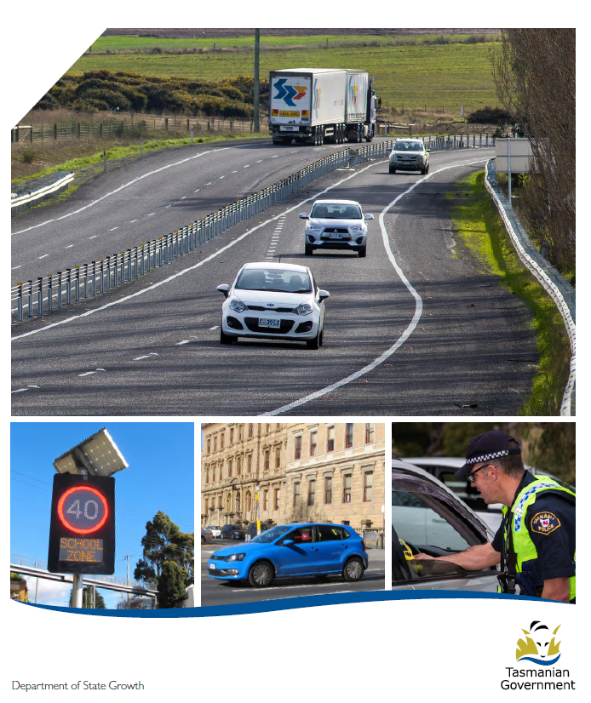

Quarterly Progress Report to RSAC
as at 30 June 2019

Progress on meeting Towards Zero Strategy targets
The key interim target for the Towards Zero – Tasmanian Road Safety Strategy 2017-2026 (Towards Zero Strategy) is to reduce the number of annual serious injuries and deaths on Tasmanian roads to fewer than 200 by 2026. This is an ambitious target of 100 fewer serious casualties per year than for the period 2012-2016 (annual average) and will move us towards the long-term goal of zero serious casualties on Tasmanian roads.
Serious Casualties
The number of serious casualties in 2018 was 324, compared to 302 in 2017, a 7.3 per cent increase. The 2018 figure of 324 is a 5.1 per cent increase on the five year serious casualty average of 308.4 (2013-2017).

Fatalities
In 2018, there were 33 fatalities on Tasmanian roads which is one fewer than the number recorded in 2017. The figure of 33 fatalities in 2018 is a 3.5 per cent decrease on the five year fatalities average of 34.2 (2013-2017).
2019 YTD
There have been 145 serious casualties (17 fatalities and 128 serious injuries) to 30 June 2019, a decrease of 4.6 per cent on the same period last year of 152 serious casualties (17 fatalities and 135 serious injuries) and a decrease of 6.7 per cent on the five year average of 163 serious casualties.
Serious Casualties Tasmania – Annual Count, Percentage Split by Quarter and Towards Zero Target

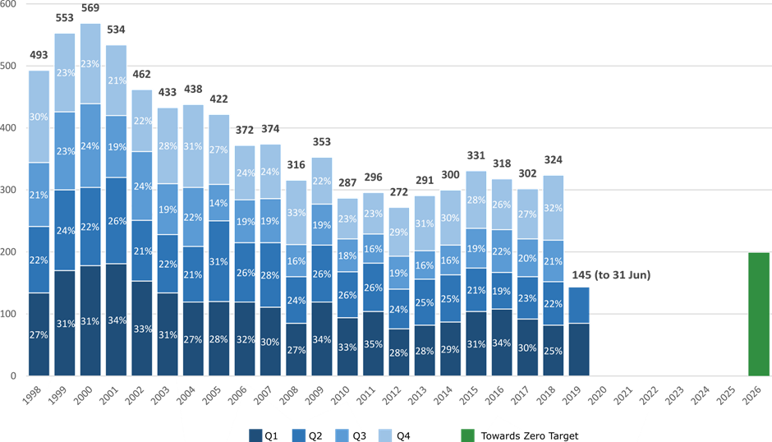
Annual fatalities – Rate per 100,000 population
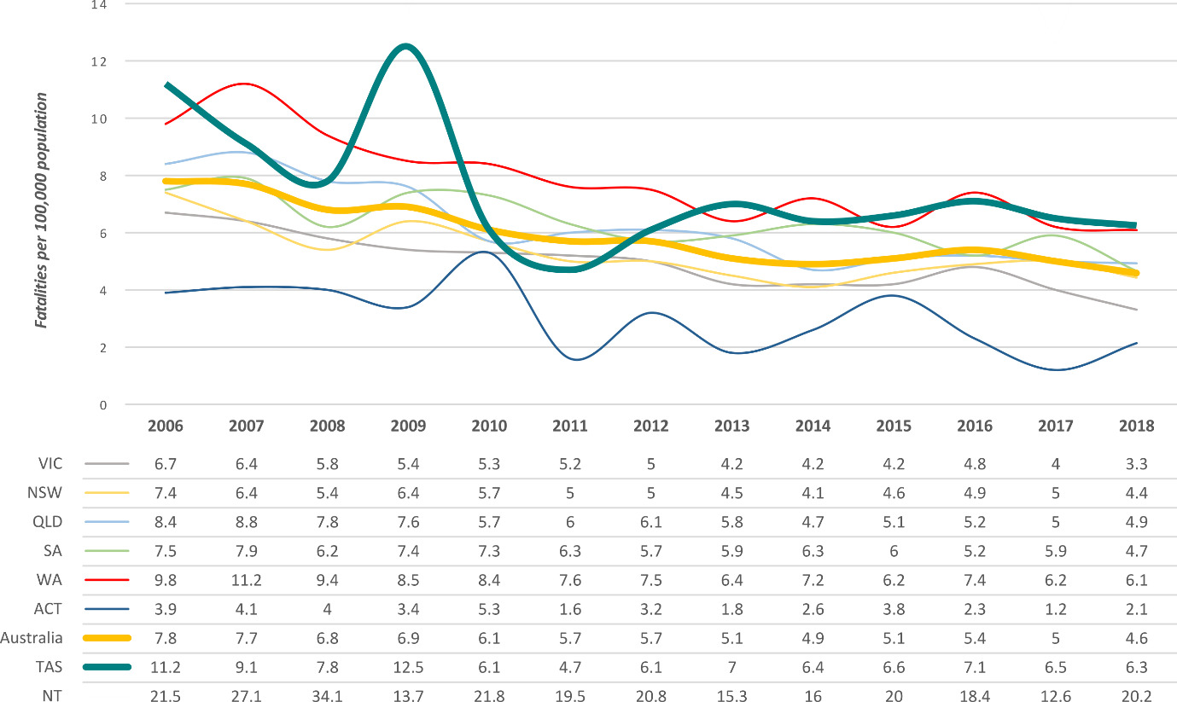
Note: NT omitted from chart for clarity purposes.

Progress on meeting MAIB targets

Motor Accidents Insurance Board (MAIB) injury statistics show the number of fatalities and the level of claims for serious injuries on our roads.
Various claim reduction targets are specified in the Memorandum of Understanding between the Department of State Growth (State Growth) and the MAIB. Progress against high level targets is shown below, expressed as 12 month moving totals.

Fatalities – 12 Month Rolling Total
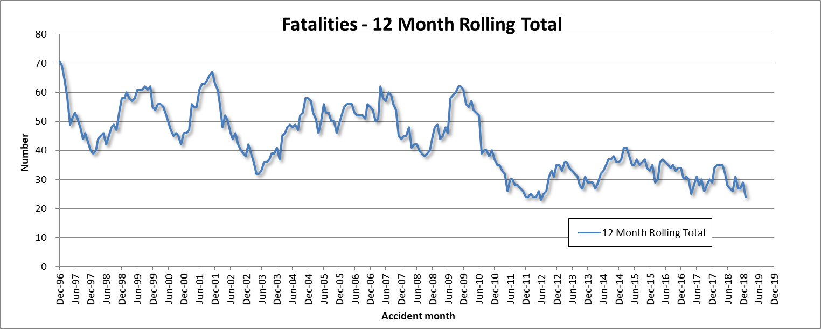

Total Serious Claims – 12 Month Rolling Total
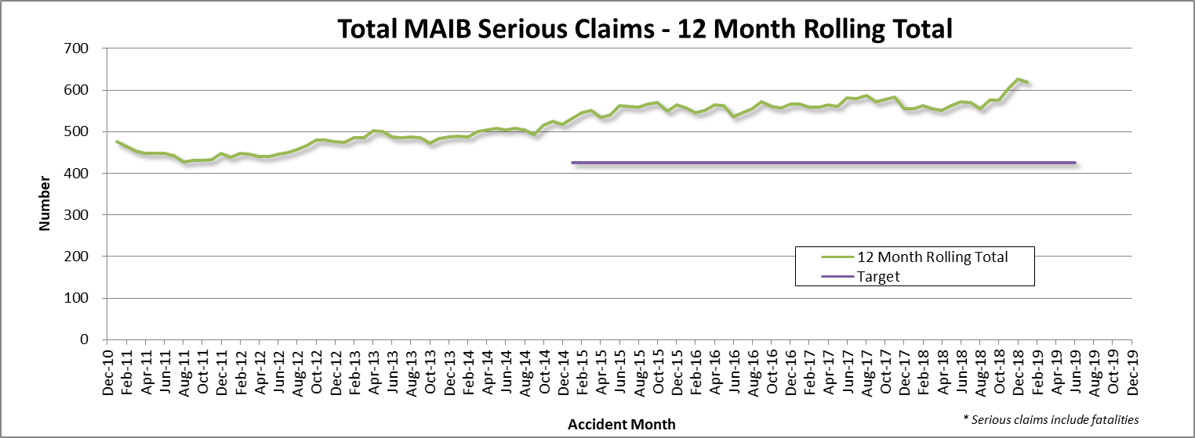

Statistics
Serious Casualties by Quarter by Age Group – 12 period moving average

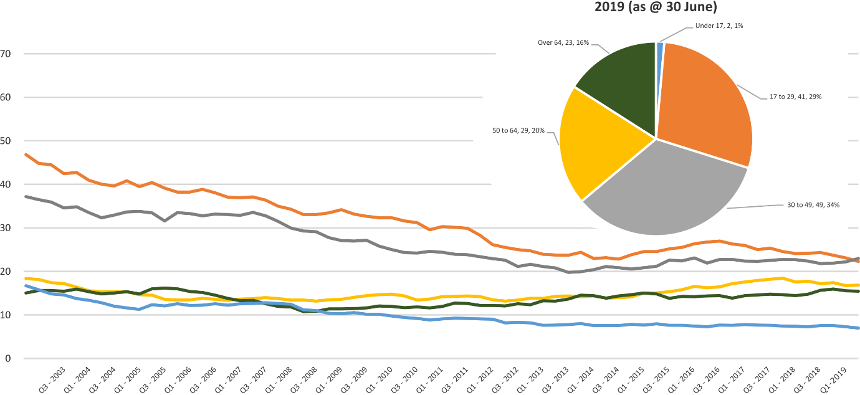

Serious Casualties by Quarter by Gender – 12 period moving average

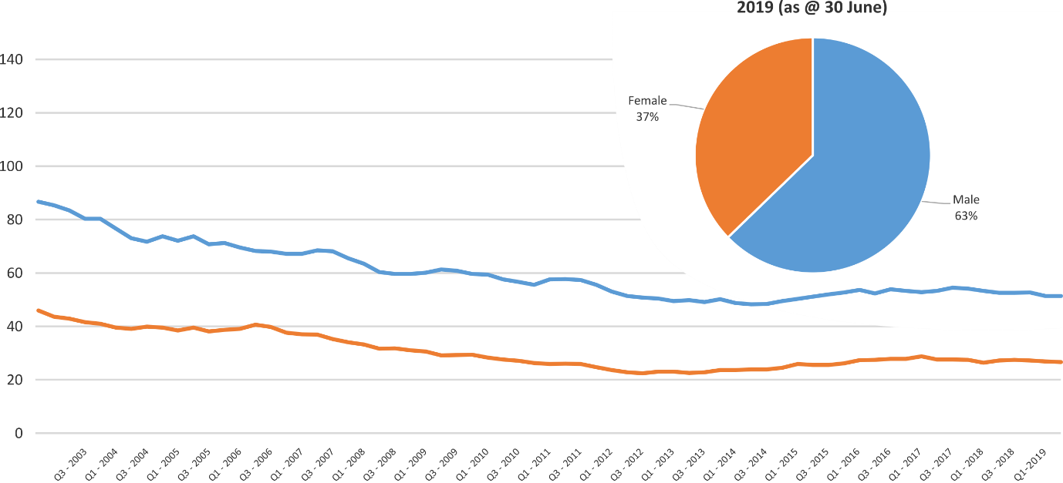

Serious Casualties by Quarter by Road User Type – 12 period moving average

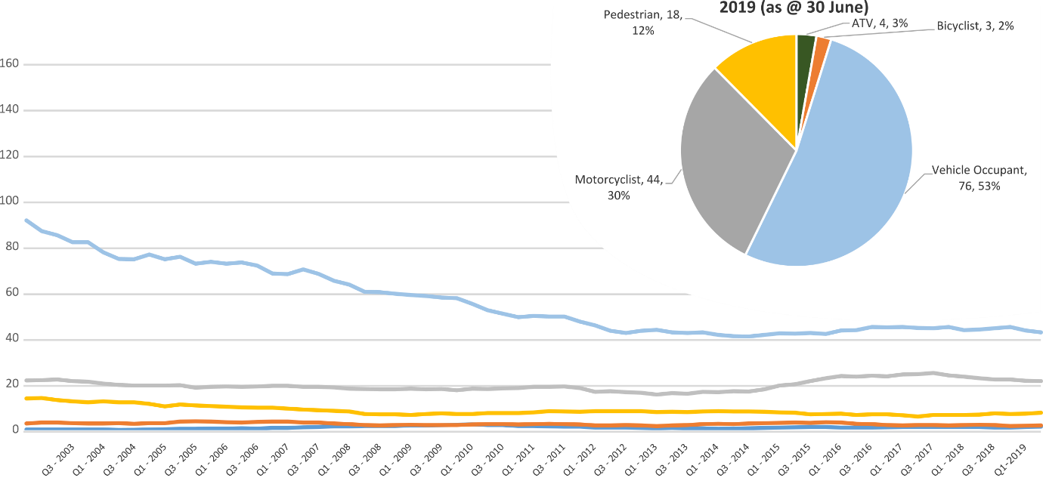

Serious Casualties by Quarter by Speed Zone – 12 period moving average

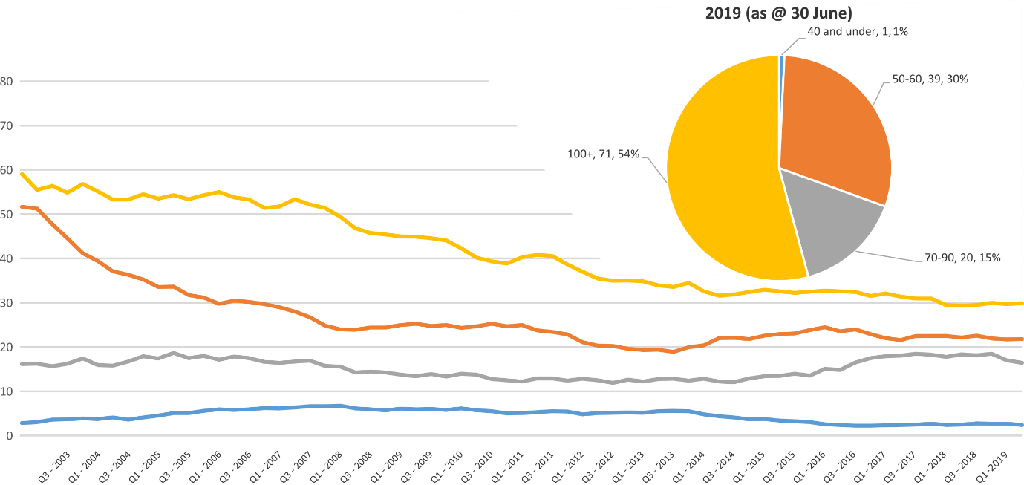
Pie chart excludes serious casualties where speed zone is recorded as ‘not known’

Serious Casualties by Quarter by Crash Type (DCA) – 12 period moving average

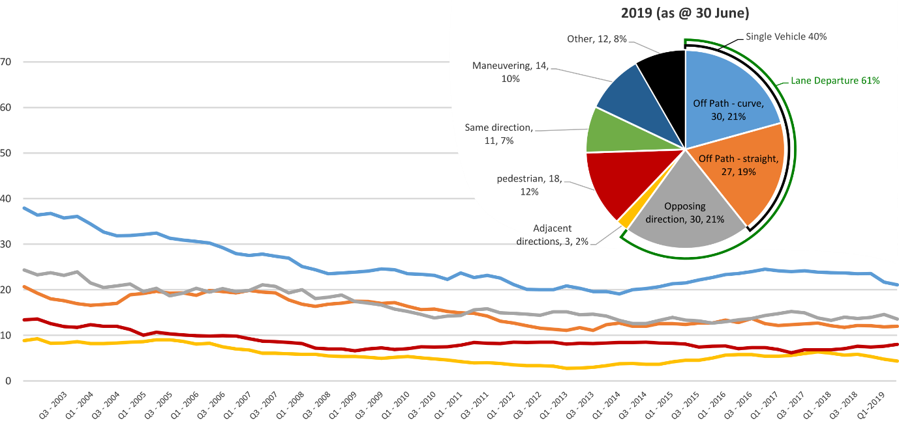
Other includes crash types: on-path (2%) & overtaking (2%).

Serious Casualties by Quarter by Urban/Non-Urban – 12 period moving average

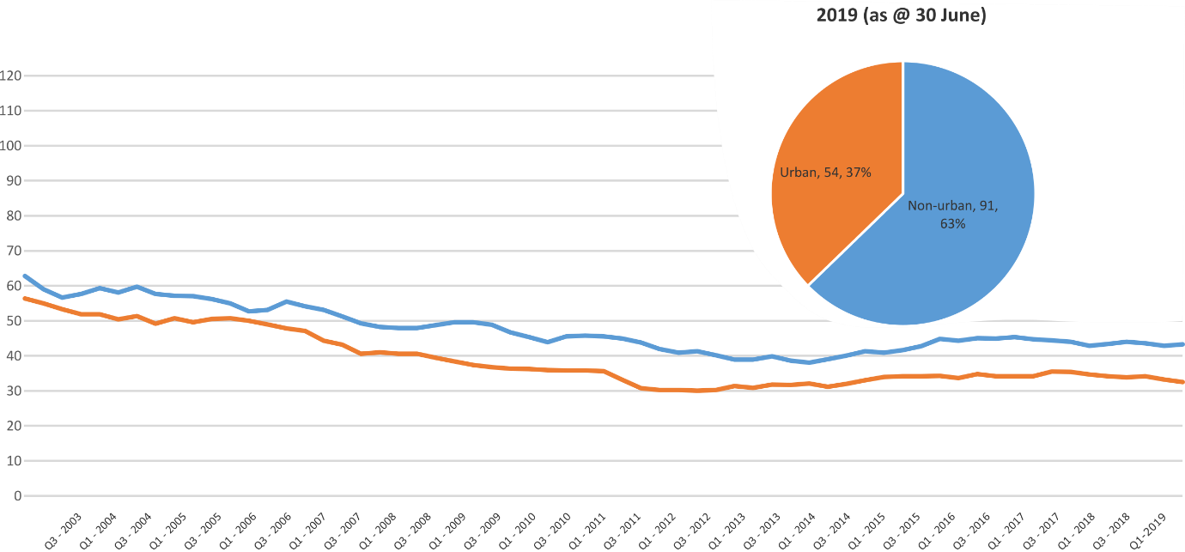
Based on the Australian Bureau of Statistics’ ‘significant urban area’ geographic definition.

Serious Casualty locations to June 2019 (Black = Fatality, Red = Serious Injury)
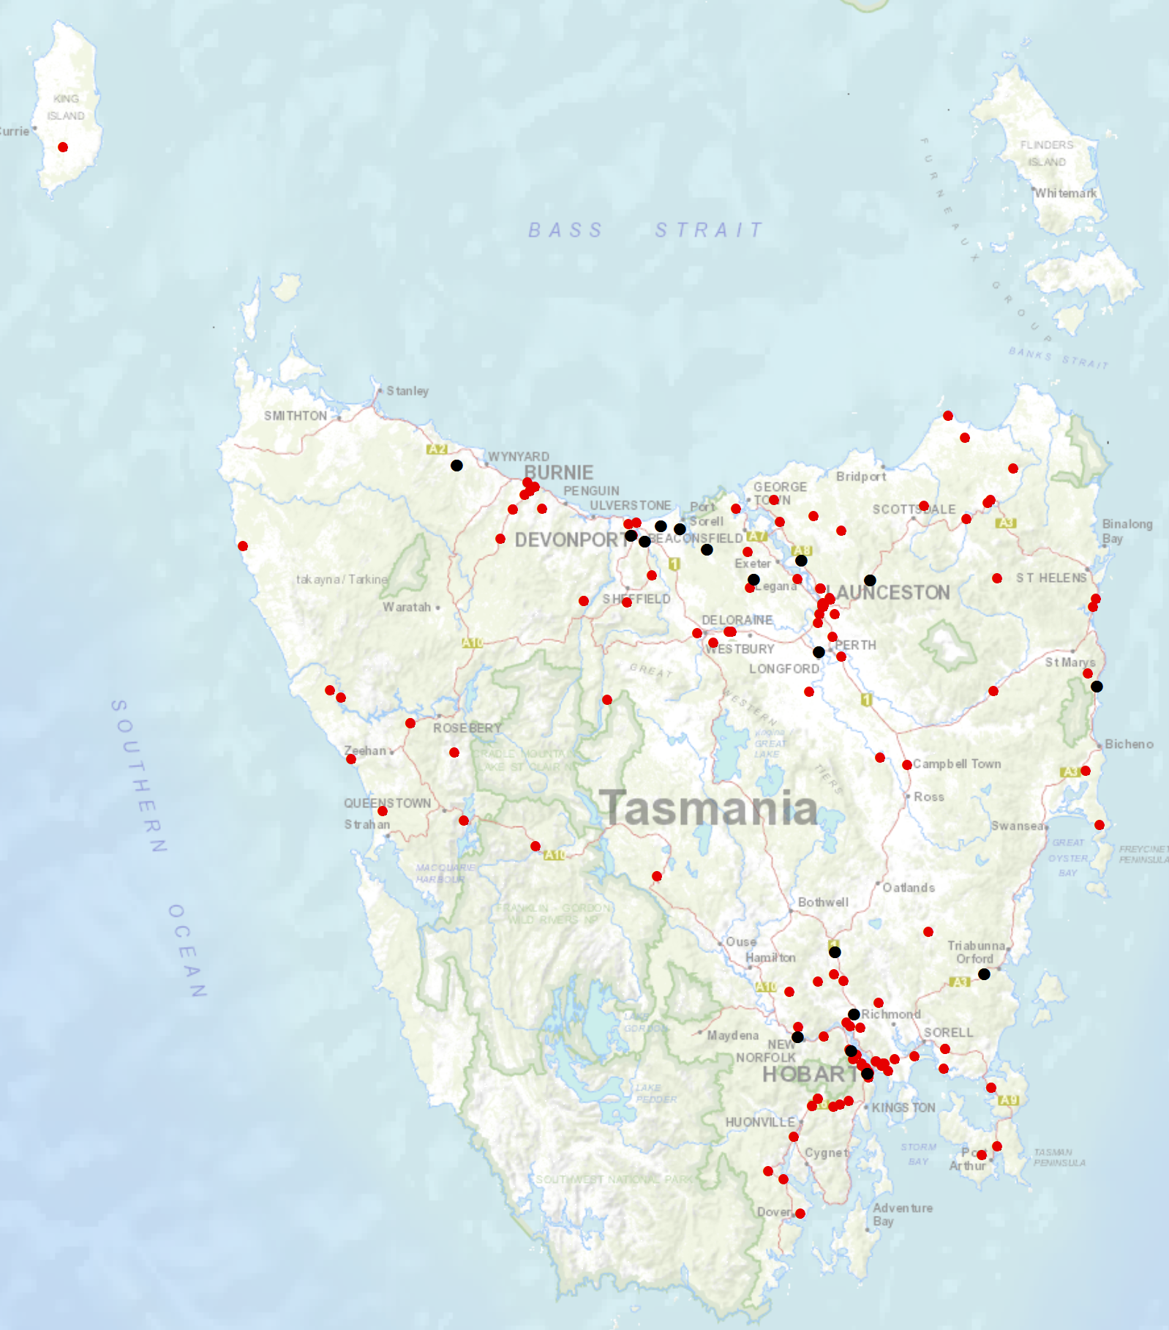

Priority Actions 2017-2019

Safe Road Users

- Improve the Graduated Licensing System to reduce serious casualties for young road users (17-25 year olds).
- Introduce safety initiatives to reduce motorcyclist serious casualties.
- Promote safer road user behaviour through education and enforcement.

Safe Roads and Roadsides

- Reduce run-off-road and head-on crashes through improved infrastructure.
- Reduce the severity of intersection crashes through improved infrastructure treatments.
- Embrace safe system thinking in road design.
- Reduce serious casualties through improved delineation such as line marking.

Safe Vehicles

- Improve the star rating of Tasmania’s vehicle fleet to include vehicles with better safety features.
- Increase the number of motorcycles with ABS.

Safe Speeds

- Introduce more appropriate speed limits to reduce serious casualties.
- Increase enforcement through technology to reduce speed related serious casualty crashes.

Progress on projects
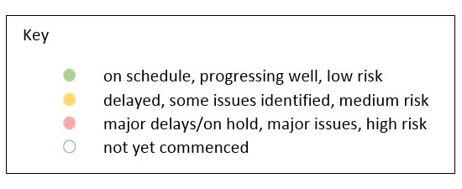
Action Plan 2017-2019
Safe Road Users
Project | Responsibility |  | Status |  |  |  |  |  | Milestones achieved |  | Milestones planned |  |  |  |  |  |  | Comments |  |  |  |  | Budget  Life of project  $ |  |  |  |  |  |  | YTD  2018/19  $
GLS Implementation  Following on from GLS Review | Road Safety, State Growth |  |  |  |  |  |  |  | On 5 May 2019 the government publicly announced the endorsed changes to Tasmania’s GLS.  The announcement was accompanied by a new GLS webpage featured on the Transport website and around 250 emails to key stakeholders informing them of the announcement.  The first phase of the GLS pre-awareness campaign commenced on 6 May 2019, including a television commercial and billboards in public carparks.  A Request for Proposal (RFP) was released on 11 May 2019 seeking proposals from businesses to create the digital platform and public education campaign to support the new GLS. |  | The RFP closes on 5 July 2019, with a contract expected to be awarded in November 2019.  The Project Team is developing a detailed implementation plan, drafting instructions for legislative amendments, and transitional arrangements for existing licence holders.  The20 have been engaged to further develop the pre-awareness campaign, which will run over 2019/20 in the lead-up to implementing the new GLS.  The Project Manager is working with key community stakeholders (TasCOSS and YNOT) to develop an engagement framework and methodology for consulting with young people on their views about getting a driver licence in Tasmania.  This work will help to inform project implementation activities including the development of the digital platform and other GLS resources. |  |  |  |  |  |  | The Project Team is closely monitoring all stakeholder contact following the public announcement, including Ministerial correspondence and direct emails to the Project. A large proportion of stakeholder contact has been supportive of the GLS changes.  The Project Team will continue to work with the Minister’s Office to keep them informed on implementation progress and opportunities for media activities in the lead up to the GLS changes. |  |  |  |  | 3 000 000 |  |  |  |  |  |  | 103 024
New motorcycle training and assessment program | Registration & Licensing, State Growth |  |  |  |  |  |  |  | The progressive roll out of the new Motorcycle and Assessment Program has concluded with the commencement of the Program in the North on 8 January 2018.  A transitional training program has been implemented in all regions.  The new training film demonstrating the safety benefits of the new Program and the top 5 motorcycle crashes has been developed and released.  A communication strategy has been implemented to ensure all existing motorcycle learner licence holders affected by the transitional arrangements are notified. |  | Finalise the development of the auditing and compliance monitoring framework including the resourcing requirements, structure and governance.  Commence scoping the Longitudinal Study that will look to evaluate the new Program and any potential linkages to crash statistics in the future.  Implementation of the electronic results portal has been trialled and was released to the external provider for a progressive implementation from March 2019. The results portal interacts directly with the Motor Registry System to enable instant result reporting for licencing upgrades and provides real time confirmation of licensing eligibility. |  |  |  |  |  |  | Implementation Project complete.  The Grant Deed established to fund the transitional arrangements is ongoing until end 2019.  Demand for the new motorcycle training and assessment program is significantly lower than the previous training regime. As at the end of 2018/2019 FY in the North and South were around 85%, however are significantly less in the North West at 42%, compared to previous years.  A review of the financial sustainability of the existing business model has been finalised by an independent financial advisor. The Department has analysed the findings of this report and is currently developing a detailed response which is likely to have financial implications. |  |  |  |  |  |  | 810 000 |  |  |  |  | 714 713  (Life of project)
Towards Zero Enforcement Project - Introduce rear-facing automated speed cameras | Tasmania Police |  |  |  |  |  |  |  | Project closed – incorporated in to the Automated Speed Enforcement Project |  |  |  |  |  |  |  |  |  |  |  |  |  |  |  | 132 000  To review 5 projects |  |  |  |  | 3 632
Towards Zero Enforcement Project - Increased motorcycle-focused enforcement | Tasmania Police |  |  |  |  |  |  |  | Project closed – incorporated in to the Automated Speed Enforcement Project
Towards Zero Enforcement Project - Increased enforcement of high-risk behaviours | Tasmania Police |  |  |  |  |  |  |  | Road Safety Strategy 2019-21 completed  Automated Speed Enforcement Project commenced  Unmarked motorcycle trial underway – three moto and state-wide coverage.  Distracted driver technology trial complete (Acusensus) |  | Deliver in-vehicle (static and mobile) speed enforcement trial (Sensys Gatso Australia)  Deliver mobile P2P trial (Tess Solutions Australia) |  |  |  |  |  |  | The trials will inform Stage One of the Automated Speed Enforcement Project
Promote safe behaviours through media campaigns | EESC,  Road Safety, State Growth |  |  |  |  |  |  |  |  |  | I’ve Been Everywhere campaign used in holiday periods updated. New content focuses on speeding motorists and motorcyclists.  Billboard collateral will support the Police’s new “anywhere, anytime in anything” strategy. |  |  |  |  |  |  | Funding approved by RSAC in May 2017. |  |  |  |  |  |  | Road Safety Levy funding  $100 000 (excluding media buy) |  |  |  |  | 103 470
 |  |  |  |  |  |  |  |  |  |  | Campaign to discourage mobile phone use while driving.  Awaiting Queensland research. |  |  |  |  |  |  | Funding approved by EESC. |  |  |  |  |  |  | MAIB funding  $100 000 (excluding media buy)
 |  |  |  |  |  |  |  |  |  |  | New anti-drink-driving Real Mates campaign targeted at men aged between 17 and 25 was launched on 21 March. |  |  |  |  |  |  | Funding approved by EESC. |  |  |  |  |  |  | MAIB funding  $80 000 (excluding media buy)
 |  |  |  |  |  |  |  |  |  |  | TAC-produced campaign about modelling driver behaviour started on 20 April to support changes to the Graduated Licensing System |  |  |  |  |  |  | Funding approved by EESC. |  |  |  |  |  |  | MAIB funding  $40 000
 |  |  |  |  |  |  |  |  |  |  | TAC-produced anti-drink-driving campaign to start in June. |  |  |  |  |  |  | Funding approved by EESC. |  |  |  |  |  |  | MAIB funding  $40 000
MAIP Implementation | Road Safety, State Growth |  |  |  |  |  |  |  |  |  | Drafting instructions to OPC. |  |  |  |  |  |  | Drafting of interim contracts complete, with GM, RUS for review before submission to procurement.  Rewrite legislative framework within the DLVR remake approved by GM RUS.  Obtaining endorsement of policy decisions prior to creating drafting instructions. |  |  |  |  |  |  | State Growth funded |  |  |  |  | 92 123
Distance makes the Difference campaign Stage 2 | Road Safety, State Growth |  |  |  |  |  |  |  |  |  |  |  |  |  |  |  |  | Campaign activity complete. |  |  |  |  |  |  | 400 000 |  |  |  |  | 386 717  (Life of project)
Tourist road safety campaign – Phase 2 (2017-2019) | Road Safety, State Growth |  |  |  |  |  |  |  | New look and feel developed and updated material in market from November 2018.  New Z-card map produced as the result of feedback from stakeholders and tourists.  Animated outdoor electronic signs operational at Hobart and Launceston Airports. |  |  |  |  |  |  |  |  | Two new animated films in production to be run in Hobart Airport and through stakeholder networks.  New materials produced for ‘new to Tasmania’ audiences, launch date TBC.  Ongoing engagement with stakeholders including Local Government, industry assocaitions and community groups.  Strategic workshop on visiting motorcyclists being planned. |  |  |  |  |  |  | 650 000 |  |  |  |  | 421 457
Community Road Safety Grants Program | Road Safety, State Growth |  |  |  |  |  |  |  | The 2019-20 CRSG Program attracted 23 applications. The Funding Assessment Panel recommend 12 projects totalling $198 791. Successful projects included the purchase of Variable Message Boards, child restraint checks and funding to improve the road safety component of the Driving For Jobs program. |  | Workshops for potential CRSG applicants to assist them to develop project proposals will be planned towards the end of 2019 in preparation for the 2020-21 funding round. |  |  |  |  |  |  | Program improvements have been made for the application process and will be reviewed prior to planning next round of CRSG.. |  |  |  |  |  |  | 200 000  p/a |  |  |  |  | 120 242
Learner Driver Mentor Program and Driver Mentoring Tasmania | Road Safety, State Growth |  |  |  |  |  |  |  | Sixteen organisations were successful for funding in the 2019-20 LDMP funding round totalling $756 424. Driver Mentoring Tasmania has been allocated $145 120. $100 000 has been allocated for the New Vehicle Replacement Program will continue to ensure the LDMP fleet has a minimum 4-star ANCAP safety rating. |  | State Growth and DMT will launch a mentor recruitment campaign around September to encourage more mentors to join LDMPs. |  |  |  |  |  |  | The Department continues to work with programs and the DMT coordinator to implement business improvements recommended in the 2017 evaluation report. |  |  |  |  |  |  | 500 000  p/a  702,000 approved for 2017/18. |  |  |  |  | 989 589
RYDA program | Road Safety, State Growth |  |  |  |  |  |  |  | Funding of $100 000 has been provided to Rotary to deliver the RYDA program in 2019-20. |  | RYDA will be held from 26 August to 6 September for 2019. |  |  |  |  |  |  | Community Road Safety will attend RYDA and work with Rotary to identify opportunities for program improvements. |  |  |  |  |  |  | 100 000 |  |  |  |  | 75 000
RACT and Bicycle Network | Road Safety, State Growth |  |  |  |  |  |  |  | The RACT and Bicycle Network have been provided with $100 000 and $90 000 per annum respectively to deliver a suite of road safety programs and for cycling safety in schools. |  |  |  |  |  |  |  |  |  |  |  |  |  |  |  | 190 000 |  |  |  |  | 190 000
Safety around Schools | Road Safety, State Growth |  |  |  |  |  |  |  | The Love40 campaign was launched on Friday 1 February 2019 and ran again at the beginning of Term 2.  The campaign started the week before school returned and included TV and radio advertisement, digital video, print media, bus backs, a mobile billboard and a trial of Love40 bumper stickers provided to select schools.  A short survey was sent to schools that received bumper stickers. A small number of responses indicated positive support for the Love 40 campaign. |  | The campaign will be repeated at the start of each term throughout 2019. |  |  |  |  |  |  | The campaign encourages drivers to slow down in school zones and around school buses.  Iterations of the campaign will continue for three calendar years and planning for 2020 will begin towards the end of 2019. |  |  |  |  |  |  | $300 000 p.a.  2019 - 2021 |  |  |  |  | 175 216
Reduced speeds around emergency vehicles | Road Safety, State Growth |  |  |  |  |  |  |  | Minister has approved $150 000 for the community education campaign for the new rule.  Drafting instructions have been prepared and sent to OPC (included in the remake of the Road Rules 2009).  Consultation with key stakeholders continues.  Evaluation framework prepared.  A survey of emergency service personnel on the risks associated with working by roadsides is complete – findings have been circulated to key stakeholders.  Key stakeholders have reviewed and approved the creative concept for the campaign – preparation of the campaign creative continues. |  | Key remaining milestones:  - preparation of Cabinet and ExCo material for approval of new road rule  - development and implementation of education campaign  - commence post-implementation evaluation, including both a campaign evaluation and road rule evaluation. |  |  |  |  |  |  | The evaluation survey was funded through the Road Safety Levy, discretionary activities fund. |  |  |  |  |  |  | $150 000 |  |  |  |  | nil
Pedestrian safety package – Stage 2 | EESC  State Growth |  |  |  |  |  |  |  |  |  |  |  |  |  |  |  |  | RSAC has referred consideration of education about pedestrian distraction from mobile phones to the EESC. |  |  |  |  |  |  | 430 000  (additional 35 000 is available from stage 1 residual) |  |  |  |  | nil
Safe Roads and Roadsides
Project | Responsibility |  | Status |  |  | Milestones achieved |  |  |  | Milestones planned |  |  |  |  | Comments |  |  |  |  |  | Budget  Life of project  $ |  |  |  |  |  | YTD  2018/19  $
Capacity Building Strategy and Action plan | Road Safety, State Growth |  |  |  |  | In March 2019, RSAC endorsed the funding request of $50 000 to engage a consultant to develop a capacity building strategy to support the next iteration of the Action Plan for 2020-24. |  |  |  | The Road Safety Branch is currently negotiating the scope of work and key milestones with the consultant for the capacity building strategy.  A consultant has been engaged to deliver this stream of work. The strategy is expected to be delivered by June 2019. |  |  |  |  | A corresponding action plan will be developed to identify avenues to increase knowledge and technical skills in Tasmania, consider a variety of engagement methods, and explore technical application and collaborative approaches to capacity building. |  |  |  |  |  | 50 000 |  |  |  |  |  | 0  (has been spent towards the consultant)  44 030 (has been spent on capacity building and Safe System Training)
Vulnerable Road User Program (VRUP) | Road Safety,  State Growth |  |  |  |  | On 4 March 2019 applications closed for the VRUP 2019-20 funding round.  20 applications were received. The VRUP Assessment Committee recommended 14 for funding equating to $523 360.  SOC approved successful applications in April. |  |  |  | Advice provided to the Minister on the outcome of the 2019-20 funding round with a supporting media release.  Following this, local councils have been advised of whether or not their application was successful.  Grant deeds being signed with councils. |  |  |  |  | The future funding allocation for VRUP post 2019-20 is being considered as part of the redevelopment of the next Action Plan for 2020-24. |  |  |  |  |  | 750 000  (allocated to the 2018-19 funding round) |  |  |  |  |  | N/A  Projects are paid on completion. Year to date figure is not accurate reflection of project value as payment occurs irregularly.
Infrastructure Risk Rating (IRR) Analysis | Road Safety,  State Growth |  |  |  |  |  | IRR analysis tool has been developed. The Road Safety Branch is procuring speed profile data to integrate into the IRR analysis tool. |  |  |  |  | Implementation of Speed profiles into risk analysis of the IRR analysis tool. |  |  |  | Speed profile data may also inform other initiatives other than just infrastructure treatments. |  |  |  |  |  | 80 000 |  |  |  |  |  | 46 258
2018-19 pavement marking maintenance program – local government | State Roads, State Growth |  |  |  |  |  | A significant proportion of the 2018-19 shoulder sealing program has been completed. A small amount of funding remains. |  |  |  |  | Support local government to optimise the safety performance of road markings (such as through the use of long life, highly visible materials). |  |  |  | Funding endorsed by RSAC at August 2018 meeting. Additional funding subsequently approved by Minister. Includes up to $90 000 for school crossing pavement marking. |  |  |  |  |  | 770 000 |  |  |  |  |  | 705 175
2018-19 Shoulder sealing program | State Roads, State Growth |  |  |  |  |  | A small proportion of shoulder sealing projects has progressed. The remainder of projects will continue to be implemented throughout 2019/20. |  |  |  |  | Program of shoulder sealing road safety infrastructure improvements to be undertaken.  Priority sections of key routes to be targeted.  Works expected to continue into 2019-20. |  |  |  | Funding endorsed by RSAC at August 2018 meeting.  Additional funding of $2 million endorsed by RSAC at its March 2019 meeting. Funding request to be approved by Minister. |  |  |  |  |  | 9 million |  |  |  |  |  | 268 933
School Electronic Speed Limit Signs –replacement | Road Safety, State Roads, State Growth |  |  |  |  |  |  |  |  |  |  | Scope and specification of replacement program to be developed. |  |  |  | Funding endorsed by RSAC at March 2019 meeting.  Funding request to be approved by Minister. |  |  |  |  |  | 100 000
Safe Vehicles
Project | Responsibility |  |  | Status |  |  | Milestones achieved |  |  |  |  |  | Milestones planned |  |  |  |  |  | Comments |  |  |  |  | Budget  Life of project  $ |  |  |  |  |  |  | YTD
Government Business Enterprise (GBE) and State Owned Company (SOC) Fleet Review | Road Safety, State Growth |  |  |  |  |  | Project planning and scoping complete.  Initial desktop analysis of fleet structure complete. Policy options and recommendations drafted.  Engaged with GBE and SOC fleet managers in partnership with Treasury. |  |  |  |  |  | Analysis of findings of GBE/SOC fleet feedback.  Policy paper to be finalised. |  |  |  |  |  | On hold. |  |  |  |  | 0 |  |  |  |  |  |  | NA
Promote vehicle fleet safety standards for commercial fleets | Road Safety, State Growth |  |  |  |  |  | Road Safety Branch attended the LGAT Conference in July 2018 and promoted Government policy and vehicle safety to attendees.  Road Safety Branch supported the National Road Safety Partnership (NRSPP) to present on the vehicle as a workplace at the 2018 WorkSafe Conference. |  |  |  |  |  | Continued collaboration with NRSPP and investigation of opportunities to further promote vehicle fleet safety in the commercial sector. |  |  |  |  |  | The outcomes of the GBE and SOC review will inform the approach to engaging with commercial fleets. |  |  |  |  | 0 |  |  |  |  |  |  | NA
ANCAP support | Road Safety, State Growth |  |  |  |  |  |  |  |  |  |  |  | An ANCAP kiosk is to be provided to Motors Pty Ltd on a trial basis. The kiosk will house an I-pad with the ANCAP app installed and will be available for buyers to browse and inform their purchases. The kiosk will be co-branded between the RACT, Tasmanian Government and ANCAP. |  |  |  |  |  |  |  |  |  |  | 12 000 p/a |  |  |  |  |  |  | 12 088
MOTOCAP | Road Safety,  State Growth |  |  |  |  |  | The MOTOCAP website launched in September 2018. The Chair of RSAC released a media statement supporting and promoting the website.  A Road Safety Branch representative attended the March 2019 meeting at Deakin University crash test lab in Geelong, VIC.  A demonstration was given of the crash test equipment. Discussion was also had on stakeholder engagement and how to promote the website further. |  |  |  |  |  | The website is updated as additional safety ratings for motorcycle clothing are published.  The current contract between State Growth and MOTOCAP expires on 1 July 2019. The next 12 month fee is $8 200.  The Road Safety Branch will continue to actively participate in the group and execute another agreement in the coming months.  MOTOCAP will soon be looking to engage a company to develop a stakeholder and engagement plan. |  |  |  |  |  | MOTOCAP aims to test 10 per cent of the motorcycle protective clothing market and star rate them on protection and comfort.  Deakin University is the current contractor testing and rating the clothing. |  |  |  |  | 8 000 |  |  |  |  |  |  | 8 000
Safe Speeds
Project |  | Responsibility |  |  | Status |  |  | Milestones achieved |  |  |  |  |  | Milestones planned |  |  |  |  |  | Comments |  |  |  |  |  | Budget  Life of project  $ |  |  |  |  |  | YTD  $
Development of speed limit setting guidelines |  | Road Safety, State Growth
Assessment of speed limits on 100km/h roads |  | Road Safety, State Roads, State Growth
Towards Zero Enforcement Project - Review of point to point (P2P) speed cameras on high risk rural roads |  | Tasmania Police |  |  |  |  |  | Mobile P2P trial design complete. One provider – Tess Solutions Australia. Trial will be performed in urban and rural environments. |  |  |  |  |  | Complete Mobile P2P trial. |  |  |  |  |  | Trial will inform Stage One of the Automated Speed Enforcement Project |  |  |  |  |  | 132 000  To review 5 projects
Automated Speed Enforcement Project |  | Road Safety, State Growth / Tasmania Police |  |  |  |  |  | RSAC has endorsed the Steering Committee Terms of Reference.  The Automated Speed Enforcement Steering Committee has been established. |  |  |  |  |  | The first Steering Committee meeting to be held 1 July 2019.  Project plan, consultancy brief and project timelines to be endorsed by Steering Committee. |  |  |  |  |  |  |  |  |  |  |  | Funded by Road Safety Branch
Reducing Urban Arterial Speed Limits in Tasmania from 60km/h to 50km/h. |  | Road Safety State Growth |  |  |  |  |  | Project planning and scoping completed. |  |  |  |  |  |  |  |  |  |  |  | Remaining roads are low volume (aside from urban arterials) and may have less community support.  Road safety benefit not immediate, but would be long term.  On hold as not a priority project, but will be progressed as a demonstration of appropriate speeds. |  |  |  |  |  | TBC
Speed Moderation Strategy |  | Road Safety, State Growth

Other
Project | Responsibility | Status | Milestones achieved | Milestones planned | Comments | Budget  Life of project  $ | YTD  $
RSAC and Towards Zero Strategy support | Road Safety, State Growth |  | Funding for Manager RSAC Secretariat, Chair and Expert sitting fees and operation of RSAC.  Funding to support development and implementation of Strategy and supporting Action Plans. |  |  | Up to 400 000  p/a | 300 765
MAIP Transitional arrangements | Registration & Licensing, State Growth |  | Support for fee waiver. |  |  | 3 300 000 | 2 303 278  Fee Waiver  2 395 401  (Life of project)
Discretionary Activities Fund | Road Safety, State Growth |  | Activities include:  RSAC Website upkeep  ANCAP interactive displays  Top 10 Misunderstood road rules  Cycling & Walking A&NZ Contribution  National Road Safety Partnership  VET campaign production  Other (small expenses) |  |  | 250 000 | 61 829
 |  |  | Motorcycle Safety Demonstration Project: Lake Leake Highway |  |  | 25 000 | 23 233

Funding

Road Safety Levy Overview
As at 30 June 2019
2018/19 Financial Year
Opening balance as at 1 July 2018 |  | $12 317 549
Revenue 2018/19 | Proposed | Actual (ytd)
Road safety levy collected | $13 500 000 | $14 572 870
Funds available for distribution | $10 900 000 | $11 972 870
Total funds available for distribution | $23 217 549 | $24 290 419
Expenditure |  | Actual (ytd)
Roads and Roadsides |  | $1 700 414
Policy and Projects |  | $3 051 695
Total Expenditure |  | $4 752 109
Balance | Forecast | Actual as of 30 June
Closing balance | $18 465 440 | $19 583 310
Funding of Expenditure (2018/19)
Remaining allocated funding
Safe Roads and Roadsides | $6 299 586
Policy and Projects | $3 532 279
Total remaining allocated funding | $9 831 865
Remaining unallocated funding
Safe Roads and Roadsides | $0
Policy and Projects | $9 751 445
Total remaining unallocated funding | $9 751 445

MAIB Funding
As at 30 June 2019
2018/19 Financial Year | Budget  $ | Actual (ytd)  $ | Balance  $
Expenditure (State Growth)
Administration & Public Relations | 336 716 | 253 564 | 83 152
Public Education | 1 150 273 | 1 114 107 | 36 166
Research | 146 085 | 68 550 | 77 535
Subtotal | 1 633 074 | 1 436 221 | 196 853
Expenditure (Tasmania Police)
Salaries | 1 899 312 | 2 041 241 | -141 929
Operating Expenses | 317 642 | 225 183 | 92 459
Equipment | 558 827 | 564 014 | -5 187
Subtotal | 2 775 781 | 2 830 438 | -54 657
Total | 4 408 855 | 4 266 659 | 142 196
Includes Carried Forward of
$333 439 (State Growth)
$429 547 (Police)

